|  |
| --- |
| **E:\My Documents\Desktop\Logo_FPT_University_doc.jpg** |
| Software Requirement Specification |
|  |
|  |
| **Rental House Finding System Team | FPT University** |
| **Hanoi, 4th Mar 2013** |

|  |
| --- |
|  |

Table of Contents

3. User Requirement Specification 3

1.1 User Requirements 3

1. Administration requirements 4

2. Ranking requirements 5

3. Comment/Answer requirement 5

4. Place Requirement 6

5. Search Requirement 6

I. System Requirement Specification (Specific Requirements) 7

1. External Interface Requirements 7

1.1 User Interfaces 7

1.2 Hardware Interfaces 7

1.3 Software Interfaces 7

1.4 Communications Protocol 7

2. System Features 8

2.1 Create a New Place 8

2.2 Edit a Place’s Information 14

2.3 Edit a Place’s Location 20

2.4 View Edit History of a Place 25

2.5 View a Revision of a Place 29

2.6 Compare 2 Revisions of a Place 33

2.7 Approve a Revision 37

2.8 Set a revision as current 42

2.9 View a Place Detail 46

2.10 Search Places 53

2.11 Report a Place 60

2.12 Mark a Place as Visited 64

2.13 Rate a Place 66

2.14 Post a Comment 69

2.15 Delete a Comment 73

2.16 Vote a Comment 76

2.17 Highlight Best Comment 80

2.18 Report a Comment 83

2.19 Question & Answer Page 88

2.20 View Question Detail 91

2.21 Create a New Question 96

2.22 Vote a Question 100

2.23 Report a Question 104

2.24 Post an answer 109

2.25 Vote an answer 112

2.26 Report an answer 116

2.27 Delete an answer 121

2.28 View Favorite List 124

2.29 Add a Place to Favorite List 127

2.30 Remove Places from Favorite List 130

2.31 List Top Places of Month 133

2.32 List Newest Places 134

2.33 List Most Searched Categories 137

2.34 List Most Contributors 140

2.35 Log In 142

2.36 Log Out 147

2.37 Register an Account 150

2.38 Reset Forgot Password 155

2.39 Edit Your Profile 159

2.40 Change Password 164

2.41 View an User’s Profile 168

2.42 <Admin> List all Users 174

2.43 <Admin> View User Detail 176

2.44 <Admin> Edit an User 179

2.45 <Admin> Delete Users 183

2.46 <Admin> List All Categories 185

2.47 <Admin> Create a New Category 188

2.48 <Admin> Edit a Category 192

2.49 <Admin> Delete Categories 196

2.50 <Admin> List All Advertises 199

2.51 <Admin> Create New Advertise 201

2.52 <Admin> Edit an Advertise 205

2.53 <Admin> Delete Advertise 208

2.54 <Admin> Manage Reported Places 211

2.55 <Admin> Manage Reported Comments 215

2.56 <Admin> Manage Reported Questions 219

2.57 <Admin> Manage Reported Answers 223

3. Software System Attributes 227

3.1 Usability 227

3.2 Reliability 228

3.3 Availability 228

3.4 Security 228

3.5 Maintainability 229

3.6 Portability 229

3.7 Performance 229

II. References 230

# User Requirement Specification

## Visitor Requirements

* Visitors can create accounts to become a registered user. Email address and password are required to register. Each email can only register once.
* Visitors can also use Open ID to register to website such as Yahoo, Google, Facebook.
* Visitors can view detail info of all houses for lease posts, which match their search and need.
* Visitors can post new house for lease with less functions comparing to registered users (they don’t have user panel to control all their posts easily).
* Visitors can add and delete a post they like to their favorite list.
* Visitors can compare two or three information of house for lease after adding them to favorite list.
* Visitors can search house for lease by using Quick Search and Advanced Search (with many options for users who know well about their needs.)
* Visitor can share their favorite post to others using many popular social networks,

## Registered user requirements

* Registered users have full functions of Visitor.
* Registered users can login into website with their registered Open ID.
* Registered users can post new house for lease.
* Registered users can view; edit information of their posts, which were posted by themselves.
* Registered users can view other post in website.
* Registered users can renew their post when their post was hidden. (After 30 days).
* Registered users can edit individual information such as: name, telephone, address….
* Register users can report if topic as spam with bad words to administrator.

## Moderator requirements

* Moderator can view a list of all users in the system, add, view, edit & delete user information.
* Moderator can view a list post on the website, add, edit or delete post.
* Moderator can view a list of report topics, decide they are spam or not to remove or edit.

## Administration requirements

* Admin have full power in the system.
* Admin can view a list of all locations in the system, add locations and delete locations.
* Admin can view a list of all users in the system, add, view, edit & delete user information.
* Admin can view a list post on the website, add, edit or delete post.
* Admin can view a list of report topics, decide they are spam or not to remove or edit.

## System Requirement

* System will auto hide the topic post after 30 days posted.
* System will auto send active require SMS to poster’s telephone in order to approve the post to the website.
* System will auto immediately active the post after poster send payment SMS successfully.
* System will auto filter all post with bad words to blacklist before sending active require SMS to posters and waiting for manual check from admin. After getting approve from admin, system auto send active SMS as normal.
* System will auto send mail to user to notification about the post had hidden.

## Post Requirement

* Title: subject of the post. (Required)
* Type: type of house for lease. There are 5 types: house for lease, rental room, finding other to rent together, room remise, office for lease. (Required)
* City: the city of house. (Required)
* District: the district of house. (Required)
* Detail address: the detail address of house.
* Price: price to rent. (Required)
* Area: total area. (Required)
* Contact telephone: the phone number of person, who have house for lease. (Required)
* Instant Message: IM, Skype
* Water fee: fee for water service.
* Electricity fee: fee for electricity service.
* Private toilet: available or not.
* Internet: available or not.
* Motor parking: available or not.
* Garage for car: available or not.
* Air conditioner: available or not.
* Bedroom with beds: available or not.
* Cable TV: available or not.
* Kitchen: private cooking allow or not.
* Security: protected by guard or not.
* Time of door closing: 22h, 22h30, 23h, 23h30, 24h or not regulation.
* Image: pictures of house.
* Location in map: the location of house on map.
* View: the number of visitor and user view this post.
* Description: more description of house for lease.

## Ranking Requirement

## Search Requirement

There are 2 kinds of search in the website: Quick Search and Advanced Search:

## 3.8.1 Quick Search

This is a main region on the home page and is displayed as a bar and is accessible from every page. The users will choose the category of house for lease they want to search and the area they want to find places in. The search area fields will automatic give user the most related meaningful suggestion from database to the search phase (using full text search) such as:

|  |  |  |
| --- | --- | --- |
| **User input** | **Sample suggestion** | **Related terms** |
| 123 | 123 Hàm Long | Location |
| Cầu | Cầu Giấy  Cầu Long Biên | Province  Place |
| Hà | Hà Nội  Hà Nam  Phố Chùa Hà | Province  Province  Street |
| Đại học | Đại học quốc gia | Location |
| Bệnh viện | Bệnh viện Bạch Mai | Place |
| Trường | Trường tiểu học Hoa Mai | Place |
| Chợ | Chợ Hoàng Cầu  Chợ Mơ | Place  Place |

## 3.8.2 Advanced Search

This function provides users more options to make search result become more precise. It is extremely effective for users who know well their needs. These options are:

+ specific location: province, city, and streets.

+ specific price and area.

+ specific interior utility with need evaluation for user. They can define the priority of each item.

+ specific external nearby useful places, services.

Search result will display in order of the highest priority matches on the top as in ranking requirements.

# System Requirement Specification (Specific Requirements)

## External Interface Requirements

### User Interfaces

Interface need to attract the attention of users to the product image. Products are things having a lot of colors and diversity combination in order to attract users. Website should have the background simple, less color, less attention but that also shows clear boundaries between each section: photos with text, photos with photos, and photos with the background…So color choices should be pleasing to the eye and should stimulate the user's interest.

The look and feel of this website should be based on user requirements. Page layout and navigation should be as intuitive and easy as possible.

The overuse of product images should not increase the time in which a page downloads, which has a negative impact on usability.

### Hardware Interfaces

PSN website needs to run are the peripheral devices mouse and keyboard. System can display many image formats, such as: jpg, png, jpeg

### Software Interfaces

Products run on web application, it requires the use of programming languages supported on the browser.

Outside, the system should use the program to manage resources data, this program can be combined with the system, can change and update from the system. Data products will be exchanged between systems and external data through data management software

|  |  |  |
| --- | --- | --- |
| Software name | Version | Source |
| .NET Framework | 4.0 | Microsoft |
| SQL Server | R2 | Microsoft |
| Visual Studio | 2010 | Microsoft |
| MVC | 3.0 | Microsoft |
| Enterprise Library |  | Microsoft |

### Communications Protocol

PSN website uses the protocol HTTP to call service from Google Map API. These web services use HTTP requests to specific URLs, passing URL parameters as arguments to the services. Generally, these services return data in the HTTP request as either JSON or XML for parsing and/or processing by system.

System implemented on the browser, using standard protocols to communicate between users and server.

In the process of communication, some important information of the user system will be encrypted using special algorithms.

Besides the design synchronize data and systems, all components of the system can access data at any time.

The system should produce nicely formatted HTML that popular social network such as Facebook, MySpace can share information.

The web pages must be easy for search bots such as Google, Yahoo to find and cache.

## System Features

### Create a New Place

#### Use Case Diagram



#### Use Case Specification

|  |  |  |  |  |
| --- | --- | --- | --- | --- |
| **USE CASE - Create a new place SPECIFICATION** | | | | |
| **Use-case No.** | UC001 | **Use-case Version** | | 1.0 |
| **Use-case Name** | Create a new place | | | |
| **Author** | QuocNM | | | |
| **Date** | 15/01/2011 | **Priority** | Normal | |
| **Actor:**  User  **Summary:**  This use case allows the user to create a place in this system when the user knows an interesting place and wants to share it to everyone.  **Goal:**  Allows the user create a new place.  **Triggers**  Click to “Tạo địa điểm” in navigator at home page  **Preconditions:**  User logged into the system successfully.  **Post Conditions:**  System redirects user to the place detail page of the just-created place.  **Main Success Scenario:**   |  |  |  | | --- | --- | --- | | Step | Actor Action | System Response | | 1 | Click on “Tạo địa điểm” in navigator at home page | Redirect to Create Place page | | 2 | Fills all mandatory data fields |  | | 3 | Click to “Tạo địa điểm” button. | Redirect to new place’s details page. |   **Alternative Scenario:**   |  |  |  | | --- | --- | --- | | Step | Actor Action | System Response | | 1 | Click on “Tạo địa điểm” in navigator at home page | Redirect to Create Place page | | 2 | Fills all mandatory data fields |  | | 3 | Click to “Bỏ qua” button. | Redirect to new place’s details page. |   **Exceptions:**   |  |  |  | | --- | --- | --- | | Step | Actor Action | System Response | | 1 | Click on “Tạo địa điểm” in navigator at home page | Redirect to Create Place page | | 2 | User fills some data fields. Some mandatory data fields are skipped. |  | | 3 | Click to “Tạo địa điểm” button. | Shows all required messages for all missing mandatory data fields. |   **Relationships:**  Log in use case  **Business Rules:**  None | | | | |
| **Description:**  When user have a place to share, they only need click to “Tạo địa điểm” menu on the navigator and get redirect to Create Place page to create a new place. In order to create a new place, user need enter place name, category, city/province, district/town/ward and detail address. Place phone number and description are optional.   * Place name: required; must be less than 200 characters * Category: required; there is a suggest list displayed below as user typing place’s category in the text box. User must choose a category from the list. An unknown or new or invalid category won’t be accepted and a new place won’t be created * City/ province/ district/ town/ ward: user need choose from combo box list * Phone number: this number will be used to contact to place’s owner/manager * Detail Address: this is detail address of new place. It contains all parts left of place address except (city/ province/ district/ town/ ward) * Description: user can write review,comment, introduction, recommendation for new place * Place location: user can zoom in and out on the map and click to a location on the map to define place’s location   When user click to “Tạo địa điểm” button, the system will open Place Detail page of newly created place. By click to “Bỏ qua” button, the user will go back to previous page. | | | | |

**Screen**

**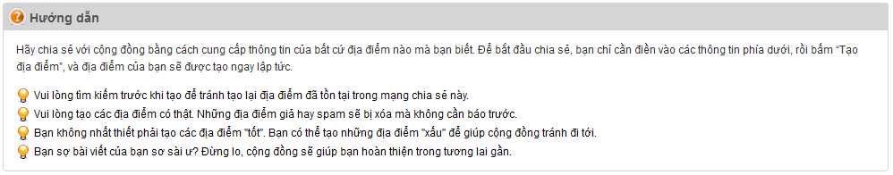**

**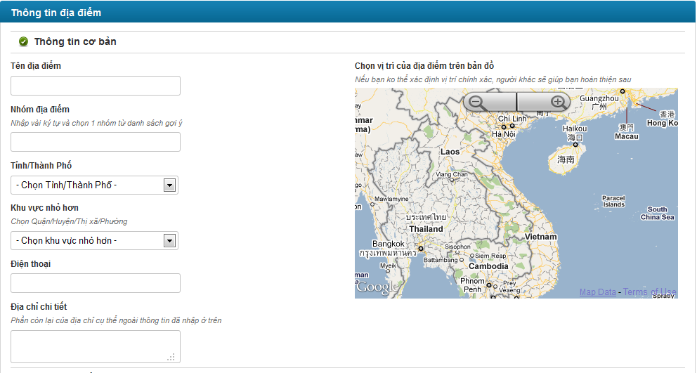**

**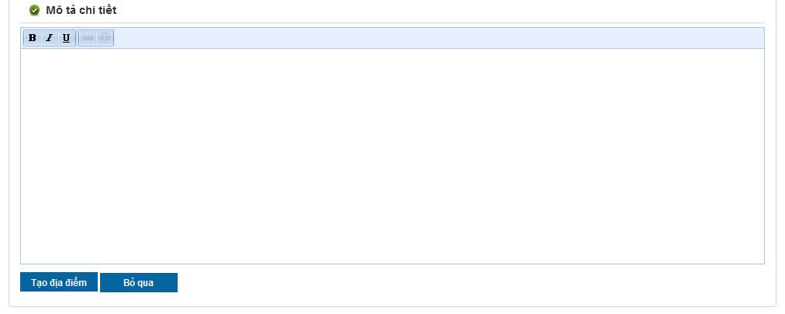**

**Data Fields Definition –Create Place Page**

|  |  |  |  |  |  |  |
| --- | --- | --- | --- | --- | --- | --- |
| **Field name** | **Description** | **Read**  **Only** | **Mandatory** | **Control Type** | **Data Type** | **Length** |
| **Instruction** | **This field contains instructions for creating a new place** | **N/A** | **N/A** | **Label** | **Text** | **Fixed** |
| **Basic information** | **The following fields will be surrounded by a border to allow logical grouping of data for the user. The border will have a heading titled “Thông tin cơ bản”** | **N/A** | **N/A** | **Group Box** | **Text** | **Fixed** |
| Place name label | A label with content “Tên địa điểm” | N/A | N/A | Label | Text | Fixed |
| Place name | The name of the place that to be created. | N | Y | Text Box | Text | 150 |
| Category label | A label with content “Nhóm địa điểm” | N/A | N/A | Label | Text | Fixed |
| Category small label | A small label with content “Nhập vài ký tự và chọn 1 nhóm từ danh sách gợi ý” | N/A | N/A | Label | Text | Fixed |
| Category | The category of the place that to be created. | N | Y | Combo Box |  |  |
| City label | A label with content “Tỉnh / Thành Phố” | N/A | N/A | Label | Text | Fixed |
| City | The name of place’s province or city. It contains all 58 provinces and 5 cities of Vietnam. | N | Y | Combo Box | Text | 100 |
| District label | A label with content “Khu vực nhỏ hơn” | N/A | N/A | Label | Text | Fixed |
| District small label | A small label with content “Chọn Quận/Huyện/Thị xã/Phường” | N/A | N/A | Label | Text | Fixed |
| District | The name of place’s district. Data of this field is filtered by selected item of City combo box. | N | Y | Combo Box | Text | 100 |
| Phone number label | A label with content “Điện thoại” | N/A | N/A | Label | Text | Fixed |
| Phone number | The telephone of place that to be created. | N | N | Numeric Text Box |  |  |
| Detail address label | A label with content “Địa chỉ chi tiết” | N/A | N/A | Label | Text | Fixed |
| Detail address small label | a small label with content “Phần còn lại của địa chỉ cụ thể ngoài thông tin đã nhập ở trên” |  |  |  |  |  |
| Detail address | The detail address of place that to be created. It can be number address, | N | Y | Text Box |  |  |
| **Detail description** | **The following fields will be surrounded by a border to allow logical grouping of data for the user. The border will have a heading titled “Mô tả chi tiết”** | **N/A** | **N/A** | **Group Box** | **Text** | **Fixed** |
| Description box | The user is able to enter text, css tag… to describe, advertise the place. | N | Y | Rich Text Box | Text | Max |
| **Location** | **The following fields will be surrounded by a border to allow logical grouping of data for the user. The border will have a heading titled “Vị trí trên bản đồ”** | **N/A** | **N/A** | **Group Box** | **Text** | **Fixed** |
| Google Map | A Google map for user chooses the location of place. This is control of Google. | N | N | Google API |  |  |

**Buttons / Hyper Links – Create Place Page**

|  |  |  |  |  |
| --- | --- | --- | --- | --- |
| **Function** | **Description** | **Available Criteria** | **Validations** | **Outcome** |
| Create a place | The button will allow the user to create a place in the system | Always available | Validate all mandatory fields and the location of the place is selected. | The record will be saved and user will be navigated to new place’s detail page |
| Cancel creating | The button will allow the user cancel creating new place | Always available | No | User will be navigated to home page |

### Edit a Place’s Information

#### Use Case Diagram



#### Use Case Specification

|  |  |  |  |  |
| --- | --- | --- | --- | --- |
| **USE CASE- Edit a Place’s Information SPECIFICATION** | | | | |
| **Use-case No.** | UC002 | **Use-case Version** | | 1.0 |
| **Use-case Name** | Edit a Place’s Information | | | |
| **Author** | QuocNM | | | |
| **Date** | 15/01/2011 | **Priority** | Normal | |
| **Actor:**  Senior User (has more than 1000 Contribution Point) and administrator (View Business Rule for more detail)  **Summary:**  When some information of a place like telephone, title, address… is changed, the user with highest rank type or the admin can make it up-to-date by click to “Chỉnh sửa thông tin” hyperlink in the place’s details page.  **Goal:**  This use case allows the actor edit information of a place.  **Triggers**  Click to “Chỉnh sửa thông tin” hyperlink in the place’s details page  **Preconditions:**  Logged into the system successfully and open a place’s detail page.  **Post Conditions:**  Redirected back to Place Detail page  **Main Success Scenario:**   |  |  |  | | --- | --- | --- | | Sep | Actor Action | System Response | | 1 | User click to “Chỉnh sửa thông tin” hyperlink | System displays the page to edit place | | 2 | User edit some data fields |  | | 3 | User click to “Sửa” button | System will redirect to the place’s details page with the up-to-date data |   **Alternative Scenario:**   |  |  |  | | --- | --- | --- | | Step | Actor Action | System Response | | 1 | User click to “Chỉnh sửa thông tin” hyperlink | System displays the page to edit place | | 2 | User edit some data fields |  | | 3 | User click to “Bỏ qua” button | System will redirect to the place’s detailspage and the data still is as before. |   **Exceptions:**   |  |  |  | | --- | --- | --- | | Step | Actor Action | System Response | | 1 | User click to “Chỉnh sửa thông tin” hyperlink | System displays the page to edit place | | 2 | User delete orleave blank some mandatory data fields |  | | 3 | User click to “Bỏ qua” button | System validates data in this page and shows all required messages for all missing mandatory data fieds. |   **Relationships:**  Log in use case, View place use case  **Business Rules:**   |  |  |  | | --- | --- | --- | |  | Business Rule | Error Message | | 1 | Rank of an user will be se based on the user’s contribution point (CP) |  | | 2 | Contribution Point (CP) is calculated as follow: **-** Starter point for every user is 10 point - Create a place: + 20 point - Your place get deleted: - 25 point |  | | 3 | For user has more than 1000 point (senior user): - Can edit a place directly - Can upload place’s image directly - Can approve suggested edit - Can approve suggested images  - Set a revision as current |  | | 4 | For user has less than 1000 point (junior user): - an revision of a place created by these users need approvals from senior users or admins to be displayed | “Bạn chưa đủ điểm để sử dụng chức năng này” | | | | | |
| **Description:**  Edit place is one of main focuses on the website. Sharing a place isn’t just simply by post a new place on the system. It is also about sharing information between users. And the most useful method to sharing is every user make all places in the system more detail, more precisely, increase its reliability, up-to-date… everything can be carry through editing places. But because editing can be contribution but also can be destruction, we can’t let every user has access to this function. So only user who has more than 1000 point can edit places. When user has more than 1000 point, It means that user has taken quite a time using our website and he/she is trustable. The chance that user will take some destructive actions is rare.  For users with less than 1000 point, they still can go to Edit place page and edit information. But the changes they made will be taken as suggestions. These suggestions need approvals from verified users (>= 1000 point) or admin team.  To edit a place, user need go to its detail page first. After that, click to “Chỉnh sửa thông tin” hyperlink will redirect you to Edit Place page. At Edit place page, click to “Sửa” button to save all changes or click to “Bỏ qua” button to go back to Detail page. All validations still take effect as creating a new place. | | | | |

**Screen**

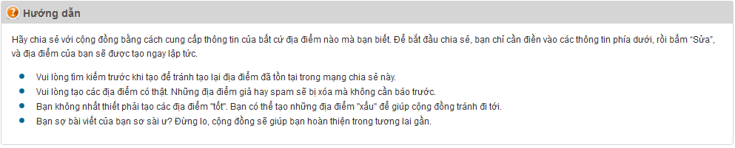

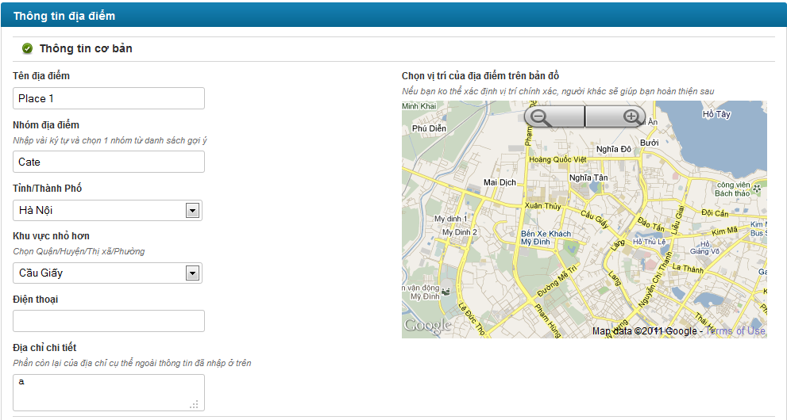

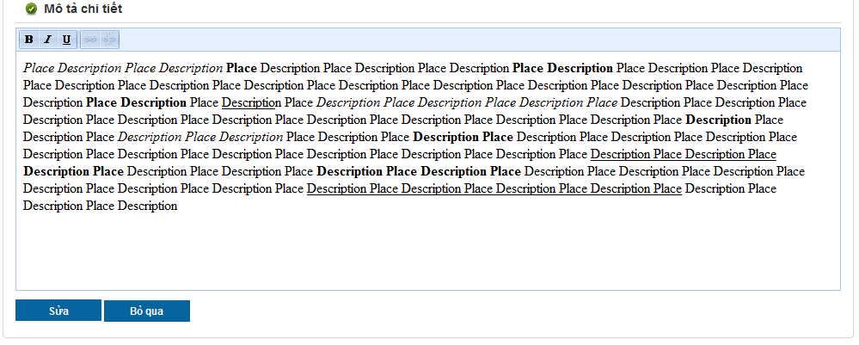

**Data Fields Definition – Attach Place Page**

|  |  |  |  |  |  |  |
| --- | --- | --- | --- | --- | --- | --- |
| **Field name** | **Description** | **Read**  **Only** | **Mandatory** | **Control Type** | **Data Type** | **Length** |
| **Instruction** | **This field contains instructions for edit a new place** | **N/A** | **N/A** | **Label** | **Text** | **Fixed** |
| **Basic information** | **The following fields will be surrounded by a border to allow logical grouping of data for the user. The border will have a heading titled “Thông tin cơ bản”** | **N/A** | **N/A** | **Group Box** | **Text** | **Fixed** |
| Place name label | A label with content “Tên địa điểm” | N/A | N/A | Label | Text | Fixed |
| Place name | The name of the place that to be edited. | N | Y | Text Box | Text | 150 |
| Category label | A label with content “Nhóm địa điểm” | N/A | N/A | Label | Text | Fixed |
| Category small label | A small label with content “Nhập vài ký tự và chọn 1 nhóm từ danh sách gợi ý” | N/A | N/A | Label | Text | Fixed |
| Category | The category of the place that to be edited. | N | Y | Combo Box |  |  |
| City label | A label with content “Tỉnh / Thành Phố” | N/A | N/A | Label | Text | Fixed |
| City | The name of place’s province or city. It contains all 58 provinces and 5 cities of Vietnam. | N | Y | Combo Box | Text | 100 |
| District label | A label with content “Khu vực nhỏ hơn” | N/A | N/A | Label | Text | Fixed |
| District small label | A small label with content “Chọn Quận/Huyện/Thị xã/Phường” | N/A | N/A | Label | Text | Fixed |
| District | The name of place’s district. Data of this field is filtered by selected item of City combo box. | N | Y | Combo Box | Text | 100 |
| Phone number label | A label with content “Điện thoại” | N/A | N/A | Label | Text | Fixed |
| Phone number | The telephone of place that to be edited. | N | N | Numeric Text Box |  |  |
| Detail address label | A label with content “Địa chỉ chi tiết” | N/A | N/A | Label | Text | Fixed |
| Detail address small label | a small label with content “Phần còn lại của địa chỉ cụ thể ngoài thông tin đã nhập ở trên” |  |  |  |  |  |
| Detail address | The detail address of place that to be edited. It can be number address, | N | Y | Text Box |  |  |
| **Detail description** | **The following fields will be surrounded by a border to allow logical grouping of data for the user. The border will have a heading titled “Mô tả chi tiết”** | **N/A** | **N/A** | **Group Box** | **Text** | **Fixed** |
| Description box | The user is able to enter text, css tag… to describe, advertise the place. | N | Y | Rich Text Box | Text | Max |
| **Location** | **The following fields will be surrounded by a border to allow logical grouping of data for the user. The border will have a heading titled “Vị trí trên bản đồ”** | **N/A** | **N/A** | **Group Box** | **Text** | **Fixed** |
| Google Map | A Google map for user chooses the location of place. This is control of Google. | N | N | Google API |  |  |

**Buttons / Hyper Links – Attach Place Page**

|  |  |  |  |  |
| --- | --- | --- | --- | --- |
| **Function** | **Description** | **Available Criteria** | **Validations** | **Outcome** |
| Save edited information | The button will allow the user to save the place information | Always available | Validate all mandatory fields and the location of the place is selected. | New information is saved. User get redirected back to Place Detail page |
| Cancel | The button will allow the user to cancel editing a place | Always available | No | User will be redirected back to Place Detail page |

### Edit a Place’s Location

#### Use Case Diagram



#### Use Case Specification

|  |  |  |  |  |
| --- | --- | --- | --- | --- |
| **USE CASE- Edit place’s location SPECIFICATION** | | | | |
| **Use-case No.** | UC003 | **Use-case Version** | | 1.0 |
| **Use-case Name** | Edit a Place’s Location | | | |
| **Author** | QuocNM | | | |
| **Date** | 15/01/2011 | **Priority** | Normal | |
| **Actor:**  Senior User (has more than 1000 Contribution Point) and administrator (View Business Rule for more detail)  **Summary:**  This use case allows the highest rank type user and admin edit the location of the place on Google map.  **Goal:**  This use case allows the actor edit the location of the place on Google map.  **Triggers**  Click to “Vị trí không chính xác?” hyperlink in Place Detail page.  **Preconditions:**  Logged into the system successfully and open Place Detail page  **Post Conditions:**  The location of the place is changed on Google map and the user stays in Place Detail page  **Main Success Scenario:**   |  |  |  | | --- | --- | --- | | Step | Actor Action | System Response | | 1 | User click to “Vị trí không chính xác?” hyperlink | Popup a map displaying place current location | | 2 | User choose place’s location on displayed map | A symbol marks the location user choose | | 3 | User click to “Cập nhật” button | System save location and closes the popup. |   **Alternative Scenario:**   |  |  |  | | --- | --- | --- | | Step | Actor Action | System Response | | 1 | User click to “Vị trí không chính xác?” hyperlink | Popup a map displaying place current location | | 2 | User click to “Bỏ qua” button | System closes the popup |   **Exceptions:**  None  **Relationships:**  Log in use case, View place detail use case, Edit place’s information use case  **Business Rules:**   |  |  |  | | --- | --- | --- | |  | Business Rule | Error Message | | 1 | Rank of an user will be set based on the user’s contribution point (CP) |  | | 2 | Contribution Point (CP) is calculated as follow: **-** Starter point for every user is 10 point - Create a place: + 20 point - Your place get deleted: - 25 point |  | | 3 | For user has more than 1000 point (senior user): - Can edit a place directly - Can upload place’s image directly - Can approve suggested edit - Can approve suggested images  - Set a revision as current |  | | 4 | For user has less than 1000 point (junior user): - an revision of a place created by these users need approvals from senior users or admins to be displayed | “Bạn chưa đủ điểm để sử dụng chức năng này” | | | | | |
| **Description:**  This function is used when users want to change place location only. It’s quick and save time. Users only need click to “Vị trí không chính xác?” hyperlink, click to new location at popup map and click to “Cập nhật” button. Place location will be replaced by new one.  Location changing made by verified users (>= 1000 point) will take effect right away but the ones made by normal users (< 100 point) will be take in consider. | | | | |

**Screen**

**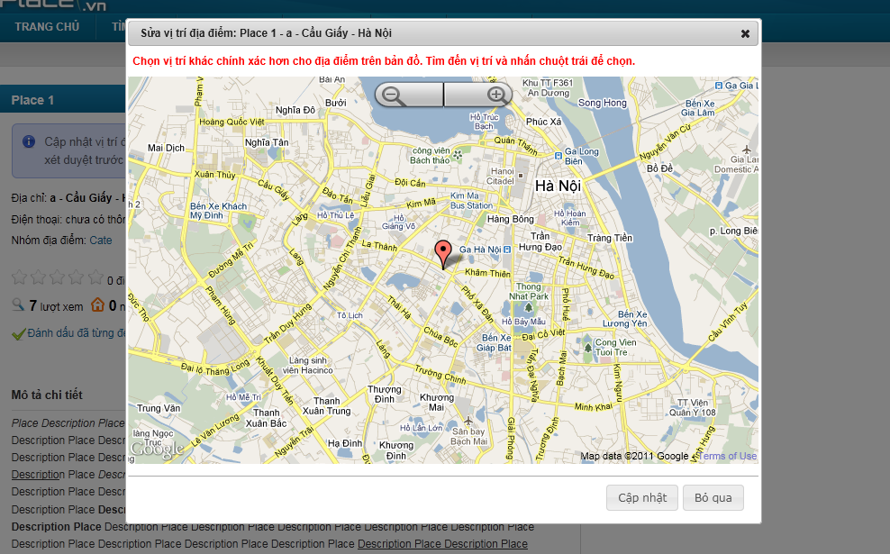**

**Data Fields Definition – Attach Place Page**

|  |  |  |  |  |  |  |
| --- | --- | --- | --- | --- | --- | --- |
| **Field name** | **Description** | **Read**  **Only** | **Mandatory** | **Control Type** | **Data Type** | **Length** |
| Map title | A title with content: “Sửa vị trí địa điểm:” + place name + ”-” + detail address + “-” + place’s district/town/ward + “-” + place’s city/province | N/A | N/A | Label | Text | Fixed |
| Map label | A label with content “**Chọn vị trí khác chính xác hơn cho địa điểm trên bản đồ. Tìm đến vị trí và nhấn chuột trái để chọn.**” | N/A | N/A | Label | Text | Fixed |

**Buttons / Hyper Links – Attach Place Page**

|  |  |  |  |  |
| --- | --- | --- | --- | --- |
| **Function** | **Description** | **Available Criteria** | **Validations** | **Outcome** |
| Save new location | The button will allow the user to save the place’s location. | Always available | No | New location is saved, popup is closed |
| cancel | The button will allow the user to close this popup | Always available | No | Pop up window will be closed |

### View Edit History of a Place

#### Use Case Diagram



#### Use Case Specification

|  |  |  |  |  |
| --- | --- | --- | --- | --- |
| **USE CASE- View edit history of a place SPECIFICATION** | | | | |
| **Use-case No.** | UC004 | **Use-case Version** | | 1.0 |
| **Use-case Name** | View edit history of a place | | | |
| **Author** | QuocNM | | | |
| **Date** | 15/01/2011 | **Priority** | Normal | |
| **Actor:**  User  **Summary:**  This use case allows the actor track the changed history of a place from created time to current time.  **Goal:**  Display the edit history of a place  **Triggers**  Click to “Xem lịch sử sửa đổi” button in the place’s details page  **Preconditions:**  User is in the place’s details page.  **Post Conditions:**  Display edit history page  **Main Success Scenario:**   |  |  |  | | --- | --- | --- | | Step | Actor Action | System Response | | 1 | User click to “Xem lịch sử sửa đổi” hyperlink | System displays the edit history page |   **Exceptions:**  None  **Relationships:**  View place use case  **Business Rules:**  None | | | | |
| **Description:**  Because users can edit place information, functions to keep track and control all the changes become essential. Everyone can see change history of places by click to “Xem lịch sử sửa đổi” at Place Detail page. This page will display every change, users who made these changes and what type of changes they are.  Each time a place was edited, a new version of that place was born. We call these versions “Revision”. Users can compare 2 revisions to see what has changed from this revision to other revision. All users need is check 2 revisions and click to “So sánh” button.  In all revisions, only 1 revision is set as current revision. This revision will be used to display at Place Detail page. In revision list, current revision has “(\*)” sign beside its name.  Revisions created by verified users (>= 1000 point) will be set as current revision right away it was created. But revisions created by users with lesser point will be displayed in gray at revision list. These revisions need approvals from verified users or admin to become a truly revision. If a revision was disapproved, it will be strikethrough and displayed in red.  At Edit history page, users can go back to Place Detail page by clicking to “Quay lại trang địa điểm” hyperlink or go to Edit Place page by clicking to “Chỉnh sửa thông tin” hyperlink. | | | | |

**Screen**

**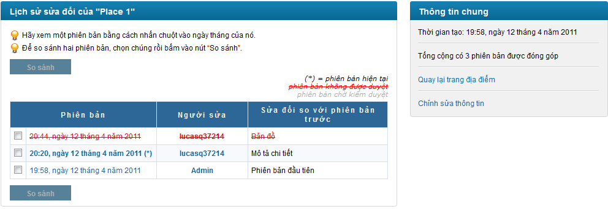**

**Data Fields Definition – Attach Place Page**

|  |  |  |  |  |  |  |
| --- | --- | --- | --- | --- | --- | --- |
| **Field name** | **Description** | **Read**  **Only** | **Mandatory** | **Control Type** | **Data Type** | **Length** |
| **Revision area** | **The following fields will be surrounded by a border to allow logical grouping of data for the user. The border will have a heading titled “Lịch sử sửa đổi của” + place name** | **N/A** | **N/A** | **Group Box** | **Text** | **Fixed** |
| Instruction | Contains instructions for viewing and compare revisions | N/A | N/A | Label | Label | Fixed |
| Revisions | A grid with 3 columns: “Phiên bản”, “Người sửa” and “sửa đổi so với phiên bản trước” | N/A | N/A | Label | Text | Fixed |
| **General information** | **The following fields will be surrounded by a border to allow logical grouping of data for the user. The border will have a heading titled “Thông tin chung”** | **N/A** | **N/A** | **Group Box** | **Text** | **Fixed** |
| Place created date | A label with content “Thời gian tạo:” + created date in vietnamese | N/A | N/A | Label | Label | Fixed |
| Revision number | A label with content “Tống cộng có” + revision number +“phiên bản được đóng góp” | N/A | N/A | Label | Label | Fixed |

**Buttons / Hyper Links – Attach Place Page**

|  |  |  |  |  |
| --- | --- | --- | --- | --- |
| **Function** | **Description** | **Available Criteria** | **Validations** | **Outcome** |
| Compare 2 revision | The button will allow the user to compare 2 edit versions. | Disable by default.  Enable when only 2 versions are selected | No validation | User is navigated to the version compare page |
| Revision hyperlink | The date time that the edit version is saved.  Open the edit version’s details page | Always available | No validation | display chosen edit version’s details in popup |
| Creator hyperlink | The username of the user that created this revision is displayed as hyperlink. | Always available | No validation | Redirect to user profile page |
| Edit page hyperlink | “[Quay lại trang địa điểm](http://localhost:2470/dia-diem/place-1-1)” hyperlink | Always available | No validation | Redirect user to Edit Place page |
| Detail page hyperlink | “[Chỉnh sửa thông tin](http://localhost:2470/places/edit/1)” hyperlink | Always available | No validation | Redirect user back to Place Detail page |

### View a Revision of a Place

#### Use Case Diagram



#### Use Case Specification

|  |  |  |  |  |
| --- | --- | --- | --- | --- |
| **USE CASE- View a revision of a place SPECIFICATION** | | | | |
| **Use-case No.** | UC005 | **Use-case Version** | | 1.0 |
| **Use-case Name** | View a revision of a place | | | |
| **Author** | QuocNM | | | |
| **Date** | 15/01/2011 | **Priority** | Normal | |
| **Actor:**  User  **Summary:**  This use case allows the actor view in detail a revision of a place.  **Goal:**  Display detail information of a revision of a place  **Triggers**  Click to the revision name hyperlink  **Preconditions:**  User is in the history page.  **Post Conditions:**  Popup a window to display revision detail  **Main Success Scenario:**   |  |  |  | | --- | --- | --- | | Step | Actor Action | System Response | | 1 | User click to revision hyperlink | Popup a window to display revision detail |   **Exceptions:**  None  **Relationships:**  Log in use case, View history of a place use case  **Business Rules:**  None | | | | |
| **Description:**  Revisions created by users with less than 1000 points will be taken in consideration. Approvals from verified users (has 1000 points or more) and admins will make it become a real revision and can be displayed at Place Detail page. At Edit history page, when users click to a Revision, a popup will open and displayed all information of that revision. Revision’s information is not different with a place’s information. It has addition information that is State. State will let people know that the current viewing revision is in need of approvals or not. | | | | |

**Screen**

**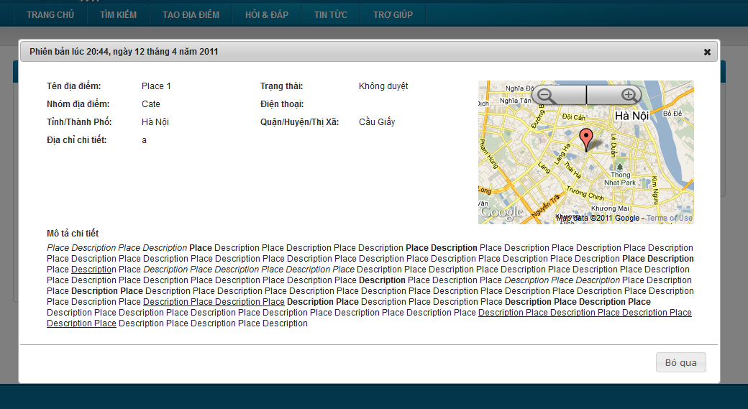**

**Data Fields Definition – Attach Place Page**

|  |  |  |  |  |  |  |
| --- | --- | --- | --- | --- | --- | --- |
| **Field name** | **Description** | **Read**  **Only** | **Mandatory** | **Control Type** | **Data Type** | **Length** |
| **Basic information** | **The following fields will be surrounded by a border to allow logical grouping of data for the user. The border will have a heading titled “Phiên bản” + created date in vietnamese** | **N/A** | **N/A** | **Group Box** | **Text** | **Fixed** |
| Place name label | A label with content “Tên địa điểm” | N/A | N/A | Label | Text | Fixed |
| Place name | Place name | N/A | N/A | Label | Text | Fixed |
| Revision state label | A label with content “Trạng thái” | N/A | N/A | Label | Text | Fixed |
| Revision state | Revision state | N/A | N/A | Label | Text | Fixed |
| Category label | A label with content “Nhóm địa điểm” | N/A | N/A | Label | Text | Fixed |
| Category | Place’s category | N/A | N/A | Label | Text | Fixed |
| City label | A label with content “Tỉnh / Thành Phố” | N/A | N/A | Label | Text | Fixed |
| City | Place’s city/province | N/A | N/A | Label | Text | Fixed |
| District label | A label with content “Quận / Huyện/Thị xã” | N/A | N/A | Label | Text | Fixed |
| District | Place’s district/town/ward | N/A | N/A | label | Text | Fixed |
| Phone number label | A label with content “Điện thoại” | N/A | N/A | Label | Text | Fixed |
| Phone number | Place’s phone number | N/A | N/A | Label | Text | Fixed |
| Detail address label | A label with content “Địa chỉ chi tiết” | N/A | N/A | Label | Text | Fixed |
| Detail address | Place’s detail address | N/A | N/A | Label | Text | Fixed |
| **Mini map** | **A mini map display place location** | N/A | N/A | **Google Map API** |  |  |
| **Detail description** | **The following fields will be surrounded by a border to allow logical grouping of data for the user. The border will have a heading titled “Mô tả chi tiết”** | **N/A** | **N/A** | **Group Box** | **Text** | Fixed |
| Description box | Place’s description | N/A | N/A | Label | Text | Fixed |

**Buttons / Hyper Links – Attach Place Page**

|  |  |  |  |  |
| --- | --- | --- | --- | --- |
| **Function** | **Description** | **Available Criteria** | **Validations** | **Outcome** |
| Cancel | This button is for closing popup | Always available | No validation | Close the popup |

### Compare 2 Revisions of a Place

#### Use Case Diagram



#### Use Case Specification

|  |  |  |  |  |
| --- | --- | --- | --- | --- |
| **USE CASE- Compare 2 revisions of a place SPECIFICATION** | | | | |
| **Use-case No.** | UC006 | **Use-case Version** | | 1.0 |
| **Use-case Name** | Compare 2 revisions of a place | | | |
| **Author** | QuocNM | | | |
| **Date** | 15/01/2011 | **Priority** | Normal | |
| **Actor:**  User  **Summary:**  This use case allows the user compare 2 edit revision of a place and spot differences.  **Goal:**  Display comparison result of 2 revisions  **Triggers**  Click to the “So sánh” button in the edit history page  **Preconditions:**  User is in the edit history page.  **Post Conditions:**  Compare result is displayed  **Main Success Scenario:**   |  |  |  | | --- | --- | --- | | Step | Actor Action | System Response | | 1 | User click to 2 check boxes of 2 revisions | The “So sánh” button is enabled | | 2 | User click to “So sánh” button | System redirect user to compare revision page |   **Exceptions:**  None  **Relationships:**  Log in use case, View a place detail, Views history of a place use case  **Business Rules:**   |  |  |  | | --- | --- | --- | |  | Business Rule | Error Message | | 1 | Only compare 2 revisions |  | | 2 | Date fields contains differences is displayed in red background |  | | | | | |
| **Description:**  At Edit history page, users can compare 2 revisions by check these 2 revisions and click to “So sánh” button. A popup will open and display compares result. These results contain information of 2 revisions. The differences are displayed in red. About place location, the system only let users know if there is difference or not. | | | | |

**Screen**

**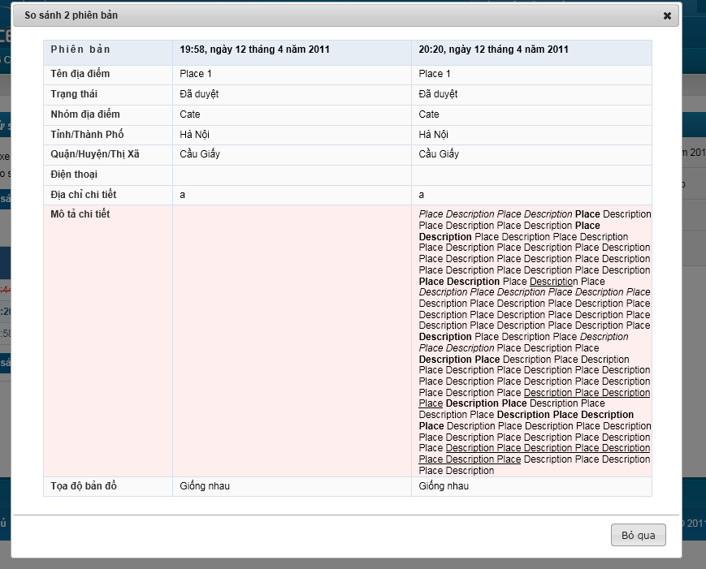**

**Data Fields Definition – Attach Place Page**

|  |  |  |  |  |  |  |
| --- | --- | --- | --- | --- | --- | --- |
| **Field name** | **Description** | **Read**  **Only** | **Mandatory** | **Control Type** | **Data Type** | **Length** |
| Place name label | A label with content “Tên địa điểm” | N/A | N/A | Label | Text | Fixed |
| Place name | Place name | N/A | N/A | Label | Text | Fixed |
| Revision state label | A label with content “Trạng thái” | N/A | N/A | Label | Text | Fixed |
| Revision state | Revision state | N/A | N/A | Label | Text | Fixed |
| Category label | A label with content “Nhóm địa điểm” | N/A | N/A | Label | Text | Fixed |
| Category | Place’s category | N/A | N/A | Label | Text | Fixed |
| City label | A label with content “Tỉnh / Thành Phố” | N/A | N/A | Label | Text | Fixed |
| City | Place’s city/province | N/A | N/A | Label | Text | Fixed |
| District label | A label with content “Quận / Huyện/Thị xã” | N/A | N/A | Label | Text | Fixed |
| District | Place’s district/town/ward | N/A | N/A | label | Text | Fixed |
| Phone number label | A label with content “Điện thoại” | N/A | N/A | Label | Text | Fixed |
| Phone number | Place’s phone number | N/A | N/A | Label | Text | Fixed |
| Detail address label | A label with content “Địa chỉ chi tiết” | N/A | N/A | Label | Text | Fixed |
| Detail address | Place’s detail address | N/A | N/A | Label | Text | Fixed |
| Description label | A label with content “Mô tả chi tiết” | N/A | N/A | Label | Text | Fixed |
| Description box | Place’s description | N/A | N/A | Label | Text | Fixed |
| Place location label | A label with content “Toạ độ bản đồ” | N/A | N/A | Label | Text | Fixed |
| Place location | “Giống nhau” or “Khác nhau” label | N/A | N/A | Label | Text | Fixed |

**Buttons / Hyper Links – Attach Place Page**

|  |  |  |  |  |
| --- | --- | --- | --- | --- |
| **Function** | **Description** | **Available Criteria** | **Validations** | **Outcome** |
| Cancel | This button is for closing popup | Always available | No validation | Close the popup |

### Approve a Revision

#### Use Case Diagram



#### Use Case Specification

|  |  |  |  |  |
| --- | --- | --- | --- | --- |
| **USE CASE- Approve a version SPECIFICATION** | | | | |
| **Use-case No.** | UC007 | **Use-case Version** | | 1.0 |
| **Use-case Name** | Approve a revision | | | |
| **Author** | QuangLM | | | |
| **Date** | 15/01/2011 | **Priority** | Normal | |
| **Actor:**  Senior user (with more than 1000 Contribution Point) or Administrations (View more Business rules for detail)  **Summary:**  Revisions created by junior user won’t be set as current revision. It needs approval to be displayed. Senior users and admins can approve or disapprove revisions when viewing revision detail.  **Goal:**  Approve or disapprove a revision  **Triggers**  Click to “Duyệt sửa đổi” button or “Không duyệt sửa đổi” button at Revision Detail popup  **Preconditions:**  Logged into the system successful and open a revision’s details popup.  **Post Conditions:**  Update revision state and still stay at Edit history Page  **Main Success Scenario:**   |  |  |  | | --- | --- | --- | | Step | Actor Action | System Response | | 1 | Click to “Duyệt sửa đổi” button | Popup closes, revision state is changed to approved |   **Alternative Scenarios:**   |  |  |  | | --- | --- | --- | | Step | Actor Action | System Response | | 1 | Click to “Không duyệt sửa đổi” button | Popup closes, revision state is changed to disapproved |  |  |  |  | | --- | --- | --- | | Step | Actor Action | System esponse | | 1 | Click to “Bỏ qua” button | Popup closes |   **Exceptions:**  None  **Relationships:**  Log in use case, Views edit history of a place, view a revision use case.  **Business Rules:**   |  |  |  | | --- | --- | --- | |  | Business Rule | Error Message | | 1 | Rank of an user will be set based on th user’s contribution point (CP) |  | | 2 | Contribution Point (CP) is calculated as follow: **-** Starter point for every user is 10 point - Create a place: + 20 point - Your place get deleted: - 25 point |  | | 3 | For user has more than 1000 point (senior user): - Can edit a place directly - Can upload place’s image directly - Can approve suggested edit - Can approve suggested images  - Set a revision as current |  | | 4 | For user has less than 1000 point (junior user): - an revision of a place created by these users need approvals from senior users or admins to be displayed | “Bạn chưa đủ điểm để sử dụng chức năng này” | | | | | |
| **Description:**  Revisions created by users with less than 1000 points will be taken in consideration. Approvals from verified users (has 1000 points or more) and admins will make it become a real revision and can be displayed at Place Detail page. At Edit history page, when users click to a Revision, a popup will open and displayed all information of that revision.  When a verified user or admin check detail of a revision which are in need of approvals, “Duyệt sửa đổi” and “Không duyệt sửa đổi” buttons are displayed. Click to “Duyệt sửa đổi” will make the current viewing revision become a real revision. Otherwise, click to “Không duyệt sửa đổi” will mark the current revision as unapproved. | | | | |

**Screen**

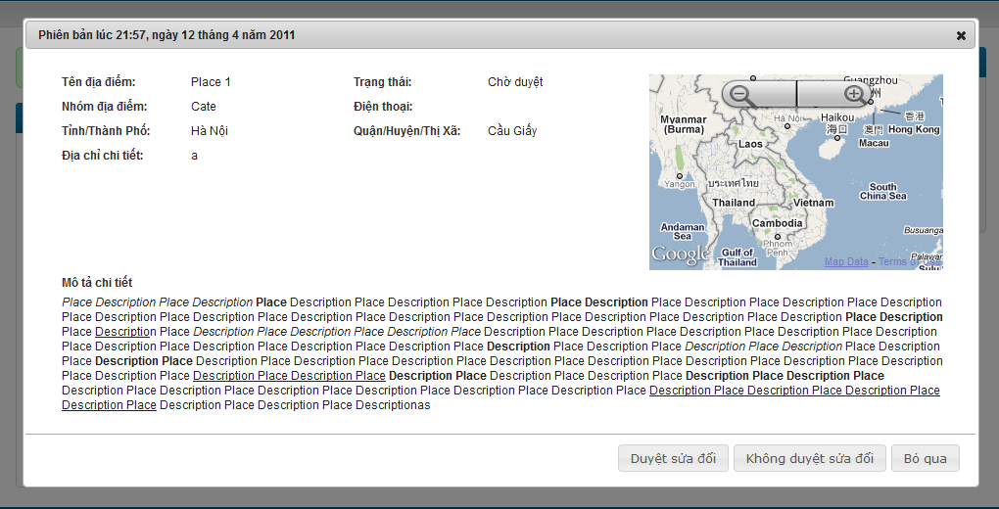

**Data Fields Definition – Attach Place Page**

|  |  |  |  |  |  |  |
| --- | --- | --- | --- | --- | --- | --- |
| **Field name** | **Description** | **Read**  **Only** | **Mandatory** | **Control Type** | **Data Type** | **Length** |
| **Basic information** | **The following fields will be surrounded by a border to allow logical grouping of data for the user. The border will have a heading titled “Phiên bản” + created date in vietnamese** | **N/A** | **N/A** | **Group Box** | **Text** | **Fixed** |
| Place name label | A label with content “Tên địa điểm” | N/A | N/A | Label | Text | Fixed |
| Place name | Place name | N/A | N/A | Label | Text | Fixed |
| Revision state label | A label with content “Trạng thái” | N/A | N/A | Label | Text | Fixed |
| Revision state | Revision state | N/A | N/A | Label | Text | Fixed |
| Category label | A label with content “Nhóm địa điểm” | N/A | N/A | Label | Text | Fixed |
| Category | Place’s category | N/A | N/A | Label | Text | Fixed |
| City label | A label with content “Tỉnh / Thành Phố” | N/A | N/A | Label | Text | Fixed |
| City | Place’s city/province | N/A | N/A | Label | Text | Fixed |
| District label | A label with content “Quận / Huyện/Thị xã” | N/A | N/A | Label | Text | Fixed |
| District | Place’s district/town/ward | N/A | N/A | label | Text | Fixed |
| Phone number label | A label with content “Điện thoại” | N/A | N/A | Label | Text | Fixed |
| Phone number | Place’s phone number | N/A | N/A | Label | Text | Fixed |
| Detail address label | A label with content “Địa chỉ chi tiết” | N/A | N/A | Label | Text | Fixed |
| Detail address | Place’s detail address | N/A | N/A | Label | Text | Fixed |
| **Mini map** | **A mini map display place location** | N/A | N/A | **Google Map API** |  |  |
| **Detail description** | **The following fields will be surrounded by a border to allow logical grouping of data for the user. The border will have a heading titled “Mô tả chi tiết”** | **N/A** | **N/A** | **Group Box** | **Text** | Fixed |
| Description box | Place’s description | N/A | N/A | Label | Text | Fixed |

**Buttons / Hyper Links – Attach Place Page**

|  |  |  |  |  |
| --- | --- | --- | --- | --- |
| **Function** | **Description** | **Available Criteria** | **Validations** | **Outcome** |
| Approve a revision | This button is used for approve a revision | Only available when revision state is unapproved | No | Revision state is updated, popup close |
| Disapprove a revision | This button is used for disapprove a revision | Only available when revision state is unapproved | No | Revision state is updated, popup close |
| cancel | The button will allow the user to close this popup | Always available | No | Popup closes |

### Set a revision as current

#### Use Case Diagram



#### Use Case Specification

|  |  |  |  |  |
| --- | --- | --- | --- | --- |
| **USE CASE- Set a revision is current SPECIFICATION** | | | | |
| **Use-case No.** | UC008 | **Use-case Version** | | 1.0 |
| **Use-case Name** | Set a revision as current | | | |
| **Author** | QuangLM | | | |
| **Date** | 15/01/2011 | **Priority** | Normal | |
| **Actor:**  Senior user (with more than 1000 Contribution Point) or Administrations  **Summary:**  When the quality for current revision is worse than older revision or the place information is changed back, we can go back and set an older revision as current.  **Goal:**  Set a revision as current  **Triggers**  Click to “Đặt làm phiên bản hiện tại” button at Revision Detail popup  **Preconditions:**  Logged into the system successful and open a revision’s details popup.  **Post Conditions:**  Update revision state and still stay at Edit history Page  **Main Success Scenario:**   |  |  |  | | --- | --- | --- | | Step | Actor Action | System Response | | 1 | Click to “Đặt làm phiên bản hiện tại” button | Popup closes, revision state is changed to current revision |   **Alternative Scenarios:**   |  |  |  | | --- | --- | --- | | Step | Actor Action | System Response | | 1 | Click to “Bỏ qua” button | Popup closes |   **Exceptions:**  None  **Relationships:**  Log in use case, Views edit history of a place, view a revision use case.  **Business Rules:**   |  |  |  | | --- | --- | --- | |  | Business Rule | Error Message | | 1 | Rank of an user will be set based on the user’s contribution point (CP) |  | | 2 | Contribution Point (CP) is calculated as follow: **-** Starter point for every user is 10 point - Create a place: + 20 point - Your place get deleted: - 25 point |  | | 3 | For user has more than 1000 point (senior user): - Can edit a place directly - Can upload place’s image directly - Can approve suggested edit - Can approve suggested images  - Set a revision as current |  | | 4 | For user has less than 1000 point (junior user): - an revision of a place created by these users need approvals from senior users or admins to be displayed | “Bạn chưa đủ điểm để sử dụng chức năng này” | | | | | |

**Screen**

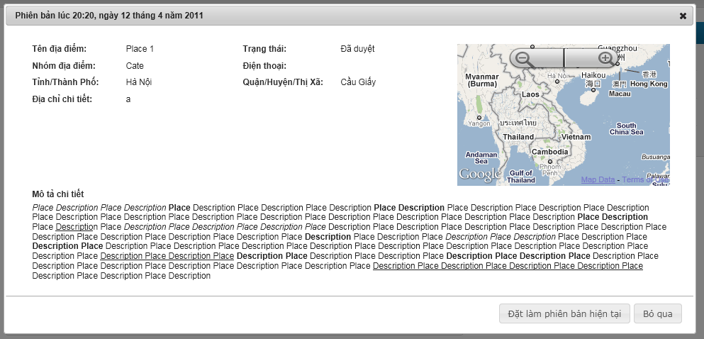

**Data Fields Definition**

|  |  |  |  |  |  |  |
| --- | --- | --- | --- | --- | --- | --- |
| **Field name** | **Description** | **Read**  **Only** | **Mandatory** | **Control Type** | **Data Type** | **Length** |
| **Basic information** | **The following fields will be surrounded by a border to allow logical grouping of data for the user. The border will have a heading titled “Phiên bản” + created date in vietnamese** | **N/A** | **N/A** | **Group Box** | **Text** | **Fixed** |
| Place name label | A label with content “Tên địa điểm” | N/A | N/A | Label | Text | Fixed |
| Place name | Place name | N/A | N/A | Label | Text | Fixed |
| Revision state label | A label with content “Trạng thái” | N/A | N/A | Label | Text | Fixed |
| Revision state | Revision state | N/A | N/A | Label | Text | Fixed |
| Category label | A label with content “Nhóm địa điểm” | N/A | N/A | Label | Text | Fixed |
| Category | Place’s category | N/A | N/A | Label | Text | Fixed |
| City label | A label with content “Tỉnh / Thành Phố” | N/A | N/A | Label | Text | Fixed |
| City | Place’s city/province | N/A | N/A | Label | Text | Fixed |
| District label | A label with content “Quận / Huyện/Thị xã” | N/A | N/A | Label | Text | Fixed |
| District | Place’s district/town/ward | N/A | N/A | label | Text | Fixed |
| Phone number label | A label with content “Điện thoại” | N/A | N/A | Label | Text | Fixed |
| Phone number | Place’s phone number | N/A | N/A | Label | Text | Fixed |
| Detail address label | A label with content “Địa chỉ chi tiết” | N/A | N/A | Label | Text | Fixed |
| Detail address | Place’s detail address | N/A | N/A | Label | Text | Fixed |
| **Mini map** | **A mini map display place location** | N/A | N/A | **Google Map API** |  |  |
| **Detail description** | **The following fields will be surrounded by a border to allow logical grouping of data for the user. The border will have a heading titled “Mô tả chi tiết”** | **N/A** | **N/A** | **Group Box** | **Text** | Fixed |
| Description box | Place’s description | N/A | N/A | Label | Text | Fixed |

**Buttons / Hyper Links**

|  |  |  |  |  |
| --- | --- | --- | --- | --- |
| **Function** | **Description** | **Available Criteria** | **Validations** | **Outcome** |
| Set a revision as current | This button is used for setting current viewing revision as current revision | Only available when revision state is approved and not current | No | Revision state is updated, popup close |
| cancel | The button will allow the user to close this popup | Always available | No | Popup closes |

### View a Place Detail

#### Use Case Diagram



#### Use Case Specification

|  |  |  |  |  |
| --- | --- | --- | --- | --- |
| **USE CASE – View a place detail SPECIFICATION** | | | | |
| **Use-case No.** | UC009 | **Use-case Version** | | 1.0 |
| **Use-case Name** | View a Place Detail | | | |
| **Author** | QuangVT | | | |
| **Date** | 24/01/2011 | **Priority** | High | |
| **Actor:**  User  **Summary:**  After a user performs searching for places, the result is returned containing the most basic information of the places. If the user wants to view more information of a place, he/she can navigate to the place details page. From this page, the user can interact with the place as well as other users. The user can rate the place, comment, edit, mark as spam… All information of the place is displayed here.  The place details page may be navigated from other locations other than the search result page. For example the “top places” list. In general, the details page may be accessed from anywhere that displays the place’s identity.  **Goal:**  Display the place details to the users, and allow the users to interact with the place as well as other users.  **Triggers**  Users click a place link from anywhere in the system  **Preconditions:**  Access the website  **Post Conditions:**  The page navigates to the details page with the place’s information displayed  **Main Success Scenario:**   |  |  |  | | --- | --- | --- | | Step | Actor Action | System Response | | 1 | Searches for places by some criteria | Search result is returned | | 2 | Click a place link | The page navigates to the place details screen |   **Alternative Scenarios:**   |  |  |  | | --- | --- | --- | | Step | Actor Action | System Response | | 1 | Click to “Tạo địa điểm” tab in navigator | Rdirect to Create Place page | | 2 | Fill in required fields |  | | 3 | Click “Tạo địa điểm” button | Redirect to Place Detail page of new place |   **Exceptions:**   |  |  |  | | --- | --- | --- | | Step | Actor Action | System Response | | 1 | Click an invalid place link | Display erro page inform the user that the pge doesn’t exsit |   **Relationships:**  Search places, View edit history of a place, Edit place location on map, Report an edit of other users on a place, Report a place as fake/spam, Mark a place as visited, Share a place on other social networks, Delete a place, Place response, User comment  **Business Rules:**  None | | | | |
| **Description:**  After the user performs a search place action, he/she can choose to view details of some places from the result list. This will bring the user to the Place Details page. This page may also be navigated from anywhere that refers to its identity. After visiting this page, the user can view all information of the place.  The page will display the information of the place including:   * Place name: name of the place * Place address: full address of the place * Location on the map: the map will be shown as a medium picture and can be zoomed in/out (like Google Map). There is a point on the map indicating location of the place. The default map will show an area of 25 square kilometers (5x5) with the place spot located at the center. * Images of the place: images include a main image that displays as the place’s avatar, and other images. All images are contributed by the society, and the most liked image will become the main image. Only approved images are displayed.   The page will also show some related places to this place. They are places in the same category and have the highest popularity. The number of related places to show is 10 in maximum.  Users can perform various actions on this page, including:   * Edit the place info: refer to use case Edit a Place’s Information * Edit place location on the map: refer to use case Edit a Place’s Location * Rate the place: refer to use case Rate a Place * Comment: refer to use case Post a Comment * Mark the place as visited: refer to use case Mark a Place as Visited * Report a place as spam: refer to use case Report a Place * Upload images for the place * View a place’s revisions: refer to use case View Edit History of a Place * Add a place to your favorite list: refer to use case Add a Place to Favorite List   Increase page view  Each hit to the place details page will increase the number of page views for this place. | | | | |

**Screen**

**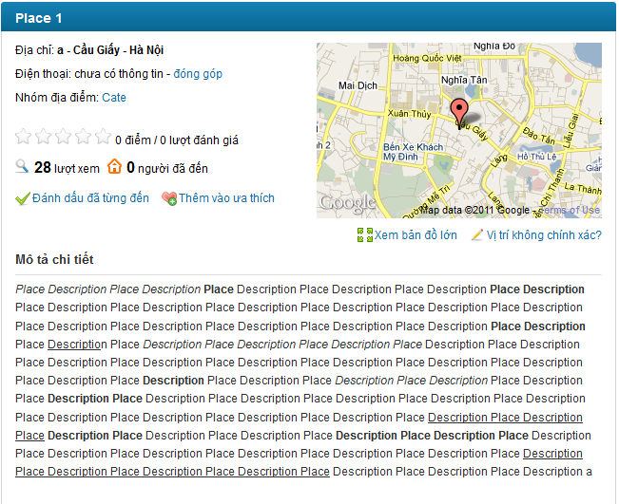**

**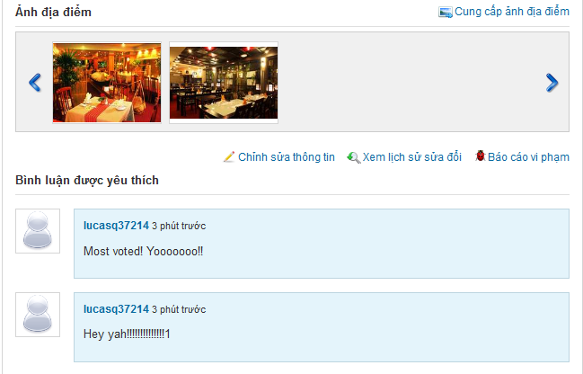**

**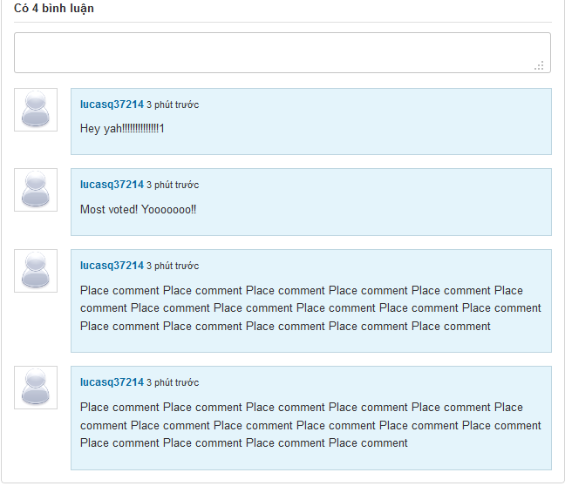**

**Data Fields Definition –Create Place Page**

|  |  |  |  |  |  |  |
| --- | --- | --- | --- | --- | --- | --- |
| **Field name** | **Description** | **Read**  **Only** | **Mandatory** | **Control Type** | **Data Type** | **Length** |
| Place name | Place name is displayed at header | N/A | N/A | Label | String | Fixed |
| Detail address | A label contains detail address, created by Detail Address + District/Town/Ward + City/Province | N/A | N/A | Label | String | Fixed |
| Phone number | A label contains place’s phone number | N/A | N/A | Label | String | Fixed |
| Rating | A label with content: 5 star symbols + current rating + rate times + “ lượt đánh giá” | N/A | N/A | Label | String | Fixed |
| View number | A label with content: view number + “lượt xem” | N/A | N/A | Label | String | Fixed |
| Visited number | A label with content: visited number + “người đã đến” | N/A | N/A | Label | String | Fixed |
| description | A label contains place description | N/A | N/A | Label | String | Fixed |

**Buttons / Hyper Links – Q&A Screen**

|  |  |  |  |  |
| --- | --- | --- | --- | --- |
| **Function** | **Description** | **Available Criteria** | **Validations** | **Outcome** |
| “đóng góp” hyperlink | Allow user open Edit Place page | Only Available when unrequired fields are leave blank when creating place | No validation | Redirect user to Edit Place page |
| “Xem bản đồ lớn” hyperlink | Allow user to see place location in bigger map | Always Available | No validation | Popup a window with bigger map |
| “Vị trí không chính xác?” hyperlink | Allow user to edit place location | Always Available | No validation | Popup a window with bigger map for changing location |
| “Đánh dấu đã từng đến” hyperlink | Allow user mark current viewing place as visited | Always Available | No validation | Visited number is increased by 1, display message “Địa điểm đã được đánh dấu.  ” |
| “Thêm vào ưa thích” hyperlink | Allow user to add current viewing place to favorite list | Always Available | No validation | Display message “Địa điểm đã được thêm vào ưa thích” |
| “Cung cấp ảnh địa điểm” hyperlink | Allow user to upload images for current viewing place | Always Available | No validation | Popup window with uploader for upload images |
| “Chỉnh sửa thông tin” hyperlink | Allow user edit open Edit Place page | Always Available | No validation | Redirect user to Edit Place page |
| “Xem lịch sử sửa đổi” hyperlink | Allow user to view revisions of current viewing place | Always Available | No validation | Redirect user to Revisions page |
| “Báo cáo vi phạm” hyperlink | Allow user to report a place | Always Available | No validation | Popup report window |
| Category link | This link will search all place belong to selected category | Always Available | No validation | Redirect user to Search Place page with search results contains all places belong to selected category |
| User link | This hyperlink helps user open User Profile page | Display with each comment | No validation | Redirect user to User Profile page |

### Search Places

#### Use Case Diagram



#### Use Case Specification

|  |  |  |  |  |
| --- | --- | --- | --- | --- |
| **USE CASE – Search places SPECIFICATION** | | | | |
| **Use-case No.** | UC010 | **Use-case Version** | | 1.0 |
| **Use-case Name** | Search Places | | | |
| **Author** | QuangVT | | | |
| **Date** | 24/01/2011 | **Priority** | High | |
| **Actor:**  User  **Summary:**  This is one of the main functions of the system. Users can search for places by some criteria in order to find the best place suitable for their need. The criteria may include place category, distance, popularity… The search result will be filtered to support users find the right place as quick as possible.  The search function will include quick search and advanced search. Quick search is available to the user right from the home page and accept the most basic criteria like category and area. Advanced search will accept more criteria to help users filter search result more precisely.  **Goal:**  Search for places  **Triggers**  Users enter search criteria and click search button  **Preconditions:**  Access the website  **Post Conditions:**  The page navigates to search result screen with the result displayed  **Main Success Scenario:**   |  |  |  | | --- | --- | --- | | Step | Actor Action | System Response | | 1 | Enters place category to the search text box |  | | 2 | Clicks “Tìm kiếm” buton | Display search result |   **Alternative Scenario - Suggestion:**   |  |  |  | | --- | --- | --- | | Step | Actor Action | System Response | | 1 | Enters place category to the search text box | The system displays suggestions which have similar spellings with the text entered | | 2 | Chooses one of the suggestions |  | | 3 | Clicks “Tìm kiếm” button | Display search result |   **Alternative Scenario – Advanced Search**   |  |  |  | | --- | --- | --- | | Step | Actor Action | System Response | | 1 | Clicks “Tìm kiếm nâng cao” hyperlink | New region on the page is displayed with more search criteria inputs | | 2 | Enters search criteria |  | | 3 | Clicks “Tìm kiếm” button | Display search result |   **Alternative Scenario – No result**   |  |  |  | | --- | --- | --- | | Step | Actor Action | System Response | | 1 | Enter category which has no place belong to |  | | 2 | Clicks “Tìm kiếm” button | Display “Không tìm thấy địa điểm nào!” |   **Exceptions:**  N/A  **Relationships:**  None  **Business Rules:**  None | | | | |
| **Description:**  Users will use this function to search for places that best fit for their need. The user will input some search criteria and the system will return the result based on those criteria.  Quick Search  This is one of main regions on the system. Use can access to it right at the home page or go to Search Place page by click to “Tìm kiếm” at navigator. The region contains 2 fields: “Tìm gì, mua gì” and “Ở đâu”. With the first field, the users will enter place’s category or place name they want to search. For example: “cà phê”, “rửa xe”, “Ngân hàng ACB”… With the second field, the users will enter the area they want to find places in. The areas are specified as a city/province/district/town/ward... For example: “Hà Nội”, “Cầu Giấy, Hà Nội”…  A place is included in the search result if it matches all the search criteria. For example, if a user enters “Cà phê” as the category, and “Cầu Giấy, Hà Nội” as the area, only coffee shops in Cau Giay, Ha Noi are included in the search result.  The search area field will be auto populated by data from the user’s browser cookies if already existed. Otherwise, it will be based on the user’s IP address. That is if the user first visits the website, the search area text box will be populated based on the user’s IP. After the user performs the search function, the content of that text box will be stored in the user’s browser cookies and will be the retrieved to populate that text box the next time user performs searching.  Advanced Search  This function will provide users more options to tailor search result more precisely. The options include:   * Search category and search area: like quick search * Distance to the user’s location. The distance will be specified in Kilometers. In order to use this feature, the user must specify his location on the map. The location will be retrieved from the user info if he has logged in, or from the user’s browser cookies if existed there. If none of the two sources exists, the user will be prompted to select his location on the map. After the user specifies his location, the location is saved to the user info (if logged in) and the user’s browser cookies. Search result will only include places distance from which is not longer than the Km specified. * Rating must be greater than or equal to. Users can restrict this field to filter places with best rating.   Search Suggestions  After the user enters first characters into the search text boxes, the system will display some suggestions below the text boxes that have the similar spelling. Here are some considerations that take into account when display the suggestions:   * The suggestions are not case-sensitive. That is it doesn’t matter that the user enters upper or lower case characters into the text boxes, the suggestions must be the same. * The suggestions are not Unicode-sensitive. That is if the user enters “ca phe”, the suggestions will be the same as if the user enters “cà phê”. * An item will be included in the suggestions if it contains the character sequence entered in the text box, ignoring the spaces. Item containing the sequence at index i will be displayed before item containing the sequence at index j if i < j. If i = j, the items will be ordered based on the number of searches performed on that item.   For example: if the user input “Cà” in the search category, the system will suggest: “Cà phê”, “Cà chua”, “Cà pháo”, “Giáp lá cà”, if the term “Cà phê” is searched the most in the triplet. If the user inputs “Cà p”, only “Cà phê” and “Cà pháo” are displayed in the suggestions.   * A category is associated with many aliases. For example “Cà phê” may also be called “café”. The suggestions must be checked with those aliases as well. * Area text box will suggest only city/province/district/town/ward. For example: “Hà Nội”, “Cầu Giấy, Hà Nội”.   Search Result  Search result must match all the criteria inputted. Each place appearing in the search result will display the following information: Place name, place image, rating, number of raters, number of comments, number of page views.  Users will have the options to sort places by rating, number of comments and number of page views. Default will be “rating descending”.  Search result will be paged with 20 items per page. User only need click to “Xem thêm” at the end of result list to see more search result. | | | | |

**Screen**

**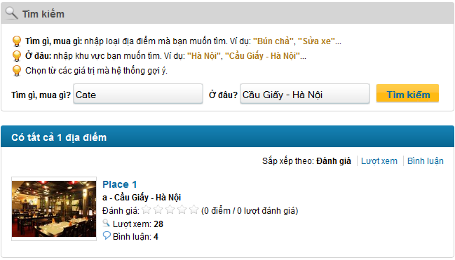**

**Data Fields Definition – Search Places**

|  |  |  |  |  |  |  |
| --- | --- | --- | --- | --- | --- | --- |
| **Field name** | **Description** | **Read**  **Only** | **Mandatory** | **Control Type** | **Data Type** | **Length** |
| **Search Area** | | | | | | |
| Instruction | Contains instructions for searching place | Y | Y | Label | String | Fixed |
| Category Seach label | A label with content “Tìm gì, mua gì?” | Y | Y | Label | String | Fixed |
| Category search | Category used for searched | N | Y | Text box | String | 100 |
| Address part search label | A label with content “Ở đâu?” | Y | Y | Label | String | Fixed |
| Address part seach | Address part used for searched | N | Y | Text box | String | 100 |
| **Sort Area** | | | | | | |
| Sort label | A label with content “Sắp xếp theo” | Y | Y | Label | String | Fixed |
| Rating label | A label with content “Đánh giá” | Y | Y | Label | String | Fixed |
| View label | A label with content “Lượt xem” | Y | Y | Label | String | Fixed |
| Comment label | A label with content “Bình luận” | Y | Y | Label | String | Fixed |
| **Result Area – each place contains:** | | | | | | |
| Place name | A label contains place name | Y | Y | Label | String | Fixed |
| Detail address | A label contains place detail address + district/town/ward + city/province | Y | Y | Label | String | Fixed |
| Rating | A label contains place rating | Y | Y | Label | String | Fixed |
| View number | A label contains place view number | Y | Y | Label | String | Fixed |
| Comment number | A label contains place comment number | Y | Y | Label | String | Fixed |

**Buttons / Hyper Links – Search Places**

|  |  |  |  |  |
| --- | --- | --- | --- | --- |
| **Function** | **Description** | **Available Criteria** | **Validations** | **Outcome** |
| Search place | A button which start searching for places based on inputted criteria | Always available | Category isn’t blank | Display results below search area or message “Không tìm thấy địa điểm nào!” |
| Sort by rating | A link that sort search results based on place’s rating, from highest to lowest | Available when dispay search results |  | All results are sorted by rating, from highest to lowest |
| Sort by view number | A link that sort search results based on place’s view number, from highest to lowest | Available when dispay search results |  | All results are sorted by view number, from highest to lowest |
| Sort by comment number | A link that sort search results based on place’s comment number, from highest to lowest | Available when dispay search results |  | All results are sorted by comment number, from highest to lowest |
| Place link | This link will navigate user to Place Detail page | Available when dispay search results |  | Redirect to Place Detail page |

### Report a Place

#### Use Case Diagram



#### Use Case Specification

|  |  |  |  |  |
| --- | --- | --- | --- | --- |
| **USE CASE- Report a place SPECIFICATION** | | | | |
| **Use-case No.** | UC011 | **Use-case Version** | | 1.0 |
| **Use-case Name** | Report a place | | | |
| **Author** | QuocNM | | | |
| **Date** | 15/01/2011 | **Priority** | Normal | |
| **Actor:**  User  **Summary:**  When user detect a place is fake, doesn’t exist or created by untrusted user or contains inappropriate content, he/she can report that place to the administrator and let administrator team handle it.  **Goal:**  This use case allows the actor report a place as fake/spam/inappropriate.  **Triggers**  Click to “Báo cáo vi phạm” hyperlink in the place’s details page.  **Preconditions:**  Successfully logged into the system and open place’s details page.  **Post Conditions:**  Stay remains at Place Detail page  **Main Success Scenario:**   |  |  |  | | --- | --- | --- | | Step | Actor Action | System Response | | 1 | Click to “Báo cáo vi phạm” hyperlink | System shows a popup to confirm and user can add more reason why this lace is reported. | | 2 | Click to “Báo cáo” button. | Display popup notify success message “Báo cáo vi phạm hoàn tất! Ban quan trị sẽ kiểm tra lại trong thời gian sớm nhất.” | | 3 | Click to OK button | Popups close |   **Alternative Scenarios:**   |  |  |  | | --- | --- | --- | | Step | Actor Action | System Reponse | | 1 | Click to “Báo cáo vi phạm” hyperlink | System shows a popup to confirm and user can add more reason why this place is reported. | | 2 | Enter reason |  | | 3 | Click to “Báo cáo” button. | Display popup notify success message “Báo cáo vi phạm hoàn tất! Ban quan trị sẽ kiểm tra lại trong thời gian sớm nhất.” | | 4 | Click to OK button | Popups close |  |  |  |  | | --- | --- | --- | | Step | Actor Action | System Response | | 1 | Click to “Báo cáo vi phạm” hyperlink | System shows a popup to confirm and user can add more reason why this place is reported. | | 2 | Enter reason |  | | 3 | Click to “Bỏ qua” button. | Popup close |   **Exceptions:**   |  |  |  | | --- | --- | --- | | Step | Actor Action | System Response | | 1 | Click to “Báo cáo vi phạm” hyperlink | System shows a popup to confirm and user can add more reason why this place is reported. | | 2 | Enter reason |  | | 3 | Click to “Báo cáo” button. | Display popup notify success message “Báo cáo vi phạm hoàn tất! Ban quan trị sẽ kiểm tra lại trong thời gian sớm nhất.” | | 4 | Click to OK button | Popups close | | 5 | Click to “Báo cáo vi phạm” hyperlink | Display popup message “Báo cáo vi phạm hoàn tất! Ban quan trị sẽ kiểm tra lại trong thời gian sớm nhất.” |   **Relationships:**  Log in use case, View a place’s details use case.  **Business Rules:**   |  |  |  | | --- | --- | --- | |  | Business Rule | Error Message | | 1 | 1 place can only be reported by 1 user once |  | | | | | |

**Screen**

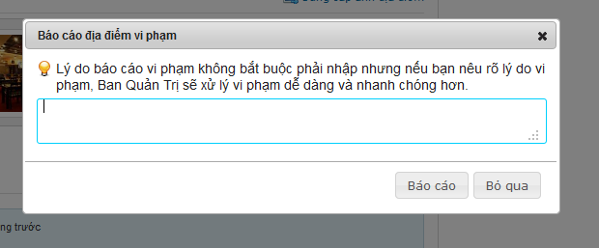

**Data Fields Definition – Comment Area**

|  |  |  |  |  |  |  |
| --- | --- | --- | --- | --- | --- | --- |
| **Field name** | **Description** | **Read**  **Only** | **Mandatory** | **Control Type** | **Data Type** | **Length** |
| instruction | Contains instructions for reporting a place | Y | Y | Label | String | Fixed |

**Buttons / Hyper Links – Comment Area**

|  |  |  |  |  |
| --- | --- | --- | --- | --- |
| **Function** | **Description** | **Available Criteria** | **Validations** | **Outcome** |
| Send a report | This button will send a report to server | Always available | No validation | Display popup notify success message “Báo cáo vi phạm hoàn tất! Ban quan trị sẽ kiểm tra lại trong thời gian sớm nhất.” |
| Cancel | This button will close popup | Always available | No validation | Close popup |

### Mark a Place as Visited

#### Use Case Diagram



#### Use Case Specification

|  |  |  |  |  |
| --- | --- | --- | --- | --- |
| **USE CASE- Mark a place as visited SPECIFICATION** | | | | |
| **Use-case No.** | UC012 | **Use-case Version** | | 1.0 |
| **Use-case Name** | Mark a place as visited | | | |
| **Author** | QuocNM | | | |
| **Date** | 15/01/2011 | **Priority** | Normal | |
| **Actor:**  User  **Summary:**  When visiting a place, user realize that he/she visited this place it is an interesting place. So it’s very convenient if he/she can click to “Đánh dấu đã từng đến” hyperlink and make this place more reliable.  **Goal:**  This use case allows the actor mark a place as visited.  **Triggers**  Click to “Đánh dấu đã từng đến” hyperlink in the place’s details page.  **Preconditions:**  Successfully logged into the system  **Post Conditions:**  Visited number is increased by 1, stay remain at Place Detail page  **Main Success Scenario:**   |  |  |  | | --- | --- | --- | | Step | Actor Action | System Response | | 1 | Click to “Đánh dấu đã từng đến” hyperlink. | Visited number is increased by 1 and a message is displayed “Địa điểm đã được đánh dấu.” |   **Exceptions:**   |  |  |  | | --- | --- | --- | | Step | Actor Action | System Response | | 1 | Click to “Đánh dấu đã từng đến” hyperlink. | Visited number is increased by 1 and a message is displayed “Địa điểm đã được đánh dấu.” | | 2 | Click to “Đánh dấu đã từng đến” hyperlink. | a message is displayed “Địa điểm đã được đánh dấu.” |   **Relationships:**  Log in use case, View a place’s details use case.  **Business Rules:**   |  |  |  | | --- | --- | --- | |  | Business Rule | Error Mssage | | 1 | Each user has only 1 time to mark a place as visited. |  | | | | | |

**Screen**

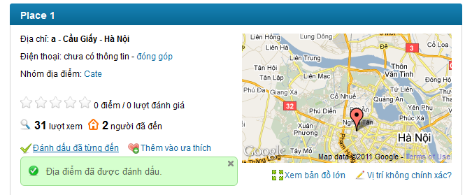

### Rate a Place

#### Use Case Diagram



#### Use Case Specification

|  |  |  |  |  |
| --- | --- | --- | --- | --- |
| **USE CASE – Rate a place SPECIFICATION** | | | | |
| **Use-case No.** | UC013 | **Use-case Version** | | 1.0 |
| **Use-case Name** | Rate a place | | | |
| **Author** | QuangLM | | | |
| **Date** | 16/01/2011 | **Priority** | High | |
| **Actor:**  User  **Summary:**  When the user views information of a place, he/she can rate that place based on the usefulness of the information or his/her opinion about that place. The user only need move the mouse to the rating bar, choose rating and click. The user rating will be used to calculate the total rating of the place. User can change the rating by rate it again. The last rating time of the user will be used to calculate. The rating is from 1 to 5 stars.  **Goal:**  Rate a place from 1 to 5 stars  **Triggers**  Click to rating bar  **Preconditions:**  Successfully logged into the system and open a place detail page  **Post Conditions:**  Stay remains at current place page with a rating saved.  **Main Success Scenario:**   |  |  |  | | --- | --- | --- | | Step | Actor Action | System Response | | 1 | Click to rating bar at the decided rating | Rating is saved and displayed by number of star turn from white to orange. A message is displaed “Cảm ơn bạn đã đánh giá địa điểm này.” |   **Alternative Scenario:**   |  |  |  | | --- | --- | --- | | Step | Actor Action | System Response | | 1 | Click to rating bar at the decided rating | Rating is saved and displayed by number of star turn from white to orange. A message is displaed “Cảm ơn bạn đã đánh giá địa điểm này.” | | 2 | Click to rating bar again at new decided rating | Save the new user rating. A message is displaed “Cảm ơn bạn đã đánh giá địa điểm này.” |   **Exceptions: -**  **Relationships:**  Log in use case  **Business Rules:**   |  |  |  | | --- | --- | --- | | **No** | **Rule Description** | **Error Message** | | 1 | The rating of 1 place is average of all user rates |  | | 2 | The rating is from 1 to 5 stars. |  | | 3 | The user can only rate 1 place many times. The last rating will be count as the user’s rate |  | | | | | |
| **Description:**  When the user views information of a place, he/she can rate that place based on the usefulness of the information or his/her opinion about that place.The user only need move the mouse to the rating bar, choose rating and click. The user rating will be used to calculate the total rating of the place. User can change the rating by rate it again. The last rating time of the user will be used to calculate. The rating is from 1 to 5 stars. The rating bar has 5 white star symbols. The saved rating will be display in orange. Beside rating bar there is user rating displayed in text with number or rate times of current viewing place.  The rating will be used for ranking all places in the system and displayed hottest place as a list at homepage. It also will be used to sorted places in search result list. The rating used for sort isn’t averate rating of a place, but total rating. We used this method for sorting because we don’t want to let a 5 stars place with only 1 vote time be put above 4stars place with 1000 vote times. So this way will be much fairer in our opinion. | | | | |

**Screen**

**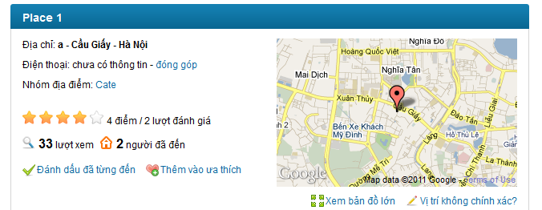**

### Post a Comment

#### Use Case Diagram



#### Use Case Specification

|  |  |  |  |  |
| --- | --- | --- | --- | --- |
| **USE CASE – Post a comment SPECIFICATION** | | | | |
| **Use-case No.** | UC014 | **Use-case Version** | | 1.0 |
| **Use-case Name** | Post A Comment | | | |
| **Author** | QuangLM | | | |
| **Date** | 12/01/2011 | **Priority** | High | |
| **Actor:**  User  **Summary:**  When the user wants to express his/her opinion about how they feel about the place, the user can do it by post a comment. The user can enter whatever he/she would like to in comment box and click to “**Bình luận**” button to post it on a place detail page.    **Goal:**  Post a comment on a place page  **Triggers**  Click to comment textbox  **Preconditions:**  Successfully logged into the system and open a place detail page  **Post Conditions:**  Stay remain at current place page with a comment was added and displayed on top of comment area.  **Main Success Scenario:**   |  |  |  | | --- | --- | --- | | Step | Actor Action | System Response | | 1 | Click to comment text box | “Bình luận” and “Bỏ qua” button are visible | | 2 | Enter the content | - | | 3 | Click “**Bình luận”** button | Add user’s comment to comment area. User’s comment was put on top so that the user can see right away that his/her comment was posted |   **Alternative Scenario:**   |  |  |  | | --- | --- | --- | | Sep | Actor Action | System Response | | 1 | Click to comment text box | “Bình luận” and “Bỏ qua” button are visible | | 2 | Enter the content | - | | 3 | Click “**Bỏ qua”** button | Clear comment box, 2 buttons are hidden |   **Exceptions:**   |  |  |  | | --- | --- | --- | | Step | Actor Action | System Response | | 1 | Click to comment text box | “Bình luận” and “Bỏ qua” button are visible | | 2 | Click “**Bình luận”** button | Nothing happen |   **Relationships:**  Log in use case  **Business Rules:**   |  |  |  | | --- | --- | --- | | **No** | **Rule Description** | **Error Message** | | 1 | A comment with blank content won’t be posted |  | | | | | |
| **Description:**  When user want to express his/her opinion about how they feel about the place, the user can do it by enter whatever he/she would like to in comment box and click to “Bình luận” button to post it on a place page. The comment cannot be blank and must be less then 4000 characters because the maximum length that can be inserted into database is 4000. The “Bình luận” and “Bỏ qua” buttons will be showed only after the user click to the comment box. The user can easily cancel posting a question by click to “Bỏ qua” button. After successfully posting a comment, the comment will be displayed on top of comment area.  Comment area is an area which displayed comments posted by users. The latest comment will be put on top. By default, only 10 latest comments are displayed at Place Detail page, user need click to “Xem thêm” at the end of comment area to see more comments. | | | | |

**Screen**

**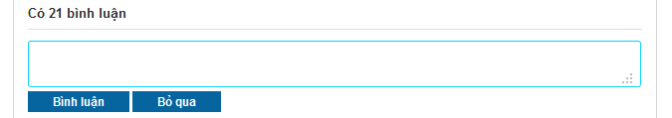**

**Buttons / Hyper Links – Comment Area**

|  |  |  |  |  |
| --- | --- | --- | --- | --- |
| **Function** | **Description** | **Available Criteria** | **Validations** | **Outcome** |
| Post a comment | This button will post a comment to place detail page | It will be showed when user click to Comment box | Comment shouldn’t be blank | Post validated comment to place detail page, put it on top of Comment area |
| Cancel | This button will clear the content of the comment | It will be showed when user click to comment box | No validation | Comment box was cleared and 2 buttons are hidden |

### Delete a Comment

#### Use Case Diagram



#### Use Case Specification

|  |  |  |  |  |
| --- | --- | --- | --- | --- |
| **USE CASE – Delete a comment SPECIFICATION** | | | | |
| **Use-case No.** | UC015 | **Use-case Version** | | 1.0 |
| **Use-case Name** | Delete a comment | | | |
| **Author** | QuangLM | | | |
| **Date** | 13/01/2011 | **Priority** | High | |
| **Actor:**  User  **Summary:**  When the user post a double comment or post something that he/she regrets later, the user can delete it from comment area so no one can see what he/she just posted or avoid get reported as spam. He/ she can move the mouse to his/her comment then click to a button with X symbol just appear to delete the comment.  **Goal:**  Delete your comment from comment area.  **Triggers**  Move the mouse to your comment and click to a button with X symbol  **Preconditions:**  Successfully logged into the system and open a place detail page  **Post Conditions:**  Stay remain at current place page with a comment was deleted from comment area.  **Main Success Scenario:**   |  |  |  | | --- | --- | --- | | Step | Actor Action | System Response | | 1 | Move the mouse to your comment | A button with X symbol appear | | 2 | Click to X button | The comment disappear from comment area |   **Alternative Scenario:**  None  **Exceptions: -**  **Relationships:**  Log in use case  **Business Rules:**   |  |  |  | | --- | --- | --- | | **No** | **Rule Description** | **Error Message** | | 1 | You can only delete your own comment |  | | | | | |

**Screen**

**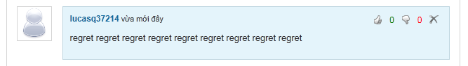**

**Buttons / Hyper Links**

|  |  |  |  |  |
| --- | --- | --- | --- | --- |
| **Function** | **Description** | **Available Criteria** | **Validations** | **Outcome** |
| Delete a comment | This button is displayed with a X symbol and it is used to delete the comment from comment area | It will be showed when user move the mouse pointer to his/her comment | No validation | The comment is deleted from comment area |
| Vote up | This button is displayed with thumb up symbol and it is used to vote up for a comment | It will be showed when user move the mouse pointer to a comment | No validation | Vote up number is increased by 1, thumb up symbol turn into green |
| Vote down | This button is displayed with thumb down symbol and it is used to vote down for a comment | It will be showed when user move the mouse pointer to a comment | No validation | Vote down number is increased by 1, thumb down symbol turn into red |

### Vote a Comment

#### Use Case Diagram



#### Use Case Specification

|  |  |  |  |  |
| --- | --- | --- | --- | --- |
| **USE CASE – Vote a comment SPECIFICATION** | | | | |
| **Use-case No.** | UC016 | **Use-case Version** | | 1.0 |
| **Use-case Name** | Vote a comment | | | |
| **Author** | QuangLM | | | |
| **Date** | 13/01/2011 | **Priority** | Normal | |
| **Actor:**  User  **Summary:**  When the user see a good/bad comment, they want to do something to show that they like it or hate it. The user can do that. They can vote a comment by move the mouse to desired comment and click to button with thumb up symbol if they like it or button with thumb down symbol if they hate it.  **Goal:**  Vote up for comment you like or vote down for comment you hate.  **Triggers**  Move the mouse to a comment and click to button with thumb up symbol or button with thumb down symbol  **Preconditions:**  Successfully logged into the system and open a place detail page  **Post Conditions:**  Stay remain at current place page with a comment was voted.  **Main Success Scenario:**   |  |  |  | | --- | --- | --- | | Step | Actor Action | System Response | | 1 | Move the mouse to the comment needed to be voted | Button with thumb up symbol and button with thumb down symbol appear | | 2 | Click to thumb up button | Change the color of thumb up button (from white color to green color), vote up number is increased by 1 |   **Alternative Scenario:**   |  |  |  | | --- | --- | --- | | Step | Actor Action | System Response | | 1 | Move the mouse to the comment needed to be voted | Button with thumb up symbol and button with thumb down symbol appear | | 2 | Click to thumb down button | Change the color of thumb down button (from white color to red color), vote down comment is increased by 1 |  |  |  |  | | --- | --- | --- | | Step | Actor Action | System Response | | 1 | Move the mouse to the comment needed to be voted | Button with thumb up symbol and button with thumb down symbol appear | | 2 | Click to thumb up button | Change the color of thumb up button (from white color to green color), vote up number is increased by 1 | | 3 | Click to thumb up button again | Nothing happen |  |  |  |  | | --- | --- | --- | | Step | Actor Action | System Response | | 1 | Move the mouse to the comment needed to be voted | Button with thumb up symbol and button with thumb down symbol appear | | 2 | Click to thumb down button | Change the color of thumb down button (from white color to red color), vote down comment is increased by 1 | | 3 | Click to thumb down button again | Nothing happen |  |  |  |  | | --- | --- | --- | | Step | Actor Action | System Response | | 1 | Move the mouse to the comment needed to be voted | Button with thumb up symbol and button with thumb down symbol appear | | 2 | Click to thumb up button | Change the color of thumb up button (from white color to green color), vote up number is increased by 1 | | 3 | Click to thumb down button | Thumb up symbol turn back into white, thumb down symbol turn into red, vote up number is decreased by 1, vote down number is increased by 1 |  |  |  |  | | --- | --- | --- | | Step | Actor Action | System Response | | 1 | Move the mouse to the comment needed to be voted | Button with thumb up symbol and button with thumb down symbol appear | | 2 | Click to thumb down button | Change the color of thumb down button (from white color to red color), vote down comment is increased by 1 | | 3 | Click to thumb up button | Thumb down symbol turn back into white, thumb up symbol turn into green, vote down number is decreased by 1, vote up number is increased by 1 |   **Exceptions:**  **Relationships:**  Log in use case  **Business Rules:**   |  |  |  | | --- | --- | --- | | **No** | **Rule Description** | **Error Message** | | 1 | Each account can only vote up or vote down and only increased vote number by 1 per comment |  | | | | | |
| **Description:**  When the user see a good/bad comment, they want to do something to show that they like it or hate it. The user can do that. They can vote a comment by move the mouse to a comment and click to thumb up icon if they like it or thumb down icon if they hate it. The vote will be record and the 2 most voted up comments will be highlighted and put on top of comment area. The last vote count means that the user can change to vote up to vote down or change back to vote up and the system will using your last vote as your vote. The vote up is displayed as thumb up icon. The vote down is displayed as thumb down icon. Both icons in white at start. When the icon is clicked, its color will change (green in case of vote up and red in case of vote down). If the user clicks to 1 icon, then clicks other icon too. The last clicked icon will be in blue/red color, the other will be in white. 2 highlighted comments still can be voted like normal comment. Highlight Comment Area is above Comment Area. Each user can only vote for other user’s comments. You can’t vote for your own comment. When you click to thumb up or thumb down icon at your comment, nothing will happen. | | | | |

**Screen**

**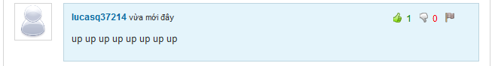**

**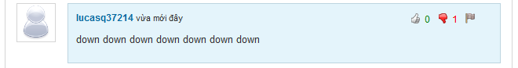**

**Buttons / Hyper Links**

|  |  |  |  |  |
| --- | --- | --- | --- | --- |
| **Function** | **Description** | **Available Criteria** | **Validations** | **Outcome** |
| Delete a comment | This button is displayed with a X symbol and it is used to delete the comment from comment area | It will be showed when user move the mouse pointer to his/her comment | No validation | The comment is deleted from comment area |
| Vote up | This button is displayed with thumb up symbol and it is used to vote up for a comment | It will be showed when user move the mouse pointer to a comment | No validation | Vote up number is increased by 1, thumb up symbol turn into green |
| Vote down | This button is displayed with thumb down symbol and it is used to vote down for a comment | It will be showed when user move the mouse pointer to a comment | No validation | Vote down number is increased by 1, thumb down symbol turn into red |

### Highlight Best Comment

#### Use Case Diagram



#### Use Case Specification

|  |  |  |  |  |
| --- | --- | --- | --- | --- |
| **USE CASE – Highlight best comment SPECIFICATION** | | | | |
| **Use-case No.** | UC017 | **Use-case Version** | | 1.0 |
| **Use-case Name** | Highlight Best Comment | | | |
| **Author** | QuangLM | | | |
| **Date** | 13/01/2011 | **Priority** | Normal | |
| **Actor:**  User  **Summary:**  Each time the user vote for a comment, the vote will be counted. 2 comments which have most votes up and will be highlighted and put up on top of comment box. The user can see them and vote for them as normal comment. The highlight comment area will be displayed as the user open a place detail page.  **Goal:**  Show 2 most vote up comments  **Triggers**  Open a place detail page  **Preconditions:**  Access the website  **Post Conditions:**  Stay remains at place detail page  **Main Success Scenario:**   |  |  |  | | --- | --- | --- | | Step | Actor Action | System Response | | 1 | Open an place detail place | Display 2 most vote up comments on top of comment box |   **Alternative Scenario:**  **Exceptions:**   |  |  |  | | --- | --- | --- | | Step | Actor Action | System Response | | 1 | Open an place detail place which has no comment has vote up | The highlight comment area is hidden |  |  |  |  | | --- | --- | --- | | Step | Actor Action | System Response | | 1 | Open an place detail place which has only 1 comment has vote up | Display only 1 most vote up comments on top of comment box |   **Relationships:**  Log in use case  **Business Rules:**   |  |  |  | | --- | --- | --- | | **No** | **Rule Description** | **Error Message** | | 1 | Only 2 most vote up comment will be highlighted and put up on highlight comment area |  | | 2 | Highlighted comments can be treated as normal comment |  | | | | | |
| **Description:**  Based on vote system, we select 2 most voted up comments, highlight it and put it at different area. These 2 comments still acted as normal comment. The thing is these comment will get more attention from other users because they are put on Highlight Comment Area on top of Comment Area. When there isn’t any comment get vote up, Highlight Comment Area will be hidden. If there is only 1comment get voted up, the Highlight Comment Area will display this only comment. | | | | |

**Screen**

**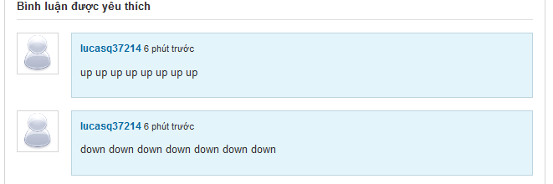**

### Report a Comment

#### Use Case Diagram



#### Use Case Specification

|  |  |  |  |  |
| --- | --- | --- | --- | --- |
| **USE CASE – Report a comment SPECIFICATION** | | | | |
| **Use-case No.** | UC018 | **Use-case Version** | | 1.0 |
| **Use-case Name** | Report a comment | | | |
| **Author** | QuangLM | | | |
| **Date** | 13/01/2011 | **Priority** | High | |
| **Actor:**  User  **Summary:**  When the user sees someone is spamming by posting many comment with nonsense, unrelated inappropriate or advertising content, they can report it. The user must move the mouse to spam comment and click to button with flag symbol. The comment will be deleted manually by admins when they review the comment.  **Goal:**  Report a comment as spam or inappropriate.  **Triggers**  Move the mouse to a comment and click to button with flag symbol  **Preconditions:**  Successfully logged into the system and open a place detail page  **Post Conditions:**  Stay remain at current place page with a comment was reported.  **Main Success Scenario:**   |  |  |  | | --- | --- | --- | | Step | Actor Action | System Response | | 1 | Move the mouse to the comment needed to be reported | A button with flag symbol appears | | 2 | Click to flag button | Popup a window | | 3 | Click to “Báo cáo” button | Popup a message “Báo cáo vi phạm hoà tất! Ban quan trị sẽ kiểm tra lại trong thời gian sớm nhất.” | | 4 | Click OK | Popups close |   **Alternative Scenario:**   |  |  |  | | --- | --- | --- | | Step | Actor Action | System Response | | 1 | Move the mouse to the comment needed to be reported | A button with flag symbol appears | | 2 | Click to flag button | Popup a window | | 3 | Enter reason |  | | 4 | Click to “Báo cáo” button | Popup a message “Báo cáo vi phạm hoàn tất! Ban quan trị sẽ kiểm tra lại trong thời gian sớm nhất.” | | 5 | Click OK | Popups close |  |  |  |  | | --- | --- | --- | | Step | Actor Action | System Response | | 1 | Move the mouse to the comment needed to be reported | A button with flag symbol appears | | 2 | Click to flag button | Popup a window | | 3 | Enter reason with more than 100 characters |  | | 4 | Click to “Báo cáo” button | Popup a message “Lý do không dài quá 100 ký tự.” | | 5 | Click OK | Wanring popup closes, report popup still opens |  |  |  |  | | --- | --- | --- | | Step | Actor Action | System Response | | 1 | Move the mouse to the comment needed to be reported | A button with flag symbol appears | | 2 | Click to flag button | Popup a window | | 3 | Enter reason |  | | 4 | Click to “Bỏ qua” button | Popup closes |  |  |  |  | | --- | --- | --- | | Step | Actor Action | System Response | | 1 | Move the mouse to the comment needed to be reported | A button with flag symbol appears | | 2 | Click to flag button | Popup a window | | 3 | Enter reason |  | | 4 | Click to “Báo cáo” button | Popup a message “Báo cáo vi phạm hoàn tất! Ban quan trị sẽ kiểm tra lại trong thời gian sớm nhất.” | | 5 | Click OK | Popups close | | 6 | Click to flag button again | Popup a message “Báo cáo vi phạm hoàn tất! Ban quan trị sẽ kiểm tra lại trong thời gian sớm nhất.” |   **Exceptions: -**  **Relationships:**  Log in use case  **Business Rules:**   |  |  |  | | --- | --- | --- | | **No** | **Rule Description** | **Error Message** | | 1 | Each user can only report 1 comment once |  | | | | | |
| **Description:**  When the user sees someone is spamming by posting many comment with nonsense, unrelated inappropriate or advertising content, they can report it. The user must move the mouse to spam comment and click to flag icon. A popup will appear and require you to enter your reason. By entering your reason, admin work will be much easier when reviewing spam reports. The reason must be less then 100 character. If you enter more than that, an inform message will popup and required you to shorten your reason down. By clicking to “Báo cáo” button, your spam report will be sent to the system and wait there for admin checking. If you don’t want to send report anymore, just click to “Bỏ qua” button, the report popup will close.  The comment will be deleted manually by admins when they review the comment. The user can’t undo the click. Admin will set the comment back to normal if it isn’t a spam or doesn’t violate any rule. Each user can only report 1 comment once. You can do the report steps many times, but only your 1st report will be saved into the system. | | | | |

**Screen**

**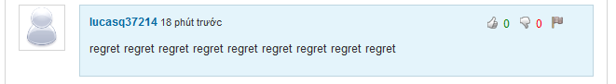**

**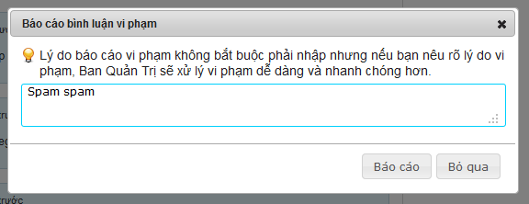**

**Button / Hyper links**

|  |  |  |  |  |
| --- | --- | --- | --- | --- |
| **Function** | **Description** | **Available Criteria** | **Validations** | **Outcome** |
| Report a comment | This button is displayed with flag symbol and it is used to report a comment | Only available when move mouse to other user’s comments | No validation | Popup report window for enter reason |
| Vote up | This button is displayed with thumb up symbol and it is used to vote up for a comment | It will be showed when user move the mouse pointer to a comment | No validation | Vote up number is increased by 1, thumb up symbol turn into green |
| Vote down | This button is displayed with thumb down symbol and it is used to vote down for a comment | It will be showed when user move the mouse pointer to a comment | No validation | Vote down number is increased by 1, thumb down symbol turn into red |
| Post a report | This button is used for post a report to the system | Always available with popup | No validation | Popup a message “Báo cáo vi phạm hoàn tất! Ban quan trị sẽ kiểm tra lại trong thời gian sớm nhất.” |
| Cancel posting a report | This button is used for cancel reporting and close the popup | Always available with popup | No validation | Popup closes |

### Question & Answer Page

#### Use Case Diagram



#### Use Case Specification

|  |  |  |  |  |
| --- | --- | --- | --- | --- |
| **USE CASE – Question & Answer Page SPECIFICATION** | | | | |
| **Use-case No.** | UC019 | **Use-case Version** | | 1.0 |
| **Use-case Name** | Question & Answer Page | | | |
| **Author** | DungTQ | | | |
| **Date** | 10/01/2011 | **Priority** | Normal | |
| **Actor:**  User  **Summary:**  This Question Page displays all questions of users.If user doesn’t find what they want, he/she can post a new question by clicks to “Gửi câu hỏi mới” hyperlink. Besides, all questions are displayed in question page will be displayed with question title, creator name, created time, number of vote up and vote down, number of views and answers. In default, Q&A will display 10 questions. User need click to “Xem thêm” to view more questions  **Goal:**  Display Q&A page  **Triggers**  Click to “Hỏi và đáp” tab in navigator.  **Preconditions:**  Access the website  **Post Conditions:**  Q&A page is displayed  **Main Success Scenario:**   |  |  |  | | --- | --- | --- | | Step | Actor Action | System Response | | 1 | Click to “Hỏi và đáp” tab at navigator | Redirect user to Q&A page and displays all questions. |   **Alternative Scenario: -**  **Exceptions:-**  **Relationships: -**  **Business Rules:**   |  |  |  | | --- | --- | --- | | **No** | **Rule Description** | **Error Message** | | 1 | In default, display 20 questions. User need click “Xem thêm” to get more question |  | | | | | |
| **Description:**  This is a page where displays all questions of users. if the user can’t find what he/she want, he/she can post a new question by clicks to “Gửi câu hỏi mới” button at the top of question list. When user clicks to this button, he/she will be redirected to Create Question page to fill information of question.  Besides, each question in “Hỏi và đáp” page will be displayed with title, creator, created date, answer number, view number, vote up number and vote down number. The title and answer number will be displayed in big size. You can vote for question at this page. If you want to vote for a question, click to its title and go to Question Detail page. At Detail page, you can do these things. Question title and creator name are displayed as link. Click to question title will get you to Question Detail page. Click to user name link will get you to User Profile page. | | | | |

**Screen**

**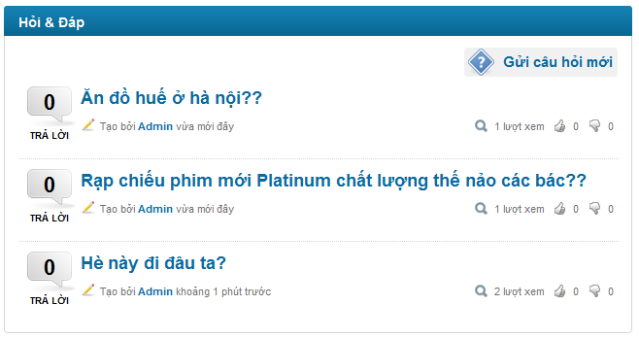**

**Buttons / Hyper Links – Q&A Screen**

|  |  |  |  |  |
| --- | --- | --- | --- | --- |
| **Function** | **Description** | **Available Criteria** | **Validations** | **Outcome** |
| Create Question | Allow user post a new question. | Always Available | No validation | Redirect user to create new question page |
| Question link | This hyperlink helps user open Question Detail page | Display with each question | No validation | Redirect user to Question Detail page |
| User link | This hyperlink helps user open User Profile page | Display with each question | No validation | Redirect user to User Profile page |

### View Question Detail

#### Use Case Diagram



#### Use Case Specification

|  |  |  |  |  |
| --- | --- | --- | --- | --- |
| **USE CASE – View question detail SPECIFICATION** | | | | |
| **Use-case No.** | UC020 | **Use-case Version** | | 1.0 |
| **Use-case Name** | View question detail | | | |
| **Author** | DungTQ | | | |
| **Date** | 10/01/2011 | **Priority** | Normal | |
| **Actor:**  User  **Summary:**  When the user clicks on any question link, they will be redirected to corresponding question detail page. It contains question and its answers.  **Goal:**  Display question’s detail.  **Triggers**  Click to question’s detail hyperlink.  **Preconditions:**  Access the website  **Post Conditions:**  Question and its answers will be displayed  **Main Success Scenario:**   |  |  |  | | --- | --- | --- | | Step | Actor Action | System Response | | 1 | Click to question hyperlink | Redirect the user to question detail page |   **Alternative Scenario:**   |  |  |  | | --- | --- | --- | | Step | Actor Action | System Response | | 1 | User create a new question and click to “Gửi” button | Redirect the user to question detail page |   **Exceptions:**  None  **Relationships:**  Login use case, Create a New Question use case  **Business Rules:**  None | | | | |
| **Description:**  When user click to Question link at anywhere on the system or create a new question, he/she will be redirected to Question Detail page. This page displays all information of a question; all answers belong to it, newest questions and most contributors.  Question information includes:   * Question title * Question content * Name of user who post this question * The time that user post this question * Vote up number and a thumb up icon * Vote down number and a thumb down icon * A flag icon for report this question as spam * 2 highlighted answers: 2 most voted up answers in all answers belong to this question * And all answers for this question. Each answer is displayed with its content, name and avatar of the user who posts it and posted time.   Newest question list: this list contains 10 questions at maximum. All these questions are just posted. The list will be updated each 10 minutes.  Most contributor list: this list contains 10 users who contribute most to Q&A page. They are 10 users who have highest answer number. The list will be updated each 10 minutes. | | | | |

**Screen**

**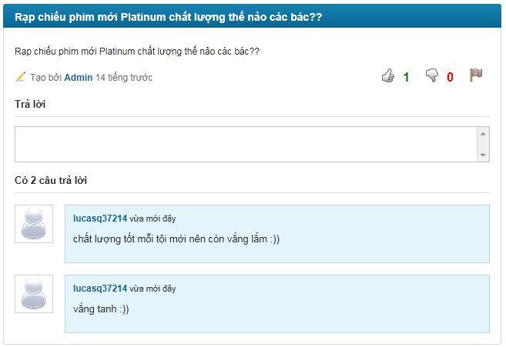**

**Data Fields Definition –Question Detail Screen**

|  |  |  |  |  |  |  |
| --- | --- | --- | --- | --- | --- | --- |
| **Field name** | **Description** | **Read**  **Only** | **Mandatory** | **Control Type** | **Data Type** | **Length** |
| Question Title | A label with content : question’s title | Y | - | Label | String | Fixed |
| Created Time | A label with content: question’s created time | Y | - | Label | Date | Fixed |
| Vote up number | A label contains vote up number | Y | - | Label | String | Fixed |
| Vote down number | A labelcontains vote down number | Y | - | Label | String | Fixed |
| Content | A label with content: content of question | Y | - | Label | String | Fixed |

**Buttons / Hyper Links – Question Detail Screen**

|  |  |  |  |  |
| --- | --- | --- | --- | --- |
| **Function** | **Description** | **Available Criteria** | **Validations** | **Outcome** |
| Vote up answer | This button is displayed with thumb up symbol and it is used to vote up for an answer | It will be showed when user move the mouse pointer to an answer | No validation | Vote up number is increased by 1, thumb up symbol turn into green |
| Vote down answer | This button is displayed with thumb down symbol and it is used to vote down for an answer | It will be showed when user move the mouse pointer to an answer | No validation | Vote down number is increased by 1, thumb down symbol turn into red |
| User link | This hyperlink helps user open User Profile page | Display with each comment | No validation | Redirect user to User Profile page |
| Vote up question | This button is displayed with thumb up symbol and it is used to vote up for a question | Always available | No validation | Vote up number is increased by 1, thumb up symbol turn into green |
| Vote down question | This button is displayed with thumb down symbol and it is used to vote down for a question | Always available | No validation | Vote down number is increased by 1, thumb down symbol turn into red |

### Create a New Question

#### Use Case Diagram



#### Use Case Specification

|  |  |  |  |  |
| --- | --- | --- | --- | --- |
| **USE CASE – Create a new question SPECIFICATION** | | | | |
| **Use-case No.** | UC021 | **Use-case Version** | | 1.0 |
| **Use-case Name** | Create A New Question | | | |
| **Author** | DungTQ | | | |
| **Date** | 13/01/2011 | **Priority** | Normal | |
| **Actor:**  User  **Summary:**  When the user come to question page and can’t find any question match with his/her question, he/she want to post a new question to find a solution for his/her issue. He/she can do that by click to “Gửi câu hỏi mới” hyperlink. The system will redirect the user to create new question page and require them fill in information. The user clicks to “Gửi” button to finish then get redirected to Question Detail page.  **Goal:**  Create a new question.  **Triggers**  Click to “Gửi câu hỏi mới” hyperlink.  **Preconditions:**  Successfully logged into the system and accessed to question page.  **Post Conditions:**  Redirect to Question Detail page  **Main Success Scenario:**   |  |  |  | | --- | --- | --- | | Step | Actor Action | System Response | | 1 | Click to “Gửi câu hỏi mới” hyperlink | Redirect user to Create new question page | | 2 | The user fills in the title and the content of the question |  | | 3 | Click to “Gửi” button | Website will redirect to Question Detail page |   **Alternative Scenario:**   |  |  |  | | --- | --- | --- | | Step | Actor Action | System Response | | 1 | Click to “Gửi câu hỏi mới” hyperlink | Redirect user to Create new question page | | 2 | The user fills in the title and the content of the question |  | | 3 | Click to “Bỏ qua” hyperlink | Redirect back to Q&A page |   **Exceptions:**   |  |  |  | | --- | --- | --- | | Step | Actor Action | System Response | | 1 | Click to “Gửi câu hỏi mới” hyperlink | Redirect user to Create new question page | | 2 | The user leaves the content blank |  | | 3 | Click to “Gửi” button | Display a warning message: “ Tiêu đề là bắt buộc.” |  |  |  |  | | --- | --- | --- | | Step | Actor Action | System Response | | 1 | Click to “Gửi câu hỏi mới” hyperlink | Redirect user to Create new question page | | 2 | The user leaves the title blank |  | | 3 | Click to “Gửi” button | Display a warning message: “Nội dung là bắt buộc.” |   **Relationships:**  Login use case, question page use case  **Business Rules:**   |  |  |  | | --- | --- | --- | | **No** | **Rule Description** | **Error Message** | | 1 | Title and content of a question can’t be blank |  | | 2 | Each user can only post 1 question per 10 minutes |  | | | | | |
| **Description:**  When user come to “Hỏi và đáp” page and can’t find problem what he/she need, he/she can post a new question to find out a solution by click to “Gửi câu hỏi mới” button at “Hỏi & Đáp” page. The sytem will redirect you to Create Question page. The form for creating a new question is simple. The user only need fill in question title and content. You can’t leave title or content blank. Click to “Gửi” button will navigate you to Question Detail page of your newly created question. Otherwise, click to “Bỏ qua” button will let you go back to “Hỏi & Đáp” page. | | | | |

**Screen**

**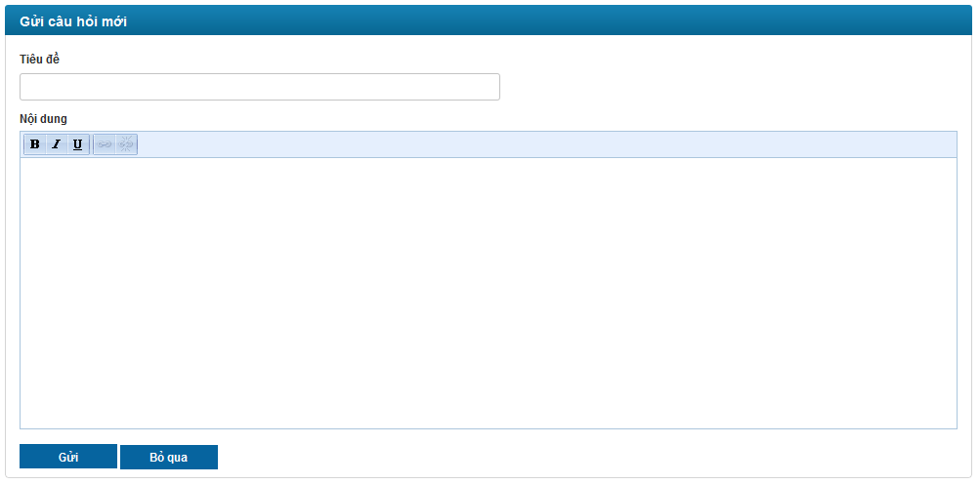**

**Data Fields Definition – Create A New Question Screen**

|  |  |  |  |  |  |  |
| --- | --- | --- | --- | --- | --- | --- |
| **Field name** | **Description** | **Read**  **Only** | **Mandatory** | **Control Type** | **Data Type** | **Length** |
| header | A label with content “Tạo câu hỏi mới” | Y | - | label | string | 30 |
| Title label | A label with content “Tiêu đề:” | Y | - | label | string | 10 |
| Title Textbox | This text box for inputting title of the question | N | Y | textbox | string | 50 |
| Content Label | A label with content “Nội dung:” | Y | - | label | string | 10 |
| Content | This text box is for inputting content of the question | N | Y | textbox | string | 500 |

**Buttons / Hyper Links – Create a New Question Screen**

|  |  |  |  |  |
| --- | --- | --- | --- | --- |
| **Function** | **Description** | **Available Criteria** | **Validations** | **Outcome** |
| Post question | Allow user post a new question | Always available. | No validation | Allow user post a new question and redirect the user to question detail page |
| Cancel | Cancel current action | Always available. | No validation | Cancel current action and redirect the user to Q&A page. |

### Vote a Question

#### Use Case Diagram



#### Use Case Specification

|  |  |  |  |  |
| --- | --- | --- | --- | --- |
| **USE CASE – Vote a question SPECIFICATION** | | | | |
| **Use-case No.** | UC022 | **Use-case Version** | | 1.0 |
| **Use-case Name** | Vote a question | | | |
| **Author** | QuangLM | | | |
| **Date** | 13/01/2011 | **Priority** | Normal | |
| **Actor:**  User  **Summary:**  When the user sees a good/bad question, they want to do something to show that they like it or hate it. The user can do that. They can vote a question by click to button with thumb up symbol if they like it or button with thumb down symbol if they hate it.  **Goal:**  Vote up for question you like or vote down for question you hate.  **Triggers**  Click to button with thumb up symbol or button with thumb down symbol  **Preconditions:**  Successfully logged into the system and open a Question Detail page  **Post Conditions:**  Stay remain at current place page with a question was voted.  **Main Success Scenario:**   |  |  |  | | --- | --- | --- | | Step | Actor Action | System Response | | 1 | Click to thumb up button | Change the color of thumb up button (from white color to green color), vote up number is increased by 1 |   **Alternative Scenario:**   |  |  |  | | --- | --- | --- | | Step | Actor Action | System Response | | 1 | Click to thumb down button | Change the color of thumb down button (from white color to red color), vote down comment is increased by 1 |  |  |  |  | | --- | --- | --- | | Step | Actor Action | System Response | | 1 | Click to thumb up button | Change the color of thumb up button (from white color to green color), vote up number is increased by 1 | | 2 | Click to thumb up button again | Nothing happen |  |  |  |  | | --- | --- | --- | | Step | Actor Action | System Response | | 1 | Click to thumb down button | Change the color of thumb down button (from white color to red color), vote down comment is increased by 1 | | 2 | Click to thumb down button again | Nothing happen |  |  |  |  | | --- | --- | --- | | Step | Actor Action | System Response | | 1 | Click to thumb up button | Change the color of thumb up button (from white color to green color), vote up number is increased by 1 | | 2 | Click to thumb down button | Thumb up symbol turn back into white, thumb down symbol turn into red, vote up number is decreased by 1, vote down number is increased by 1 |  |  |  |  | | --- | --- | --- | | Step | Actor Action | System Response | | 1 | Click to thumb down button | Change the color of thumb down button (from white color to red color), vote down comment is increased by 1 | | 2 | Click to thumb up button | Thumb down symbol turn back into white, thumb up symbol turn into green, vote down number is decreased by 1, vote up number is increased by 1 |   **Exceptions:**  **Relationships:**  Log in use case  **Business Rules:**   |  |  |  | | --- | --- | --- | | **No** | **Rule Description** | **Error Message** | | 1 | Each account can only vote up or vote down and only increased vote number by 1 per question |  | | | | | |
| **Description:**  When the user sees a good/bad question, they want to do something to show that they like it or hate it. The user can do that. They can vote a question by click to thumb up icon if they like it or thumb down icon if they hate it. The last vote count means that the user can change to vote up to vote down or change back to vote up and the system will use your last vote. The vote up is displayed as thumb up icon. The vote down is displayed as thumb down icon. Both icons in white at start. When the icon is clicked, its color will change (green in case of vote up and red in case of vote down). If the user clicks to 1 icon, then clicks other icon too. The last clicked icon will be in blue/red color, the other will be in white. You can’t vote for your own question. When you click to thumb up or thumb down icon at your question, nothing will happen. | | | | |

**Screen**

**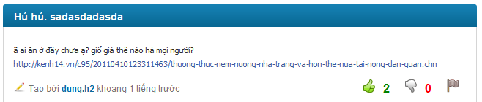**

**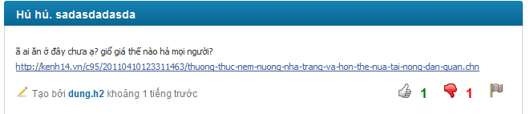**

**Buttons / Hyper Links**

|  |  |  |  |  |
| --- | --- | --- | --- | --- |
| **Function** | **Description** | **Available Criteria** | **Validations** | **Outcome** |
| User link | This hyperlink helps user open User Profile page | Display with each comment | No validation | Redirect user to User Profile page |
| Vote up question | This button is displayed with thumb up symbol and it is used to vote up for a question | Always available | No validation | Vote up number is increased by 1, thumb up symbol turn into green |
| Vote down question | This button is displayed with thumb down symbol and it is used to vote down for a question | Always available | No validation | Vote down number is increased by 1, thumb down symbol turn into red |
| Report a question | This flag symbol is used for report a question as spam/inappropriate | Always available | No validation | Popup a report window |

### Report a Question

#### Use Case Diagram



#### Use Case Specification

|  |  |  |  |  |
| --- | --- | --- | --- | --- |
| **USE CASE – Report a question SPECIFICATION** | | | | |
| **Use-case No.** | UC023 | **Use-case Version** | | 1.0 |
| **Use-case Name** | Report a question | | | |
| **Author** | QuangLM | | | |
| **Date** | 13/01/2011 | **Priority** | High | |
| **Actor:**  User  **Summary:**  When the user sees someone is spamming by posting many question with nonsense, unrelated inappropriate or advertising content, they can report it. The user need click to button with flag symbol. The question will be deleted manually by admins when they review the question.  **Goal:**  Report a question as spam or inappropriate.  **Triggers**  Click to button with flag symbol  **Preconditions:**  Successfully logged into the system and open a question detail page  **Post Conditions:**  Stay remain at current place page with a question was reported.  **Main Success Scenario:**   |  |  |  | | --- | --- | --- | | Step | Actor Action | System Response | | 1 | Click to flag symbol | Popup a window | | 2 | Click to “Báo cáo” button | Popup a message “Báo cáo vi phạm hoàn tất! Ban quan trị sẽ kiểm tra lại trong thời gian sớm nhất.” | | 3 | Click OK | Popups close |   **Alternative Scenario:**   |  |  |  | | --- | --- | --- | | Step | Actor Action | System Response | | 1 | Click to flag symbol | Popup a window | | 2 | Enter reason |  | | 3 | Click to “Báo cáo” button | Popup a message “Báo cáo vi phạm hoàn tất! Ban quan trị sẽ kiểm tra lại trong thời gian sớm nhất.” | | 4 | Click OK | Popups close |  |  |  |  | | --- | --- | --- | | Step | Actor Action | System Response | | 1 | Click to flag symbol | Popup a window | | 2 | Enter reason with more than 100 characters |  | | 3 | Click to “Báo cáo” button | Popup a message “Lý do không dài quá 100 ký tự.” | | 4 | Click OK | Wanring popup closes, report popup still opens |  |  |  |  | | --- | --- | --- | | Step | Actor Action | System Response | | 1 | Click to flag symbol | Popup a window | | 2 | Enter reason |  | | 3 | Click to “Bỏ qua” button | Popup closes |  |  |  |  | | --- | --- | --- | | Stp | Actor Action | System Response | | 1 | Click to flag symbol | Popup a window | | 2 | Enter reason |  | | 3 | Click to “Báo cáo” button | Popup a message “Báo cáo vi phạm hoàn tất! Ban quan trị sẽ kiểm tra lại trong thời gian sớm nhất.” | | 4 | Click OK | Popups close | | 5 | Click to flag button again | Popup a message “Báo cáo vi phạm hoàn tất! Ban quan trị sẽ kiểm tra lại trong thời gian sớm nhất.” |   **Exceptions: -**  **Relationships:**  Log in use case  **Business Rules:**   |  |  |  | | --- | --- | --- | | **No** | **Rule Description** | **Error Message** | | 1 | Each user can only report 1 question once |  | | 2 | The question can only be deleted manually by admins when they review the question. |  | | | | | |

**Screen**

**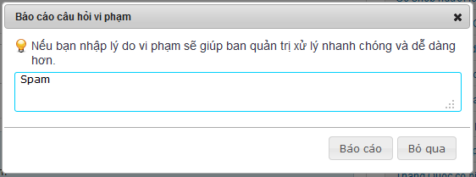**

**Button / Hyper links**

|  |  |  |  |  |
| --- | --- | --- | --- | --- |
| **Function** | **Description** | **Available Criteria** | **Validations** | **Outcome** |
| Report a comment | This button is displayed with flag symbol and it is used to report a comment | Only available when move mouse to other user’s comments | No validation | Popup report window for enter reason |
| Vote up | This button is displayed with thumb up symbol and it is used to vote up for a comment | It will be showed when user move the mouse pointer to a comment | No validation | Vote up number is increased by 1, thumb up symbol turn into green |
| Vote down | This button is displayed with thumb down symbol and it is used to vote down for a comment | It will be showed when user move the mouse pointer to a comment | No validation | Vote down number is increased by 1, thumb down symbol turn into red |
| Post a report | This button is used for post a report to the system | Always available with popup | No validation | Popup a message “Báo cáo vi phạm hoàn tất! Ban quan trị sẽ kiểm tra lại trong thời gian sớm nhất.” |
| Cancel posting a report | This button is used for cancel reporting and close the popup | Always available with popup | No validation | Popup closes |

### Post an answer

#### Use Case Diagram



#### Use Case Specification

|  |  |  |  |  |
| --- | --- | --- | --- | --- |
| **USE CASE – Post an answer SPECIFICATION** | | | | |
| **Use-case No.** | UC024 | **Use-case Version** | | 1.0 |
| **Use-case Name** | Post an answer | | | |
| **Author** | DungTQ | | | |
| **Date** | 10/01/2011 | **Priority** | Normal | |
| **Actor:**  User  **Summary:**  When open question page, the user can realize a question that he/she knows the answer or a question that propose the same problem with the user problem. The user can post an answer to propose a solution or showing empathy with the asker. Clicking to that question will redirect the user to question detail page. The user need fill in answer content and click to “Trả lời” button to post the reply.  **Goal:**  Allow user posts an anwser  **Triggers**  Click to “Trả lời” button  **Preconditions:**  Successfully logged in to the system and accessed to question detail page.  **Post Conditions:**  Stay remain at question detail page with new answer on top of answer area  **Main Success Scenario:**   |  |  |  | | --- | --- | --- | | Step | Actor Action | System Response | | 1 | Click to the answer text box | “Trả lời” and “Bỏ qua” buttons appear | | 2 | Enter the content in reply box. |  | | 3 | Click to “Trả lời” button | The answer will be added to top of answer area with the content, creator, creator’s avatar and created time. |   **Alternative Scenario:**   |  |  |  | | --- | --- | --- | | Step | Actor Actio | System Respons | | 1 | Click to the answer text box | “Trả lời” and “Bỏ qua” buttons appear | | 2 | Enter the content in reply box. |  | | 3 | Click to “Bỏ qua” button | Clear the content, 2 buttons are hidden |   **Exceptions:**   |  |  |  | | --- | --- | --- | | Step | Actor Action | System Response | | 1 | Click to th answer text bo | “Trả lời” and “Bỏ qua” buttons appear | | 2 | Click to “Trả lời” button | Nothing happen |   **Relationships:**  Login use case and question page use case  **Business Rules:**   |  |  |  | | --- | --- | --- | | **No** | **Rule Description** | **Error Message** | | 1 | Blank answer won’t be posted |  | | 2 | Each usr can only pos1 reply per 1 minutes |  | | | | | |
| **Description**  When user want to express his/her opinion or answer a question, the user can do it by enter whatever he/she would like to in answer box and click to “Trả lời” button to post it on Question Detail page. The answer cannot be blank and must be less then 4000 characters because the maximum length that can be inserted into database is 4000. The “Trả lời” and “Bỏ qua” buttons will be showed only after the user click to the answer box. The user can easily cancel posting an answer by click to “Bỏ qua” button. After successfully posting an answer, the answer will be displayed on top of answer area.  Answer area is an area which displayed answers posted by users. The latest answer will be put on top. By default, only 10 latest answers are displayed at Question Detail page, user need click to “Xem thêm” at the end of answer area to see more answers. | | | | |

**Screen**

**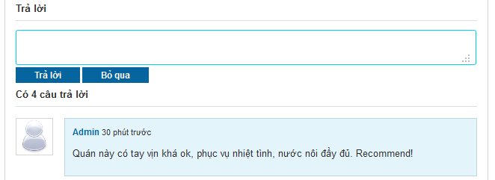**

**Buttons / Hyper Links – Reply Question Screen**

|  |  |  |  |  |
| --- | --- | --- | --- | --- |
| **Function** | **Description** | **Available Criteria** | **Validations** | **Outcome** |
| Post an answer | This button allow user post an answer | Displayed when user click to answer text area | No validation | Post a new answer on top of answer area |
| Cancel Hyperlink | Cancel reply. | Displayed when user click to answer text area | No validation | Clear answer content, 2 buttons are hidden |

### Vote an answer

#### Use Case Diagram



#### Use Case Specification

|  |  |  |  |  |
| --- | --- | --- | --- | --- |
| **USE CASE – Vote an answer SPECIFICATION** | | | | |
| **Use-case No.** | UC025 | **Use-case Version** | | 1.0 |
| **Use-case Name** | Vote an answer | | | |
| **Author** | DungTQ | | | |
| **Date** | 11/01/2011 | **Priority** | Normal | |
| **Actor:**  User  **Summary:**  When visiting a place, user can realize that there is an answer which resembles his/her thinking or that it is just so good. It’s very convenient if he/she can click to thumb up symbol (which will appear when he/she move mouse to any answer) and doesn’t have to write same content as existed answer. But the user can also realize that there is an answer which is different with his/her thinking or that it is just so lame. So it’s very convenient if they can click thumb down symbol which also will appear when he/she move mouse to any answer.  **Goal:**  Allow users vote for an answer  **Triggers**  Click to thumb up or thumb down symbol  **Preconditions:**  Successfully logged into the system and accessed to question’s details page which has at least one answer.  **Post Conditions:**  Stay remain at question detail page with a reply get voted  **Main Success Scenario:**   |  |  |  | | --- | --- | --- | | Step | Actor Action | System Response | | 1 | Move mouse to a comment which user wants to vote | thumb up symbol and thumb down symbol appear | | 2 | Click to thumb up | Thumb up symbol turn into green, vote up number is increased by 1 |   **Alternative Scenario:**   |  |  |  | | --- | --- | --- | | Step | Actor Action | System Response | | 1 | Move mouse to a comment which user wants to vote | thumb up symbol and thumb down symbol appear | | 2 | Click to thumb down | Thumb down symbol turn into red, vote down number is increased by 1 |  |  |  |  | | --- | --- | --- | | Step | Actor Action | System Response | | 1 | Move mouse to a comment which user wants to vote | thumb up symbol and thumb down symbol appear | | 2 | Click to thumb up | Thumb up symbol turn into green, vote up number is increased by 1 | | 3 | Click to thumb up again | Nothing happen |  |  |  |  | | --- | --- | --- | | Step | Actor Action | System Response | | 1 | Move mouse to a comment which user wants to vote | thumb up symbol and thumb down symbol appear | | 2 | Click to thumb down | Thumb down symbol turn into red, vote down number is increased by 1 | | 3 | Click to thumb down again | Nothing happen |  |  |  |  | | --- | --- | --- | | Step | Actor Action | System Response | | 1 | Move mouse to a comment which user wants to vote | thumb up symbol and thumb down symbol appear | | 2 | Click to thumb up | Thumb up symbol turn into green, vote up number is increased by 1 | | 3 | Click to thumb down | Thumb up symbol turn back into white, thumb down symbol turn into red, vote up number is decreased by 1, vote down number is increased by 1 |  |  |  |  | | --- | --- | --- | | Step | Actor Action | System Response | | 1 | Move mouse to a comment which user wants to vote | thumb up symbol and thumb down symbol appear | | 2 | Click to thumb down | Thumb down symbol turn into red, vote down number is increased by 1 | | 3 | Click to thumb up | Thumb down symbol turn back into white, thumb up symbol turn into green, vote down number is decreased by 1, vote up number is increased by 1 |   **Exceptions:**  **Relationships:**  Login use case, Q&A use case  **Business Rules:**   |  |  |  | | --- | --- | --- | | **No** | **Rule Description** | **Error Message** | | 1 | Each account can only vote up or vote down and only increased vote number by 1 per answer |  | | | | | |
| **Description**  When the user see a good/bad answer, they want to do something to show that they like it or hate it. The user can do that. They can vote an answer by move the mouse to an answer and click to thumb up icon if they like it or thumb down icon if they hate it. The vote will be record and the 2 most voted up answers will be highlighted and put on top of answer area. The last vote count means that the user can change to vote up to vote down or change back to vote up and the system will use your last vote. The vote up is displayed as thumb up icon. The vote down is displayed as thumb down icon. Both icons in white at start. When the icon is clicked, its color will change (green in case of vote up and red in case of vote down). If the user clicks to 1 icon, then clicks other icon too. The last clicked icon will be in blue/red color, the other will be in white. 2 highlighted answers still can be voted like normal answer. Highlight Answer Area is above Answer Area. Each user can only vote for other user’s answers. You can’t vote for your own answer. When you click to thumb up or thumb down icon at your answer, nothing will happen. | | | | |

**Screen**

**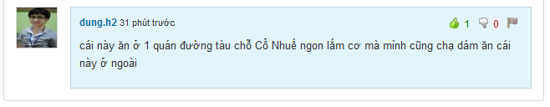**

**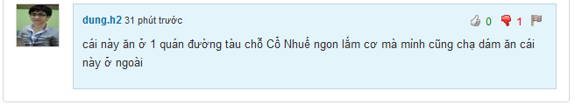**

**Buttons / Hyper Links – Vote Up Screen**

|  |  |  |  |  |
| --- | --- | --- | --- | --- |
| **Function** | **Description** | **Available Criteria** | **Validations** | **Outcome** |
| Vote up an answer | This button will vote up for an answer. It is displayed with thumb up symbol | Default hidden. It will be showed when user move mouse to an answer. | No validation | Thumb up symbol turn into green, vote up number is increased by 1 |
| Vote down an answer | This button will vote down for an answer. It is displayed with thumb down symbol | Default hidden. It will be showed when user move mouse to an answer. | No validation | Thumb down symbol turn into red, vote down number is increased by 1 |

### Report an answer

#### Use Case Diagram



#### Use Case Specification

|  |  |  |  |  |
| --- | --- | --- | --- | --- |
| **USE CASE –Report an answer SPECIFICATION** | | | | |
| **Use-case No.** | UC026 | **Use-case Version** | | 1.0 |
| **Use-case Name** | Report an answer | | | |
| **Author** | DungTQ | | | |
| **Date** | 11/01/2011 | **Priority** | Normal | |
| **Actor:**  User  **Summary:**  Because website stores a lot of information and replies, admin can’t control all answers which users posted day by day. Report an answer will help admin detect and remove bad answers for a better network. User can use this function by clicking to flag symbol (which will appear when he/she move mouse to other user answer).  **Goal:**  Users can report any answer which they think is spam or has inappropriate content.  **Triggers**  Click to flag symbol  **Preconditions:**  Successfully logged into the system and accessed to question’s details page which has at least one answer.  **Post Conditions:**  Stay remain at question detail page  **Main Success Scenario:**   |  |  |  | | --- | --- | --- | | Step | Actor Action | System Response | | 1 | Move mouse to a comment which user wants to report | X symbol appear | | 2 | Click to X symbol | Popup Report window | | 3 | Click to “Báo cáo” button | Popup a message “Báo cáo vi phạm hoàn tất! Ban quan trị sẽ kiểm tra lại trong thờ gian sớm nhất.” | | 4 | Click OK | Popups close |   **Alternative Scenario:**   |  |  |  | | --- | --- | --- | | Step | Actor Action | System Response | | 1 | Move mouse to a comment which user wants to report | X symbol appear | | 2 | Click to X symbol | Popup Report window | | 3 | Enter reason |  | | 4 | Click to “Báo cáo” button | Popup a message “Báo cáo vi phạm hoàn tất! Ban quan trị sẽ kiểm tra lại trong thời gian sớm nhất.” | | 5 | Click OK | Popups close |  |  |  |  | | --- | --- | --- | | Step | Actor Action | System Response | | 1 | Click to flag symbol | Popup a window | | 2 | Enter reason with more than 100 characters |  | | 3 | Click to “Báo cáo” button | Popup a message “Lý do không dài quá 100 ký tự.” | | 4 | Click OK | Wanring popup closes, report popup still opens |  |  |  |  | | --- | --- | --- | | Step | Actor Action | System Response | | 1 | Click to flag symbol | Popup a window | | 2 | Enter reason |  | | 3 | Click to “Bỏ qua” button | Popup closes |  |  |  |  | | --- | --- | --- | | Step | Actor Action | System Response | | 1 | Click to flag symbol | Popup a window | | 2 | Enter reason |  | | 3 | Click to “Báo cáo” button | Popup a message “Báo cáo vi phạm hoàn tất! Ban quan trị sẽ kiểm tra lại trong thời gian sớm nhất.” | | 4 | Click OK | Popups close | | 5 | Click to flag button again | Popup a message “Báo cáo vi phạm hoàn tất! Ban quan trị sẽ kiểm tra lại trong thời gian sớm nhất.” |   **Exceptions:**  **Relationships:**  Login use case, view question detail use case  **Business Rules:**   |  |  |  | | --- | --- | --- | | **No** | **Rule Description** | **Error Message** | | 1 | Each account can only report an answer once |  | | | | | |
| **Description**  When the user sees someone is spamming by posting many answers with nonsense, unrelated inappropriate or advertising content, they can report it. The user must move the mouse to spam answer and click to flag icon. A popup will appear and require you to enter your reason. By entering your reason, admin work will be much easier when reviewing spam reports. The reason must be less then 100 character. If you enter more than that, an inform message will popup and required you to shorten your reason down. By clicking to “Báo cáo” button, your spam report will be sent to the system and wait there for admin checking. If you don’t want to send report anymore, just click to “Bỏ qua” button, the report popup will close.  The answer will be deleted manually by admins when they review the answer. The user can’t undo the click. Admin will set the answer back to normal if it isn’t a spam or doesn’t violate any rule. Each user can only report 1 answer once. You can do the report steps many times, but only your 1st report will be saved into the system. | | | | |

**Screen**

**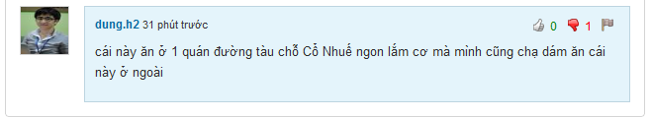**

**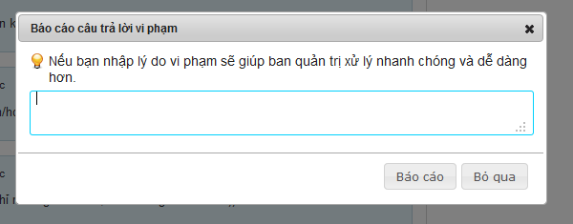**

**Button / Hyper links**

|  |  |  |  |  |
| --- | --- | --- | --- | --- |
| **Function** | **Description** | **Available Criteria** | **Validations** | **Outcome** |
| Report an answer | This button is displayed with flag symbol and it is used to report an answer | Only available when move mouse to other user’s answers | No validation | Popup report window for enter reason |
| Vote up | This button is displayed with thumb up symbol and it is used to vote up for an answer | It will be showed when user move the mouse pointer to an answer | No validation | Vote up number is increased by 1, thumb up symbol turn into green |
| Vote down | This button is displayed with thumb down symbol and it is used to vote down for an answer | It will be showed when user move the mouse pointer to an answer | No validation | Vote down number is increased by 1, thumb down symbol turn into red |
| Post a report | This button is used for post a report to the system | Always available with popup | No validation | Popup a message “Báo cáo vi phạm hoàn tất! Ban quan trị sẽ kiểm tra lại trong thời gian sớm nhất.” |
| Cancel posting a report | This button is used for cancel reporting and close the popup | Always available with popup | No validation | Popup closes |

### Delete an answer

#### Use Case Diagram



#### Use Case Specification

|  |  |  |  |  |
| --- | --- | --- | --- | --- |
| **USE CASE – Delete an answer SPECIFICATION** | | | | |
| **Use-case No.** | UC027 | **Use-case Version** | | 1.0 |
| **Use-case Name** | Delete an answer | | | |
| **Author** | QuangLM | | | |
| **Date** | 13/01/2011 | **Priority** | High | |
| **Actor:**  User  **Summary:**  When the user post a double answer or post something that he/she regrets later, the user can delete it from answer area so no one can see what he/she just posted or avoid get reported as spam. He/ she can move the mouse to his/her answer then click to a button with X symbol just appear to delete the answer.  **Goal:**  Delete your answer from answer area.  **Triggers**  Click to a button with X symbol  **Preconditions:**  Successfully logged into the system and open a Question Detail page  **Post Conditions:**  Stay remain at current place page with an answer was deleted from answer area.  **Main Success Scenario:**   |  |  |  | | --- | --- | --- | | Step | Actor Action | System Response | | 1 | Move the mouse to your answer | A button with X symbol appear | | 2 | Click to X button | The answer disappear from answer area |   **Alternative Scenario:**  None  **Exceptions: -**  **Relationships:**  Log in use case  **Business Rules:**   |  |  |  | | --- | --- | --- | | **No** | **Rule Description** | **Error Message** | | 1 | You can only delete your own answer |  | | | | | |

**Screen**

****

**Buttons / Hyper Links**

|  |  |  |  |  |
| --- | --- | --- | --- | --- |
| **Function** | **Description** | **Available Criteria** | **Validations** | **Outcome** |
| Delete an answer | This button is displayed with a X symbol and it is used to delete the answer from answer area | It will be showed when user move the mouse pointer to his/her answer | No validation | The answer is deleted from answer area |
| Vote up | This button is displayed with thumb up symbol and it is used to vote up for an answer | It will be showed when user move the mouse pointer to an answer | No validation | Vote up number is increased by 1, thumb up symbol turn into green |
| Vote down | This button is displayed with thumb down symbol and it is used to vote down for an answer | It will be showed when user move the mouse pointer to an answer | No validation | Vote down number is increased by 1, thumb down symbol turn into red |

### View Favorite List

#### Use Case Diagram



#### Use Case Specification

|  |  |  |  |  |
| --- | --- | --- | --- | --- |
| **USE CASE – View favorite list SPECIFICATION** | | | | |
| **Use-case No.** | UC028 | **Use-case Version** | | 1.0 |
| **Use-case Name** | View Favorite List | | | |
| **Author** | DungTQ | | | |
| **Date** | 13/01/2011 | **Priority** | Normal | |
| **Actor:**  User  **Summary:**  When using website, maybe user will find out some interesting places and they want to save for using later or share for friends. Favorite List will help user to manage favorite places.  **Goal:**  Display list of places which user favor.  **Triggers**  Click to “Địa điểm yêu thích” tab at user profile page  **Preconditions:**  Successfully logged into the system and go to your profile page  **Post Conditions:**  Favorite tab is displayed with all favorite places  **Main Success Scenario:**   |  |  |  | | --- | --- | --- | | Stp | Actor Action | System Response | | 1 | Click to “Địa điểm yêu thích” tab | Favorite tab is displayed with all favorite places |   **Alternative Scenario:**  None  **Exceptions:**  None  **Relationships:**  Login use case  **Business Rules:**   |  |  |  | | --- | --- | --- | | **No** | **Rule Description** | **Error Message** | | 1 | There are 20 places per page |  | | | | | |
| **Description**  When using website, maybe user will find out some interesting places and they want to save for using later or share for friends. Favorite List will help user to manage favorite places. User can go to list by click to "Thêm vào yêu thích" hyperlink at Place Detail page.  To see your favorite list, click to your name at log in area at top right corner of the website then click to “Địa điểm” yêu thích tab. Each place at favorite list is displayed with an avatar, place name, place rating, detail address, com ment number and view number. Favorited places will be divided into pages. Each page contains 20 places. | | | | |

**Screen**

**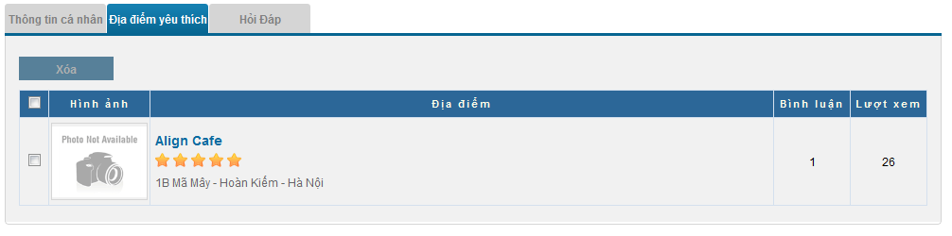**

**Data Fields Definition – Favorite List Screen**

|  |  |  |  |  |  |  |
| --- | --- | --- | --- | --- | --- | --- |
| **Field name** | **Description** | **Read**  **Only** | **Mandatory** | **Control Type** | **Data Type** | **Length** |
| Favorite Title | A label with content: “Địa điểm yêu thích” | Y | - | Label | String | Fixed |
| Place image | Contains place’s main image | Y | - | Image | - | - |
| Place info | Contains place name, its rating and its detail address | Y | - | Label | String | Fixed |
| Comment number | Contains place’s comment number | Y | - | Label | String | Fixed |
| View number | Contains place’s view number | Y | - | Label | String | Fixed |

**Buttons / Hyper Links**

|  |  |  |  |  |
| --- | --- | --- | --- | --- |
| **Function** | **Description** | **Available Criteria** | **Validations** | **Outcome** |
| Remove Button | Remove selected places from favorite list | Only available when atleast 1 place is selected | No validation | Selected places are removed from list |
| Place Name Hyperlink | Name of place | Always available with each place | No validation | Redirect to Place Detail page |

### Add a Place to Favorite List

#### Use Case Diagram



#### Use Case Specification

|  |  |  |  |  |
| --- | --- | --- | --- | --- |
| **USE CASE – Add a place to favorite list SPECIFICATION** | | | | |
| **Use-case No.** | UC029 | **Use-case Version** | | 1.0 |
| **Use-case Name** | Add Place To Favorite List | | | |
| **Author** | DungTQ | | | |
| **Date** | 11/01/2011 | **Priority** | Normal | |
| **Actor:**  User  **Summary:**  When using website, maybe user will find out some interesting places. Feeling like people will want to know about or going to love that place too, the user want to save for using later or share that place to friends. So this function is really useful for them.  **Goal:**  Users can add any place to their favorite list.  **Triggers**  Click to “Thêm vào yêu thích” button.  **Preconditions:**  Successfully logged into the system and open a place detail page  **Post Conditions:**  Stay remains at Place Detail page  **Main Success Scenario:**   |  |  |  | | --- | --- | --- | | Step | Actor Action | System Response | | 2 | Click to “Thêm vào yêu thích” button | Display message “Địa điểm đã được thêm vào yêu thích.” |   **Alternative Scenario:**  None  **Exceptions:**  None  **Relationships:**  Login use case  **Business Rules:**  None | | | | |

**Screen**

**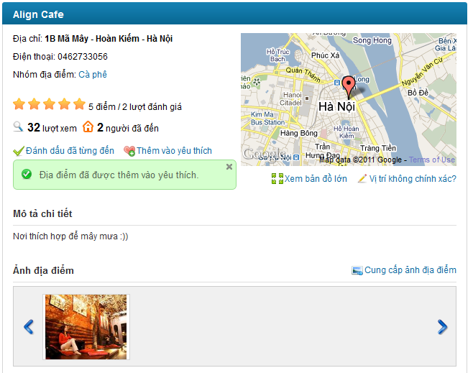**

**Buttons / Hyper Links – Add Place to Favorite List Screen**

|  |  |  |  |  |
| --- | --- | --- | --- | --- |
| **Function** | **Description** | **Available Criteria** | **Validations** | **Outcome** |
| Add To Favorite | This button add current viewing place to favorite list | Default available. | No validation | Display message “Địa điểm đã được thêm vào yêu thích.” |

### Remove Places from Favorite List

#### Use Case Diagram



#### Use Case Specification

|  |  |  |  |  |
| --- | --- | --- | --- | --- |
| **USE CASE – Remove Places from Favorite List SPECIFICATION** | | | | |
| **Use-case No.** | UC030 | **Use-case Version** | | 1.0 |
| **Use-case Name** | Remove Places From Favorite List | | | |
| **Author** | DungTQ | | | |
| **Date** | 11/01/2011 | **Priority** | Normal | |
| **Actor:**  User  **Summary:**  A place which user liked before, but at the moment user doesn’t like anymore and want to remove it from favorite list. So he/she can use this function. User can click to boxes which beside places he/she wants to remove and click to “Xóa” button. After this function is done, these places will be removed.  **Goal:**  Users can remove any place which existed in their favorite list.  **Triggers**  Click to “Xoá” button  **Preconditions:**  Successfully logged into the system and accessed to favorite list page.  **Post Conditions:**  Selected places will be removed from user’s favorite list.  **Main Success Scenario:**   |  |  |  | | --- | --- | --- | | Step | Actor Action | System Response | | 1 | Select check box besides place A which user want to remove |  | | 2 | Click to “Xóa” button | Selected place is removed and a message is displayed “Địa điểm yêu thích đã được xóa.” |   **Alternative Scenario:**   |  |  |  | | --- | --- | --- | | Step | Actor Action | System Response | | 1 | Select check box besides “Hình ảnh” title | All check boxes in page will be selected. | | 2 | Click to “Xóa” button | All places are removed and a message is displayed “Địa điểm yêu thích đã được xóa.” |   **Exceptions:**  None  **Relationships:**  Login use case, View Favorite List use case.  **Business Rules:**  None | | | | |

**Screen**

**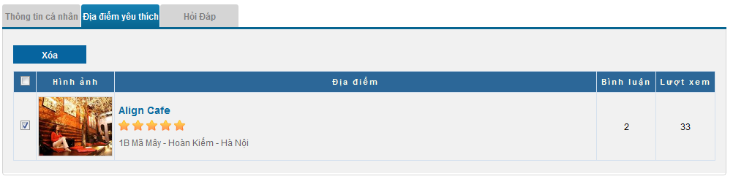**

**Data Fields Definition – Favorite List Screen**

|  |  |  |  |  |  |  |
| --- | --- | --- | --- | --- | --- | --- |
| **Field name** | **Description** | **Read**  **Only** | **Mandatory** | **Control Type** | **Data Type** | **Length** |
| Favorite Title | A label with content: “Địa điểm yêu thích” | Y | - | Label | String | Fixed |
| Place image | Contains place’s main image | Y | - | Image | - | - |
| Place info | Contains place name, its rating and its detail address | Y | - | Label | String | Fixed |
| Comment number | Contains place’s comment number | Y | - | Label | String | Fixed |
| View number | Contains place’s view number | Y | - | Label | String | Fixed |

**Buttons / Hyper Links**

|  |  |  |  |  |
| --- | --- | --- | --- | --- |
| **Function** | **Description** | **Available Criteria** | **Validations** | **Outcome** |
| Remove Button | Remove selected places from favorite list | Only available when atleast 1 place is selected | No validation | Selected places are removed from list |
| Place Name Hyperlink | Name of place | Always available with each place | No validation | Redirect to Place Detail page |

### List Top Places of Month

#### Use Case Diagram



#### Use Case Specification

|  |  |  |  |  |
| --- | --- | --- | --- | --- |
| **USE CASE – List top places of the month SPECIFICATION** | | | | |
| **Use-case No.** | UC031 | **Use-case Version** | | 1.0 |
| **Use-case Name** | List Top Places of Month | | | |
| **Author** | QuangLM | | | |
| **Date** | 16/01/2011 | **Priority** | Normal | |
| **Actor:**  User  **Summary:**  Each time the user accesses the website, he/she can see a list of top 20 places of the month at home page based on page view, rating and comment number. This list is used for help the user can find a best place to go.  **Goal:**  See top hot places in the website  **Triggers:**  Access the home page  **Preconditions: -**  **Post Conditions:**  Stay remains at home page.  **Main Success Scenario:**   |  |  |  | | --- | --- | --- | | Step | Actor Action | System Response | | 1 | Access home page | Display top 20 hottest places |   **Alternative Scenario: -**  **Exceptions: -**  **Relationships: -**  **Business Rules:**  -   |  |  |  | | --- | --- | --- | | **No** | **Rule Description** | **Error Message** | | 1 | Sorted by page view, rating and comment number |  | | 2 | The list is updated each 10 minutes |  | | | | | |

### List Newest Places

#### Use Case Diagram



#### Use Case Specification

|  |  |  |  |  |
| --- | --- | --- | --- | --- |
| **USE CASE – List newest places SPECIFICATION** | | | | |
| **Use-case No.** | UC032 | **Use-case Version** | | 1.0 |
| **Use-case Name** | List Newest Places | | | |
| **Author** | QuangLM | | | |
| **Date** | 16/01/2011 | **Priority** | Normal | |
| **Actor:**  User  **Summary:**  Each time the user accesses the home page, he/she can see a list of top 20 newest places which was just added to the system by someone. This list is used to inform user about which place just added to the system.  **Goal:**  See top newest places in the website  **Triggers:**  Access the home page  **Preconditions: -**  **Post Conditions:**  Stay remains at home page.  **Main Success Scenario:**   |  |  |  | | --- | --- | --- | | Step | Actor Action | System Response | | 1 | Access home page | Display top 20 newest place |   **Alternative Scenario: -**  **Exceptions: -**  **Relationships: -**  **Business Rules:**   |  |  |  | | --- | --- | --- | | No | Rule Description | Error Message | | 1 | Sorted by newest to older places |  | | | | | |
| **Description:**  Each time the user accesses the website, he/she can see a list of top 20 most searched categories. The list is display as a tag cloud. Category names in the list are sorted by name. Top 5 most searched categories will be in bold and blue text. The last 15 categories are just in normal plain black text .This list is used to let user know which categories get the most concern on the website. The tag cloud is below newest places list. The result list is based on search queries from users on the system. | | | | |

**Screen**

**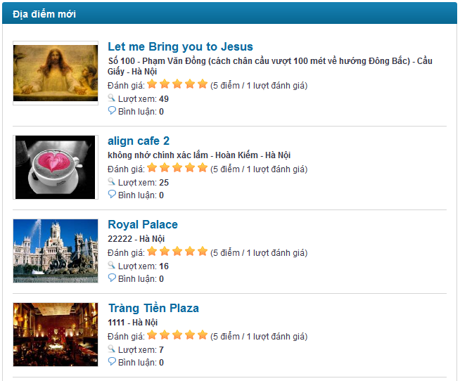**

### List Most Searched Categories

#### Use Case Diagram



#### Use Case Specification

|  |  |  |  |  |
| --- | --- | --- | --- | --- |
| **USE CASE – List most searched categories SPECIFICATION** | | | | |
| **Use-case No.** | UC033 | **Use-case Version** | | 1.0 |
| **Use-case Name** | List most searched categories | | | |
| **Author** | QuangLM | | | |
| **Date** | 16/01/2011 | **Priority** | Normal | |
| **Actor:**  User  **Summary:**  Each time the user accesses the home page, he/she can see a list of top 20 most searched categories. The list is display as a tag cloud. This list is used to let user know which categories get the most concern on the website.  **Goal:**  See most researched categories in the website  **Triggers:**  Access the home page  **Preconditions: -**  **Post Conditions:**  Stay remains at home page.  **Main Success Scenario:**   |  |  |  | | --- | --- | --- | | Step | Actor Action | System Response | | 1 | Access home page | Display a tag cloud of 20 most searched categories |   **Alternative Scenario: -**  **Exceptions: -**  **Relationships: -**  **Business Rules:**   |  |  |  | | --- | --- | --- | | No | Rule Description | Error Message | | 1 | Category names in the list are sorted by name. |  | | | | | |
| **Description:**  Each time the user accesses the website, he/she can see a list of top 50 most searched categories. The list is display as a tag cloud. Category names in the list are sorted by name. The tag cloud has 2 view modes: short view and detail view. Short view only display 20 most searched categories while detail view display 50 most searched categories. The short view is default. User need click to “Xem thêm” to redirect to new page with Detail view. This list is used to let user know which categories get the most concern on the website. The result list is based on search queries from users on the system. The more the category entered in search box, the bigger size and bolder it has. | | | | |

**Screen**

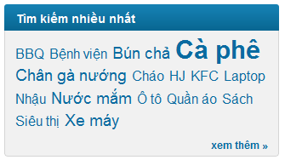

### List Most Contributors

#### Use Case Diagram



#### Use Case Specification

|  |  |  |  |  |
| --- | --- | --- | --- | --- |
| **USE CASE – List most contributors SPECIFICATION** | | | | |
| **Use-case No.** | UC034 | **Use-case Version** | | 1.0 |
| **Use-case Name** | List most contributors | | | |
| **Author** | QuangLM | | | |
| **Date** | 16/01/2011 | **Priority** | Normal | |
| **Actor:**  User  **Summary:**  Each time the user accesses Q&A page, he/she can see a list of top 10 most contributors. This list is used to let user know who contribute most to the website.  **Goal:**  See most contributors  **Triggers:**  Click to “Hỏi & Đáp” menu at navigator  **Preconditions:**  **Post Conditions:**  Stay remains at Q&A page.  **Main Success Scenario:**   |  |  |  | | --- | --- | --- | | Step | Actor Action | System Response | | 1 | Click to “Hỏi & Đáp” menu at navigator | Display top 10 most contributor on the right side |   **Alternative Scenario: -**  **Exceptions: -**  **Relationships: -**  **Business Rules:**   |  |  |  | | --- | --- | --- | | No | Rule Description | Error Message | | 1 | The most contributor list is based on number of posted answers |  | | 2 | Sorted by highest point to lesser contributors |  | | | | | |
| **Description:**  Each time the user accesses Q&A page, he/she can see a list of top 10 most contributors. The list is sorted by highest answer number to lesser .This list is used to let user know who contribute most to Q&A page. Each user is displayed with avatar, name and number of answers that user has posted. User name is displayed as link. User can click to these links to open User profile page. | | | | |

**Screen**

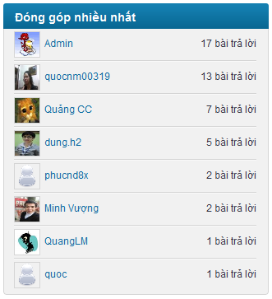

### Log In

#### Use Case Diagram



#### Use Case Specification

|  |  |  |  |  |
| --- | --- | --- | --- | --- |
| **USE CASE – Log in SPECIFICATION** | | | | |
| **Use-case No.** | UC035 | **Use-case Version** | | 1.0 |
| **Use-case Name** | Log in | | | |
| **Author** | VuongNM | | | |
| **Date** | 10/01/2011 | **Priority** | High | |
| **Actor:**  User  **Summary:**  User must be login to be able to use such functions as create place, edit place, rating... There are 2 ways to login into website; the first way is register one account on system. The second way is logon via third party account: Yahoo or Google. The second way is recommended.  **Goal:**  Allow guest login to website.  **Triggers**  Click to “Đăng nhập” at log in area on top right corner of the website  **Preconditions:**  Access to the website  **Post Conditions:**  User logged to system  **Main Success Scenario:**   |  |  |  | | --- | --- | --- | | **Step** | **Actor Action** | **System Response** | | 1 | Click to “Đăng nhập” at log in area on top right corner of the website | Redirect user to log in page | | 2 | Enter Username, password |  | | 3 | Click to “Đăng nhập” button | Navigate the user back to previous page |   **Alternative Scenario:**   |  |  |  | | --- | --- | --- | | **Step** | **Actor Action** | **System Response** | | 1 | Click to “Đăng nhập” at log in area on top right corner of the website | Redirect user to log in page | | 2 | Select Google or Yahoo image to login | Redirect to log in page belong to Goole or Yahoo | | 3 | Enter third party account’s username & password correctly |  | | 4 | Click to “Đăng nhập” button | notification message will be showed to confirm if the user really want to use this account to login to the system | | 5 | Click to “Có” button | Navigate the user back to previous page |   **Exceptions:**   |  |  |  | | --- | --- | --- | | **Step** | **Actor Action** | **System Response** | | 1 | Click to “Đăng nhập” at log in area on top right corner of the website | Redirect user to log in page | | 2 | Enter wrong user name, password |  | | 3 | Click to “Đăng nhập” button | Show error message “Bạn hãy sửa những lỗi bên dưới và thử lại.   * Incorrect username or password.” |  |  |  |  | | --- | --- | --- | | **Step** | **Actor Action** | **System Response** | | 1 | Click to “Đăng nhập” hyperlink at home page | Redirect user to log in page | | 2 | Select Google or Yahoo image to login | Popup is displayed and require user enter username & password | | 3 | Enter wrong third party account’s username or password |  | | 4 | Click to “Đăng nhập” button | Show error message, require the user re-enter user name and password |   **Relationships:**  **Business Rules:**   |  |  |  | | --- | --- | --- | | **No** | **Rule Description** | **Error Message** | | 1 | In order to log in to the system, user name and password are required. |  | | | | | |
| **Description:**  There are functions that required users log in to the system to be able to use such as create new place, edit a place, post a question, and post a comment or an answer… User need click to “Đăng nhập” button on log in panel at top right corner of the website. The system will navigate user to Log in page. Log in page gives user 3 choices for logging in: using google account, using yahoo account or using PSN account. Click to google icon, the user will log in through Google account system. Click to Yahoo icon, the user will log in through Yahoo account system. To log in through account registerd at our website, user need fill in yout email address and password. If you check “Tự động đăng nhập lần sau”, your account info will be saved into cookie. And next time when you access the website again, you don’t need to log in cause the system will auto recognize you. The user can change his/her password incase he/she forgot it by clicking to “Quên mật khẩu” hyperlink. | | | | |

**Screen**

**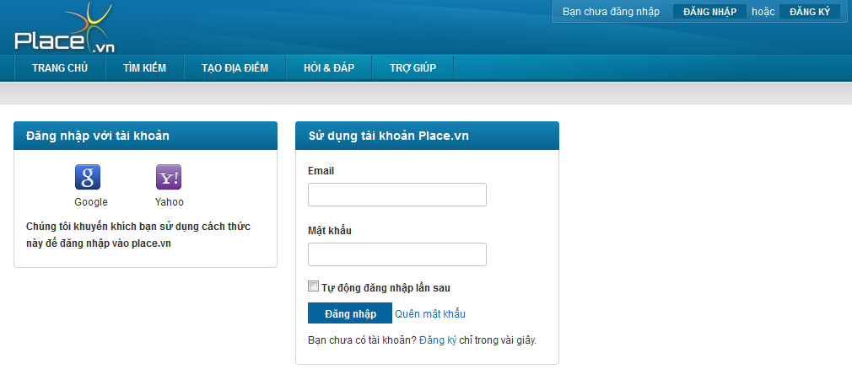**

**Data Fields Definition – Attach Place Page**

|  |  |  |  |  |  |  |
| --- | --- | --- | --- | --- | --- | --- |
| **Field name** | **Description** | **Read**  **Only** | **Mandatory** | **Control Type** | **Data Type** | **Length** |
| **PSN Account Area with title “Sử dụng tài khoản Place.vn”** | | | | | | |
| Email label | A label with content “Email” | - | - | Label | String | Fixed |
| Email | Email address used for registering | - | Y | Textbox | String | 100 |
| Password label | A label with content “Mật khẩu” | - | - | Label | String | Fixed |
| Password | Users enter your password to login into PSN website.  Displayed text is password | - | Y | Textbox | String | 50 |
| Remember me | A check box with content “Tự động đăng nhập lần sau” | - | - | Checkbox | Boolean | fixed |
| Register label | A label with content “Bạn chưa có tài khoản?” + “[Đăng ký](http://place.vn/account/register) “hyperlink + “chỉ trong vài giây.” | - | - | Label | String | Fixed |
| **3rd party account area with title “Đăng nhập với tài khoản”** | | | | | | |
| Google | User click it to logon website by Google account | Y | - | Image | - | - |
| Yahoo | User click it to logon website by Yahoo account | Y | - | Image | - | - |
| Suggestion | A label with content “Chúng tôi khuyến khích bạn sử dụng cách thức này để đăng nhập vào place.vn” | - | - | Label | String | Fixed |

**Buttons / Hyperlinks**

|  |  |  |  |  |
| --- | --- | --- | --- | --- |
| **Function** | **Description** | **Available Criteria** | **Validations** | **Outcome** |
| Log in Button | This button is used for log in into the system | Always available | No validation | Redirected back to previous page with user name appear on log in area instead of “Đăng nhập” and “Đăng kí” button |
| Register hyperlink | When clicked guest is navigated to register page to create new account in website | Always available | No validation | Redirect to register page |
| Forgot password hyperlink | User navigated to forgot password page when clicked | Always available | No validation | navigated the user to forgot password page |

### Log Out

#### Use Case Diagram



#### Use Case Specification

|  |  |  |  |  |
| --- | --- | --- | --- | --- |
| **USE CASE – Log out SPECIFICATION** | | | | |
| **Use-case No.** | UC036 | **Use-case Version** | | 1.0 |
| **Use-case Name** | Log out | | | |
| **Author** | VuongNM | | | |
| **Date** | 10/01/2011 | **Priority** | High | |
| **Actor:**  User  **Summary:**  After done using the website and plan to leave, the user can log out of the system.  **Goal:**  Allow users log out website  **Triggers**  Click on “Thoát” at log in area on top right corner of the website  **Preconditions:**  Logged into the system  **Post Conditions:**  Display the user as guest  **Main Success Scenario:**   |  |  |  | | --- | --- | --- | | **Step** | **Actor Action** | **System Response** | | 1 | click “Thoát” button | Redirect to home page, “Đăng nhập” and “Đăng kí” button appear instead of user name, user point and “Thoát” button on log in area at top right corner of the website |   **Alternative Scenario:**  None  **Exceptions:**  None  **Relationships:**  Login function  **Business Rules:**  None | | | | |

**Buttons / Hyperlinks**

|  |  |  |  |  |
| --- | --- | --- | --- | --- |
| **Function** | **Description** | **Available Criteria** | **Validations** | **Outcome** |
| Logout hyperlink | By clicking this user will log out of website |  |  | Displayed user as guest |

### Register an Account

#### Use Case Diagram



#### Use Case Specification

|  |  |  |  |  |
| --- | --- | --- | --- | --- |
| **USE CASE – Register an account SPECIFICATION** | | | | |
| **Use-case No.** | UC037 | **Use-case Version** | | 1.0 |
| **Use-case Name** | Register an account | | | |
| **Author** | VuongNM | | | |
| **Date** | 10/01/2011 | **Priority** | High | |
| **Actor:**  User  **Summary:**  Because of permission of guest is limited. So guest must register an account to be able to create place, rating, or comment …  **Goal:**  Register an account in the system.  **Triggers**  Click to “Đăng kí” button on log in area at top right corner of the website  **Preconditions:**  Access to the website  **Post Conditions:**  Navigate the user back to home page.  **Main Success Scenario:**   |  |  |  | | --- | --- | --- | | **Step** | **Actor Action** | **System Response** | | 1 | Click to “Đăng kí” button on log in area at top right corner of the website | Website navigate the user to register page | | 2 | Type in email address correctly |  | | 3 | Enter password correctly |  | | 4 | Re-enter password into confirm password textbox correctly |  | | 5 | Enter full name |  | | 6 | Click to “Đăng kí” button | Send activation email to registered email address and redirect to Success page |   **Alternative Scenario: -**  **Exceptions:**   |  |  |  | | --- | --- | --- | | **Step** | **Actor Action** | **System Response** | | 1 | Click to “Đăng kí” button on log in area at top right corner of the website | Website navigate the user to register page | | 2 | Type in email address **in wrong format** | Display error message “Địa chỉ Email không đúng.” |  |  |  |  | | --- | --- | --- | | **Step** | **Actor Action** | **System Response** | | 1 | Click to “Đăng kí” button on log in area at top right corner of the website | Website navigate the user to register page | | 2 | Type in email address correctly |  | | 3 | Enter password correctly |  | | 4 | Re-enter password into confirm password textbox **mistakenly** | Display error message “'Nhập lại mật khẩu' và 'Mật khẩu' phải giống nhau.” |  |  |  |  | | --- | --- | --- | | **Step** | **Actor Action** | **System Response** | | 1 | Click to “Đăng kí” button on log in area at top right corner of the website | Website navigate the user to register page | | 2 | Type in **used** email address | check email format | | 3 | Enter password correctly |  | | 4 | Re-enter passwod into confirm password textbox correctly |  | | 5 | Enter full name |  | | 6 | Click to “Đăng kí” button | Display error message” Bạn hãy sửa những lỗi bên dưới và thử lại.   * Địa chỉ email đã tồn tại” |   **Relationships:**  Forget password function  **Business Rules:**   |  |  |  | | --- | --- | --- | | **No** | **Rule Description** | **Error Message** | | 1 | In order to register a new account, email address, password and confirm password is required. |  | | 2 | One email address can only be used for registering once |  | | | | | |
| **Description:**  In order to has full access to our website, user need to log in by using Google account or Yahoo account or register a PSN account. To register an account on our system, user needs to have a vaild email address. This email address must exist to be able to get activation email from the system. Each email can only be used for registering once, you can use it again. After register an account, you must log in to your email to find validation email. In this email, we send to you an activation link. Click to that link will active your account. An unactived account will get limited access on our website | | | | |

**Screen**

**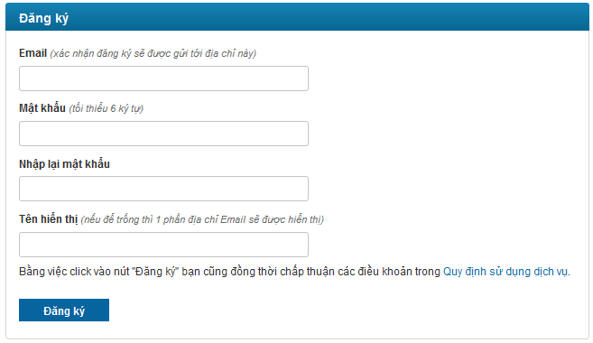**

**Data Fields Definition – Attach Place Page**

|  |  |  |  |  |  |  |
| --- | --- | --- | --- | --- | --- | --- |
| **Field name** | **Description** | **Read**  **Only** | **Mandatory** | **Control Type** | **Data Type** | **Length** |
| Email label | A label with content “Email (xác nhận đăng ký sẽ được gửi tới địa chỉ này) ” | - | - | Label | String | Fixed |
| Email | Email address used for registering | - | Y | Textbox | Text | 50 |
| Password label | A label with content “Mật khẩu (tối thiểu 6 ký tự) ” | - | - | Label | String | Fixed |
| Password | This text box for enter password | - | Y | Textbox | Text | 50 |
| Confirm label | A label with content “Nhập lại mật khẩu” | - | - | Label | String | Fixed |
| Confirm password | This text box for enter confirm password | - | Y | Textbox | Text | 50 |
| Nickname label | A label with content “Tên hiển thị (nếu để trống thì 1 phần địa chỉ Email sẽ được hiển thị) ” | - | - | Label | String | Fixed |
| Nickname | This text box for enter nickname | - | Y | Textbox | Text | 100 |
| Agreement | This label contains: “Bằng việc click vào nút "Đăng ký" bạn cũng đồng thời chấp thuận các điều khoản trong” + “[Quy định sử dụng dịch vụ](http://place.vn/home/termsofservice)” hyperlink | Y | Y | Checkbox | True/False | - |

**Buttons / Hyperlinks**

|  |  |  |  |  |
| --- | --- | --- | --- | --- |
| **Function** | **Description** | **Available Criteria** | **Validations** | **Outcome** |
| Register button | When clicked all information which entered by user is submitted to website to create new account. | Always available | Enter valid information | Send activation email to registered email address and redirect to Success page |
| Policies hyperlink | This link will open policies page | Always available | No validation | Redirect user to Terms of Service page |

### Reset Forgot Password

#### Use Case Diagram



#### Use Case Specification

|  |  |  |  |  |
| --- | --- | --- | --- | --- |
| **USE CASE – Reset forgot password SPECIFICATION** | | | | |
| **Use-case No.** | UC038 | **Use-case Version** | | 1.0 |
| **Use-case Name** | Reset Forgot Password | | | |
| **Author** | VuongNM | | | |
| **Date** | 10/01/2011 | **Priority** | High | |
| **Actor:**  User  **Summary:**  By some reasons, registered user forgot their password and wanted to recovery this. When user report forgot password, website send confirm email to the user. The user clicks confirm reset password in email, after that system will reset user password and sent new password in email to user.  **Goal:**  Reset user’s password.  **Triggers**  Click to “Quên mật khẩu” hyperlink  **Preconditions:**  Access to the website and open log in page  **Post Conditions:**  Stay remains at forgot pass page with notification ask user check for new email with new password  **Main Success Scenario:**   |  |  |  | | --- | --- | --- | | **Step** | **Actor Action** | **System Response** | | 1 | Click to “Quên mật khẩu” hyperlink | navigate user to forgot password page | | 2 | Type email address into email address textbox |  | | 3 | Click to “Quên mật khẩu” button | Confirm email sent to user. Website show message to inform the user check email to confirm resetting his/her password | | 4 | User click confirm hyperlink in email | Redirect the user to reset password page | | 5 | Enter new password and confirm password |  | | 5 | Click to “Thay đổi” button | New password is saved |   **Alternative Scenario:**  **Exceptions:**   |  |  |  | | --- | --- | --- | | **Step** | **Actor Action** | **System Response** | | 1 | Click to “Quên mật khẩu” hyperlink | navigate user to forgot password page | | 2 | Type invalida email address into email address textbox |  | | 3 | Click to “Tạo mật khẩu mới” button | Display error message, inform the user that he/she justentered an invalid email address |     **Relationships:**  **Business Rules:**   |  |  |  | | --- | --- | --- | | **No** | **Rule Description** | **Error Message** | | 1 | Email address is required to be able to reset pasword |  | | 2 | Confirm link will be sent through email |  | | | | | |
| **Description:**  The system allows user change password when they forgot it. User goes to log in page at PSN website and click “Quên mật khẩu” hyperlink to get redirected to Forgot Password page. Users need enter their email address, system will check this email is registered or not. If valid, one email is sent to user with reset password link. Follow this link, user is navigated to reset password page. In here, user selects “Tạo mật khẩu mới” button, the system will replace your password with the new one. | | | | |

**Screen**

**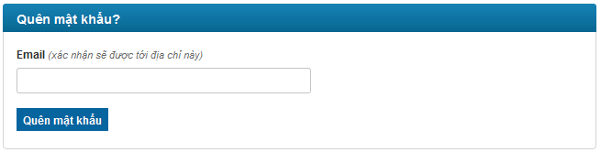**

**oOo**

**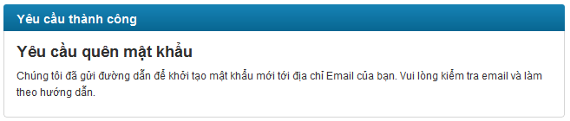**

**oOo**

**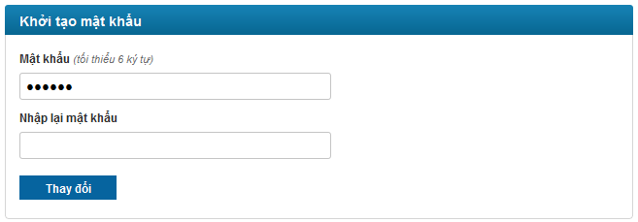**

**Data Fields Definition – Attach Place Page**

|  |  |  |  |  |  |  |
| --- | --- | --- | --- | --- | --- | --- |
| **Field name** | **Description** | **Read**  **Only** | **Mandatory** | **Control Type** | **Data Type** | **Length** |
| **Forgot password area with title “Quên mật khẩu?”** | | | | | | |
| Email label | A label with content “Email (xác nhận sẽ được tới địa chỉ này) ” | - | - | Label | String | Fixed |
| Email | Email address used for get reset password link | - | Y | Textbox | String | 254 |
| **Reset password area with title “Khởi tạo mật khẩu”** | | | | | | |
| New password label | A label with content “Mật khẩu (tối thiểu 6 ký tự) ” | - | - | Label | String | Fixed |
| New password | password that will replace old password | - | Y | Textbox | String | 100 |
| Confirm password label | A label with content “Nhập lại mật khẩu” | - | - | Label | String | Fixed |
| Confirm password | Confirm password | - | Y | Button | String | 100 |

**Buttons / Hyperlinks**

|  |  |  |  |  |
| --- | --- | --- | --- | --- |
| **Function** | **Description** | **Available Criteria** | **Validations** | **Outcome** |
| forgot password | When clicked a mail with link used for resetting will be sent to user email address | Always available | Email can’t be blank | Notification message is displayed to inform that user check email and follow hyperlink to generate new password |
| Reset password | Using button will save new password instead of the old one | Always available | Password and confirm password can’t be blank | Notification message is displayed to inform that new password is generated and is sent to user’s email. |

### Edit Your Profile

#### Use Case Diagram



#### Use Case Specification

|  |  |  |  |  |
| --- | --- | --- | --- | --- |
| **USE CASE – Edit your profile SPECIFICATION** | | | | |
| **Use-case No.** | UC039 | **Use-case Version** | | 1.0 |
| **Use-case Name** | Edit your profile | | | |
| **Author** | VuongNM | | | |
| **Date** | 10/01/2011 | **Priority** | High | |
| **Actor:**  User  **Summary:**  When viewing his/her profile, user can change his/her nickname and avatar.  **Goal:**  Allow user edit and complete their profile  **Triggers**  Click on “Sửa đổi” button  **Preconditions:**  Logged into the system and open your profile page  **Post Conditions:**  None  **Main Success Scenario:**   |  |  |  | | --- | --- | --- | | **Step** | **Actor Action** | **System Response** | | 1 | Change nickname |  | | 2 | Click to “Sửa đổi” button | Display message “Thông tin cá nhân đã được cập nhật.” |   **Alternative Scenario:**   |  |  |  | | --- | --- | --- | | **Step** | **Actor Action** | **System Response** | | 1 | Click uploader | Popup a window for choosing image | | 2 | Choose an image | Display image url | | 3 | Click to “Sửa đổi” button | Display message “Thông tin cá nhân đã được cập nhật.” |   **Exceptions:**   |  |  |  | | --- | --- | --- | | **Step** | **Actor Action** | **System Response** | | 1 | Change nickname to more than 50 characters |  | | 2 | Click to “Sửa đổi” button | Display message “Thông tin cập nhập lỗi” |  |  |  |  | | --- | --- | --- | | **Step** | **Actor Action** | **System Response** | | 1 | Click uploader | Popup a window for choosing image | | 2 | Choose an image with any extension except JPG, PNG | Display image url | | 3 | Click to “Sửa đổi” button | Display message “Cập nhật ảnh đại diện không thành công. Chỉ hỗ trợ ảnh định dạng JPG và PNG. Kích thước ảnh không được vượt quá 2Mb. Nếu lỗi vẫn xảy ra bạn hãy thử lại vào lúc khác.” |  |  |  |  | | --- | --- | --- | | **Step** | **Actor Action** | **System Response** | | 1 | Click uploader | Popup a window for choosing image | | 2 | Choose an image with size bigger then 2MB | Display image url | | 3 | Click to “Sửa đổi” button | Display message “Cập nhật ảnh đại diện không thành công. Chỉ hỗ trợ ảnh định dạng JPG và PNG. Kích thước ảnh không được vượt quá 2Mb. Nếu lỗi vẫn xảy ra bạn hãy thử lại vào lúc khác.” |   **Relationships:**  View user profile  **Business Rules:**   |  |  |  | | --- | --- | --- | | **No** | **Rule Description** | **Error Message** | | 1 | In order to change password, old password, new password and retype new password are required |  | | 2 | Avatar’s size can’t be exceed than 1M |  | | 3 | Email address can’t be changed because this used as username in logging in |  | | 4 | View permission combo box has default value is “Everyone” |  | | | | | |
| **Description:**  User can update his/her profile. He/she can change Display name, change avatar or click to “Đổi mật khẩu” hyperlink to chage password. User need click to “Sửa đổi” button to save changes. Display Name can not has more than 50 characters, if not, there will be an error message require user to reenter. About user’s avatar, it must be JPG or PNG and must be smaller than 4Mb. The changing in user profile will be update right away as you click “Sửa đổi” button on the whole system. | | | | |

**Screen**

**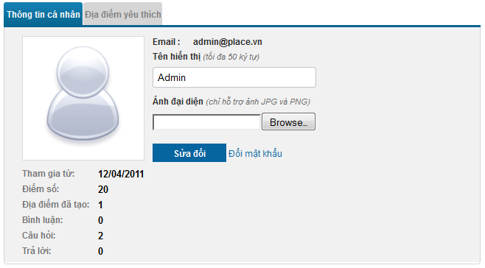**

**Data Fields Definition – Attach Place Page**

|  |  |  |  |  |  |  |
| --- | --- | --- | --- | --- | --- | --- |
| **Field name** | **Description** | **Read**  **Only** | **Mandatory** | **Control Type** | **Data Type** | **Length** |
| Email label | A label with content “Email:” | Y | - | Label | String | Fixed |
| Email | Contain your email address | N | Y | Textbox | String | 254 |
| Nickname label | A label with content “Tên hiển thị (tối đa 50 ký tự) ” | Y | - | Label | String | Fixed |
| Nick name | Contain your nickname | N | Y | Text box | String | 50 |
| Avatar label | A label with content “Ảnh đại diện (chỉ hỗ trợ ảnh JPG và PNG)” | Y | - | Label | String | Fixed |
| Avatar uploader | Uploader used for upload your image to server | Y | - | Uploader | - | - |
| Avatar | Your current avatar | Y | - | Image | - | - |
| Created date label | “Tham gia từ:” label | Y | - | Label | String | Fixed |
| Created date | Contains created date of current viewing profile | Y | - | Label | String | Fixed |
| Point label | “Điểm số:” label | Y | - | Label | String | Fixed |
| Point | Contains your point | Y | - | Label | String | Fixed |
| Created place label | “Địa điểm đã tạo:” label | Y | - | Label | String | Fixed |
| Create place number | Contains number of places you created | Y | - | Label | String | Fixed |
| Comment posted label | “Bình luận:” label | Y | - | Label | String | Fixed |
| Comment posted number | Contains number of comments you posted | Y | - | Label | String | Fixed |
| Question posted label | “Câu hỏi:” label | Y | - | Label | String | Fixed |
| Question posted number | Contains number of questions you posted | Y | - | Label | String | Fixed |
| Answer posted label | “Trả lời:” label | Y | - | Label | String | Fixed |
| Answer posted number | Contains number of answers you posted | Y | - | Label | String | Fixed |

**Buttons / Hyperlinks**

|  |  |  |  |  |
| --- | --- | --- | --- | --- |
| **Function** | **Description** | **Available Criteria** | **Validations** | **Outcome** |
| Edit your profile | This button is used for edit your profile | Only available when open your own profile |  | Display message “Thông tin cá nhân đã được cập nhật.” |
| “Đổi mật khẩu” hyperlink | This link will open change password page | Only available when open your own profile |  | Redirect to Change Password page |

### Change Password

#### Use Case Diagram



#### Use Case Specification

|  |  |  |  |  |
| --- | --- | --- | --- | --- |
| **USE CASE – Change password SPECIFICATION** | | | | |
| **Use-case No.** | UC040 | **Use-case Version** | | 1.0 |
| **Use-case Name** | Change Password | | | |
| **Author** | QuangLM | | | |
| **Date** | 10/01/2011 | **Priority** | High | |
| **Actor:**  User  **Summary:**  For security, many users often change their account password each 2-3 months. User can change their password by go to their user profile and click to “Đổi mật khẩu” hyperlink  **Goal:**  Allow user change his/her account password.  **Triggers**  Click to “Đổi mật khẩu” hyperlink  **Preconditions:**  Access to the website and open your profile  **Post Conditions:**  Stay remains at forgot pass page  **Main Success Scenario:**   |  |  |  | | --- | --- | --- | | **Step** | **Actor Action** | **System Response** | | 1 | Click to “Quên mật khẩu” hyperlink | navigate user to forgot password page | | 2 | Enter old password |  | | 3 | Enter new password |  | | 4 | Enter confirm password |  | | 5 | Click to “Thay đổi” button | Display message “Thay đổi mật khẩu thành công” |   **Alternative Scenario:**  **Exceptions:**   |  |  |  | | --- | --- | --- | | **Step** | **Actor Action** | **System Response** | | 1 | Click to “Quên mật khẩu” hyperlink | navigate user to forgot password page | | 2 | Enter not matched old password |  | | 3 | Enter new password |  | | 4 | Enter confirm password |  | | 5 | Click to “Thay đổi” button | Display message “Mật khẩu cũ không đúng” |  |  |  |  | | --- | --- | --- | | **Step** | **Actor Action** | **System Response** | | 1 | Click to “Quên mật khẩu” hyperlink | navigate user to forgot password page | | 2 | Enter old password |  | | 3 | Enter new password |  | | 4 | Enter not matched confirm password |  | | 5 | Click to “Thay đổi” button | Display message “Nhập lại mật khẩu mới' và 'Mật khẩu mới' phải giống nhau.” |   **Relationships:**  **Business Rules:**   |  |  |  | | --- | --- | --- | | **No** | **Rule Description** | **Error Message** | | 1 | Old password, new password and confirm password are required to change password |  | | | | | |

**Screen**

**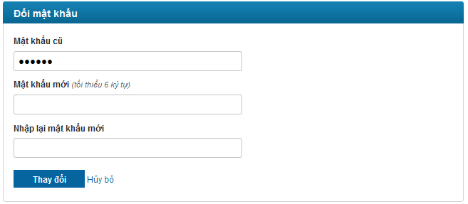**

**Data Fields Definition – Attach Place Page**

|  |  |  |  |  |  |  |
| --- | --- | --- | --- | --- | --- | --- |
| **Field name** | **Description** | **Read**  **Only** | **Mandatory** | **Control Type** | **Data Type** | **Length** |
| Old password label | A label with content “Mật khẩu cũ ” | - | - | Label | String | Fixed |
| Old password | Your old password | - | Y | Textbox | String | 100 |
| New password label | A label with content “Mật khẩu mới (tối thiểu 6 ký tự) ” | - | - | Label | String | Fixed |
| New password | password that will replace old password | - | Y | Textbox | String | 100 |
| Confirm password label | A label with content “Nhập lại mật khẩu mới” | - | - | Label | String | Fixed |
| Confirm password | Confirm password | - | Y | Button | String | 100 |

**Buttons / Hyperlinks**

|  |  |  |  |  |
| --- | --- | --- | --- | --- |
| **Function** | **Description** | **Available Criteria** | **Validations** | **Outcome** |
| Change password | This button is used to change user password | Always available | Old password, new password and confirm password can’t be blank | Display message “Thay đổi mật khẩu thành công” |
| Cancel changing password | This hyperlink will navigate user back to his/her profile | Always available | No validation | Redirect back to user profile |

### View an User’s Profile

#### Use Case Diagram



#### Use Case Specification

|  |  |  |  |  |
| --- | --- | --- | --- | --- |
| **USE CASE – View an user’s profile SPECIFICATION** | | | | |
| **Use-case No.** | UC041 | **Use-case Version** | | 1.0 |
| **Use-case Name** | View an user’s profile | | | |
| **Author** | VuongNM | | | |
| **Date** | 10/01/2011 | **Priority** | High | |
| **Actor:**  User  **Summary:**  Website is as bridge connects people with people, so user can view other user’s profile to know more information about him or her. The user can see his own/ her own profile.  **Goal:**  Allow user view his/her of other user profile.  **Triggers**  User clicks on username hyperlink to navigate to their personal page.  **Preconditions:**  Access the website  **Post Conditions:**  Redirect the user to profile page  **Main Success Scenario:**   |  |  |  | | --- | --- | --- | | **Step** | **Actor Action** | **System Response** | | 1 | Click to other user’s name link | Navigated to correspond profile page |   **Alternative Scenario:**   |  |  |  | | --- | --- | --- | | **Step** | **Actor Action** | **System Response** | | 1 | Log in to website |  | | 1 | Click to your name on log in area at top right corner of website | Navigated to your profile page |   **Exceptions:**  None  **Relationships:**  Log in use case  **Business Rules:** | | | | |
| **Description:**  User Profile page will be opened as user click to a user link on anywhere on the website. This page contains all information about a user. There will be a litte different when open your own profile and open other user’s profile. At your profile, there are textbox, uploader and hyperlink for changing information. At other user’s profile there won’t be. you can’t know other user’s email address but you can know the user name, the day that user registered on the system, how many point that user have, how many places that user created, how many comments, questions and answers that user posted on the system. | | | | |

**Screen**

****

**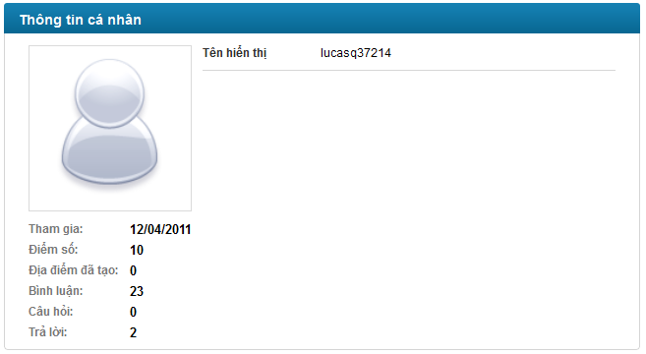**

**Data Fields Definition – Attach Place Page**

|  |  |  |  |  |  |  |
| --- | --- | --- | --- | --- | --- | --- |
| **Field name** | **Description** | **Read**  **Only** | **Mandatory** | **Control Type** | **Data Type** | **Length** |
| **Your profile** | | | | | | |
| Email label | A label with content “Email:” | Y | - | Label | String | Fixed |
| Email | Contain your email address | N | Y | Textbox | String | 254 |
| Nickname label | A label with content “Tên hiển thị (tối đa 50 ký tự) ” | Y | - | Label | String | Fixed |
| Nick name | Contain your nickname | N | Y | Text box | String | 50 |
| Avatar label | A label with content “Ảnh đại diện (chỉ hỗ trợ ảnh JPG và PNG)” | Y | - | Label | String | Fixed |
| Avatar uploader | Uploader used for upload your image to server | Y | - | Uploader | - | - |
| Avatar | Your current avatar | Y | - | Image | - | - |
| Created date label | “Tham gia từ:” label | Y | - | Label | String | Fixed |
| Created date | Contains created date of current viewing profile | Y | - | Label | String | Fixed |
| Point label | “Điểm số:” label | Y | - | Label | String | Fixed |
| Point | Contains your point | Y | - | Label | String | Fixed |
| Created place label | “Địa điểm đã tạo:” label | Y | - | Label | String | Fixed |
| Create place number | Contains number of places you created | Y | - | Label | String | Fixed |
| Comment posted label | “Bình luận:” label | Y | - | Label | String | Fixed |
| Comment posted number | Contains number of comments you posted | Y | - | Label | String | Fixed |
| Question posted label | “Câu hỏi:” label | Y | - | Label | String | Fixed |
| Question posted number | Contains number of questions you posted | Y | - | Label | String | Fixed |
| Answer posted label | “Trả lời:” label | Y | - | Label | String | Fixed |
| Answer posted number | Contains number of answers you posted | Y | - | Label | String | Fixed |
| **Other user profile** | | | | | | |
| Nickname label | A label with content “Tên hiển thị” | Y | - | Label | String | Fixed |
| Nick name | Contain other user’s nickname | N | Y | Text box | String | 50 |
| Avatar | Other user’s avatar | Y | - | Image | - | - |
| Created date label | “Tham gia từ:” label | Y | - | Label | String | Fixed |
| Created date | Contains created date of current viewing profile | Y | - | Label | String | Fixed |
| Point label | “Điểm số:” label | Y | - | Label | String | Fixed |
| Point | Contains other user’s point | Y | - | Label | String | Fixed |
| Created place label | “Địa điểm đã tạo:” label | Y | - | Label | String | Fixed |
| Create place number | Contains number of places other user created | Y | - | Label | String | Fixed |
| Comment posted label | “Bình luận:” label | Y | - | Label | String | Fixed |
| Comment posted number | Contains number of comments other user posted | Y | - | Label | String | Fixed |
| Question posted label | “Câu hỏi:” label | Y | - | Label | String | Fixed |
| Question posted number | Contains number of questions other user posted | Y | - | Label | String | Fixed |
| Answer posted label | “Trả lời:” label | Y | - | Label | String | Fixed |
| Answer posted number | Contains number of answers other user posted | Y | - | Label | String | Fixed |

**Buttons / Hyperlinks**

|  |  |  |  |  |
| --- | --- | --- | --- | --- |
| **Function** | **Description** | **Available Criteria** | **Validations** | **Outcome** |
| Edit your profile | This button is used for edit your profile | Only available when open your own profile |  | Display message “Thông tin cá nhân đã được cập nhật.” |
| “Đổi mật khẩu” hyperlink | This link will open change password page | Only available when open your own profile |  | Redirect to Change Password page |

### <Admin> List all Users

#### Use Case Diagram



#### Use Case Specification

|  |  |  |  |  |
| --- | --- | --- | --- | --- |
| **USE CASE – List all users SPECIFICATION** | | | | |
| **Use-case No.** | UC042 | **Use-case Version** | | 1.0 |
| **Use-case Name** | List all users | | | |
| **Author** | VuongNM | | | |
| **Date** | 10/01/2011 | **Priority** | High | |
| **Actor:**  Administrator  **Summary:**  Administrator can view all member of website  **Goal:**  Allow administrator list all users in website  **Triggers**  Click to “Users” menu then click to “Manage Users” sub menu  **Preconditions:**  Logged into the system with admin role and go to Admin page  **Post Conditions:**  Open manage user page  **Main Success Scenario:**   |  |  |  | | --- | --- | --- | | **Step** | **Actor Action** | **System Response** | | 1 | Click to “Users” menu then click to “Manage Users” sub menu | Display Manage User page with all user in the system |   **Alternative Scenario:**  **Exceptions:**  **Relationships:**  **Business Rules:** | | | | |

**Screen**

**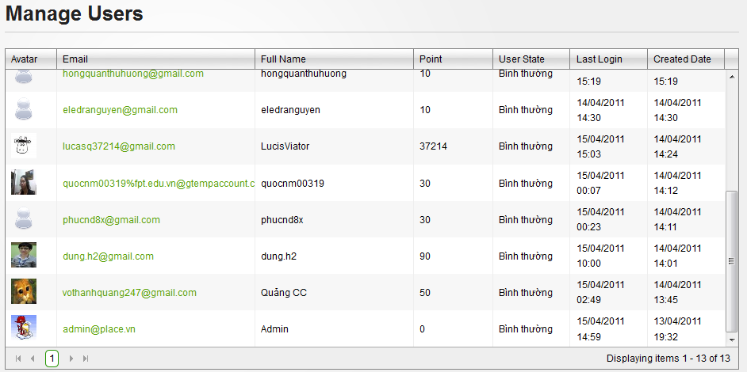**

**Data Fields Definition – Attach Place Page**

|  |  |  |  |  |  |  |
| --- | --- | --- | --- | --- | --- | --- |
| **Field name** | **Description** | **Read**  **Only** | **Mandatory** | **Control Type** | **Data Type** | **Length** |
| Avatar | Avatar of user | Y | Y | Image | Image | - |
| Full name | Full name or nickname of user | Y | Y | Label | String | Fixed |
| Posts | User’s point | Y | Y | Label | String | Fixed |
| User State | User’s state | Y | Y | Label | String | Fixed |
| Last login | User’s last login time | Y | Y | Label | String | Fixed |
| Created date | User’s created date | Y | Y | Label | String | Fixed |

**Buttons / Hyperlinks**

|  |  |  |  |  |
| --- | --- | --- | --- | --- |
| **Function** | **Description** | **Available Criteria** | **Validations** | **Outcome** |
| Email link | This link will redirect to User Detail page |  |  | Redirect to User Detail page |

### <Admin> View User Detail

#### Use Case Diagram



#### Use Case Specification

|  |  |  |  |  |
| --- | --- | --- | --- | --- |
| **USE CASE – View user detail SPECIFICATION** | | | | |
| **Use-case No.** | UC043 | **Use-case Version** | | 1.0 |
| **Use-case Name** | View user detail | | | |
| **Author** | QuangLM | | | |
| **Date** | 10/01/2011 | **Priority** | High | |
| **Actor:**  Administrator  **Summary:**  Administrator view detail information of users by click to email link at Manage User page  **Goal:**  Administrator can view detail information of users  **Triggers**  Click to email link at Manage User page  **Preconditions:**  Logged into the system with admin role and open manager user page  **Post Conditions:**  Display User Detail page  **Main Success Scenario:**   |  |  |  | | --- | --- | --- | | **Step** | **Actor Action** | **System Response** | | 1 | Click to email link at Manage User page | Redirect to User Detail page |   **Alternative Scenario:**  **Exceptions:**  **Relationships:**  List all users use case  **Business Rules:** | | | | |

**Screen**

**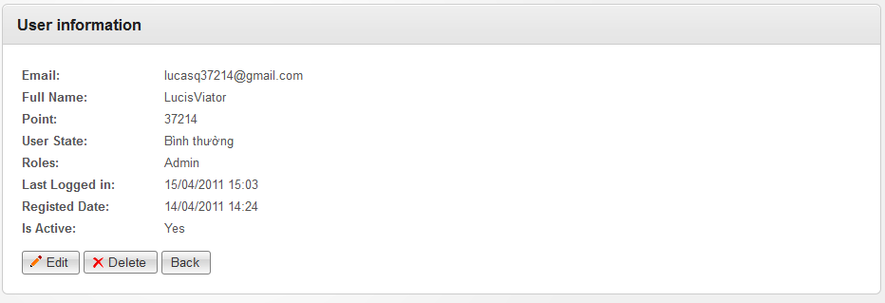**

**Data Fields Definition – Attach Place Page**

|  |  |  |  |  |  |  |
| --- | --- | --- | --- | --- | --- | --- |
| **Field name** | **Description** | **Read**  **Only** | **Mandatory** | **Control Type** | **Data Type** | **Length** |
| Email | Contains user email address | Y | Y | Label | String | Fixed |
| Full name | Contains user full name or nick name | Y | Y | Label | String | Fixed |
| Point | Contains user point | Y | Y | Label | String | Fixed |
| User state | Contains user state | Y | Y | Label | String | Fixed |
| Role | Contains user role | Y | Y | Label | String | Fixed |
| Last log in | Contains the last time user logged into the system | Y | Y | Label | String | Fixed |
| Registered date | Contains the time user registered on the system | Y | Y | Label | String | Fixed |
| Active status | Contains user activation status | Y | Y | Label | String | Fixed |

**Buttons / Hyperlinks**

|  |  |  |  |  |
| --- | --- | --- | --- | --- |
| **Function** | **Description** | **Available Criteria** | **Validations** | **Outcome** |
| Edit user information | This button is used to open edit user page | Always available | No validation | Redirect to Edit User page |
| Delete current viewing user | This button is used to delete current viewing user | Always available | No validation | Popup confirm |
| Back to manage user page | This button will navigate admin back to manage user page | Always available | No validation | Redirect back to Manage User page |

### <Admin> Edit an User

#### Use Case Diagram



#### Use Case Specification

|  |  |  |  |  |
| --- | --- | --- | --- | --- |
| **USE CASE – Edit an user SPECIFICATION** | | | | |
| **Use-case No.** | UC044 | **Use-case Version** | | 1.0 |
| **Use-case Name** | Edit an user | | | |
| **Author** | VuongNM | | | |
| **Date** | 10/01/2011 | **Priority** | High | |
| **Actor:**  Administrator  **Summary:**  Administrator can edit existing member in system such as change email address, edit full name, point, change user state or assign role.  **Goal:**  Allow administrator update user profile.  **Triggers**  Click to “Edit” button  **Preconditions:**  Logged into the system with admin role and open User Detail page  **Post Conditions:**  Redirect back to manage user page  **Main Success Scenario:**   |  |  |  | | --- | --- | --- | | **Step** | **Actor Action** | **System Response** | | 1 | Click to “Edit” button | Redirect to Edit User page | | 2 | Change some information |  | | 3 | Click to “Save” button | Redirect to Manage User page and display message “User has been updated successfully” |   **Alternative Scenario:**  **Exceptions:**   |  |  |  | | --- | --- | --- | | **Step** | **Actor Action** | **System Response** | | 1 | Click to “Edit” button | Redirect to Edit User page | | 2 | Leave required fields blank |  | | 3 | Click to “Save” button | Displayed error message inform admin can’t leave required fields blank |   **Relationships:**  View user detail use case  **Business Rules:** | | | | |

**Screen**

**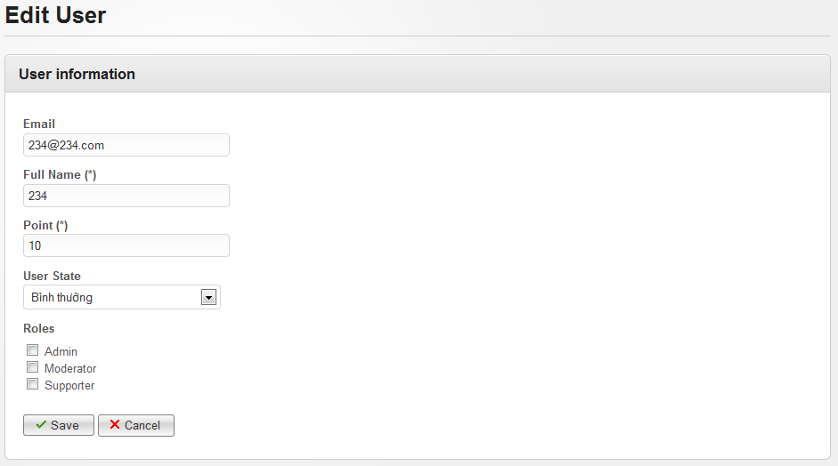**

**Data Fields Definition – Attach Place Page**

|  |  |  |  |  |  |  |
| --- | --- | --- | --- | --- | --- | --- |
| **Field name** | **Description** | **Read**  **Only** | **Mandatory** | **Control Type** | **Data Type** | **Length** |
| Email label | “Email” label | Y | Y | Label | String | Fixed |
| Email | Contains user email address | Y | Y | Label | String | Fixed |
| Full name label | “Full name (\*)” label | Y | Y | Label | String | Fixed |
| Full name | Contains user full name or nick name | Y | Y | Label | String | Fixed |
| Point label | “Point (\*)” label |  |  |  |  |  |
| Point | Contains user point | Y | Y | Label | String | Fixed |
| User state label | “User State” label | Y | Y | Label | String | Fixed |
| User state | A commbox contains all states | Y | Y | Combobox | String | Fixed |
| Role label | “Roles” label | Y | Y | Label | String | Fixed |
| Role | Contains all roles, each row displayed with a check box | Y | Y | Checkbox | String | Fixed |

**Buttons / Hyperlinks**

|  |  |  |  |  |
| --- | --- | --- | --- | --- |
| **Function** | **Description** | **Available Criteria** | **Validations** | **Outcome** |
| Save | This button will save all edited information | Always available | All required fields can’t be blank | Redirect to Manage User page and display message “User has been updated successfully” |
| cancel | This button will navigate admin back to Manage User page | Always available | No validation | Redirect to Manage User page |

### <Admin> Delete Users

#### Use Case Diagram



#### Use Case Specification

|  |  |  |  |  |
| --- | --- | --- | --- | --- |
| **USE CASE – Delete users SPECIFICATION** | | | | |
| **Use-case No.** | UC045 | **Use-case Version** | | 1.0 |
| **Use-case Name** | Delete users | | | |
| **Author** | VuongNM | | | |
| **Date** | 10/01/2011 | **Priority** | High | |
| **Actor:**  Administrator  **Summary:**  Administrator can delete an user  **Goal:**  Allow administrator delete spam user or who have bad behavior in website  **Triggers**  Click to “Delete” button  **Preconditions:**  Logged into the system with admin role and open User Detail page  **Post Conditions:**  Redirect back to Manage User page  **Main Success Scenario:**   |  |  |  | | --- | --- | --- | | **Step** | **Actor Action** | **System Response** | | 1 | Click to “Delete” button | Pop up confirm message “Are you sure you want to delete this User?” | | 2 | Click to “Ok” button | Popup close, redirect back to Manage User page, display message “User has been deleted successfully” |   **Alternative Scenario:**   |  |  |  | | --- | --- | --- | | **Step** | **Actor Action** | **System Response** | | 1 | Click to “Delete” button | Pop up confirm message “Are you sure you want to delete this User?” | | 2 | Click to “Cancel” button | Popup closes |   **Exceptions:**  None  **Relationships:**  List of user use case  **Business Rules:** | | | | |

**Screen**

**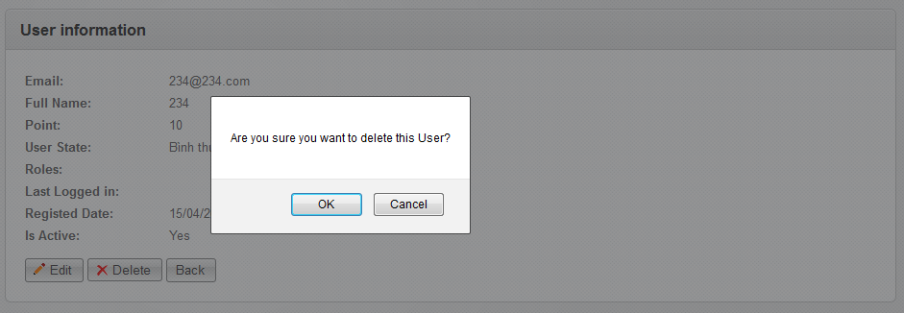**

### <Admin> List All Categories

#### Use Case Diagram



#### Use Case Specification

|  |  |  |  |  |
| --- | --- | --- | --- | --- |
| **USE CASE – List all Categories SPECIFICATION** | | | | |
| **Use-case No.** | UC046 | **Use-case Version** | | 1.0 |
| **Use-case Name** | List all categories | | | |
| **Author** | DungTQ | | | |
| **Date** | 19/01/2011 | **Priority** | Normal | |
| **Actor:**  Admin  **Summary:**  Category is only be managed by admins. A list of all categories in the system will be listed.  **Goal:**  Admin can view existed category list.  **Triggers**  Click to “Categories” menu then click to “Manage Categories” sub menu  **Preconditions:**  Successfully logged into the system with Admin role and go to Admin page  **Post Conditions:**  Categories List page will be displayed with all existed categories  **Main Success Scenario:**   |  |  |  | | --- | --- | --- | | Step | Actor Action | System Response | | 1 | Click to “Categories” menu then click to “Manage Categories” sub menu | Categories List page will be displayed with all existed categories |   **Alternative Scenario:**  None  **Exceptions:**  None  **Relationships:**  Login use case  **Business Rules:**   |  |  |  | | --- | --- | --- | | **No** | **Rule Description** | **Error Message** | | 1 | Each page display 20 categories |  | | | | | |

**Screen**

**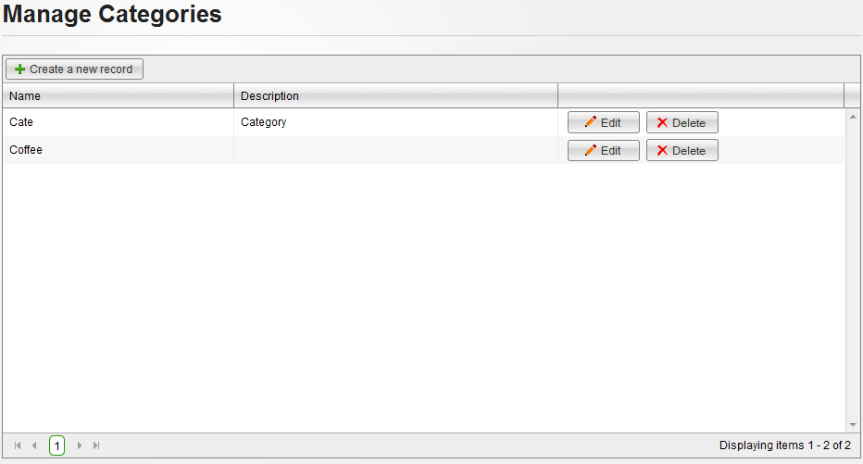**

**Data Fields Definition – Category List Screen**

|  |  |  |  |  |  |  |
| --- | --- | --- | --- | --- | --- | --- |
| **Field name** | **Description** | **Read**  **Only** | **Mandatory** | **Control Type** | **Data Type** | **Length** |
| Category name | Contains category name | Y | - | Label | String | Fixed |
| Category description | Contains category description | Y | - | label | string | 50 |

**Buttons / Hyper Links – Category List Screen**

|  |  |  |  |  |
| --- | --- | --- | --- | --- |
| **Function** | **Description** | **Available Criteria** | **Validations** | **Outcome** |
| Create new category | This button is used for adding a new category | Always available | No validation | Redirect to Create Category page |
| Edit category | This button is used to edit a category | Always available with each category | No validation | Redirect to Edit Category page |
| Delete category | This button is used to delete a category | Always available with each category | No validation | Popup confirm |

### <Admin> Create a New Category

#### Use Case Diagram



#### Use Case Specification

|  |  |  |  |  |
| --- | --- | --- | --- | --- |
| **USE CASE – Create a new category SPECIFICATION** | | | | |
| **Use-case No.** | UC047 | **Use-case Version** | | 1.0 |
| **Use-case Name** | Create A New Category | | | |
| **Author** | DungTQ | | | |
| **Date** | 19/01/2011 | **Priority** | Normal | |
| **Actor:**  Admin  **Summary:**  Admin can create a new category in the system  **Goal:**  Create a new category in database.  **Triggers**  Click to “Categories” menu then click to “Create a new category” sub menu  **Preconditions:**  Successfully logged into the system with Admin role and go to admin page.  **Post Conditions:**  New category will be added to database and displayed in Manage Category page.  **Main Success Scenario:**   |  |  |  | | --- | --- | --- | | Step | Actor Action | System Response | | 1 | Click to “Categories” menu then click to “Create a new category” sub menu | Redirect to Create Category page | | 2 | Enter needed infomration |  | | 3 | Click to “Save” button | Redirect to Manage Category page with new category was added and display message “Category has been inserted successfully” |   **Alternative Scenario:**   |  |  |  | | --- | --- | --- | | Step | Actor Action | System Response | | 1 | Click to “Categories” menu then click to “Manage Categories” sub menu | Redirect to Manage Category page | | 2 | Click to “Create a new record” | Redirect to Create Category page | | 3 | Enter needed infomration |  | | 4 | Click to “Save” button | Redirect to Manage Category page with new category was added and display message “Category has been inserted successfully” | | Step | Actor Action | System Response | | 1 | Click to “Categories” menu then click to “Create a new category” sub menu | Redirect to Create Category page | | 2 | Enter needed infomration |  | | 3 | Click to “Cancel” button | Redirect to Manage Category page |   **Exceptions:**     |  |  |  | | --- | --- | --- | | Step | Actor Action | System Response | | 1 | Click to “Categories” menu then click to “Create a new category” sub menu | Redirect to Create Category page | | 2 | Leave Category name blank |  | | 3 | Click to “Save” button | Display message “Name is required.” |   **Relationships:**  Login use case  **Business Rules:**   |  |  |  | | --- | --- | --- | | **No** | **Rule Description** | **Error Message** | | 1 | Can’t create new category without enter its name |  | | | | | |

**Screen**

**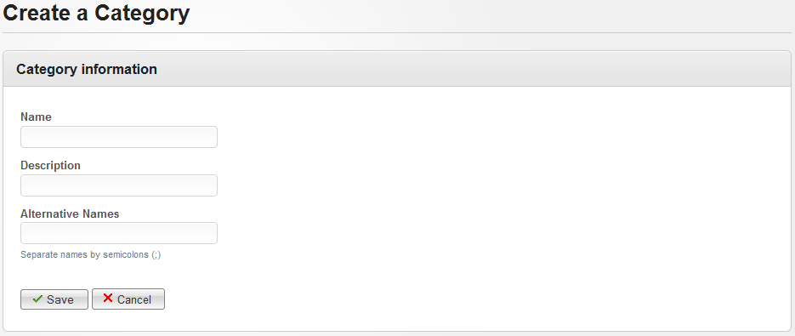**

**Data Fields Definition – Create A New Category Screen**

|  |  |  |  |  |  |  |
| --- | --- | --- | --- | --- | --- | --- |
| **Field name** | **Description** | **Read**  **Only** | **Mandatory** | **Control Type** | **Data Type** | **Length** |
| Name label | “Name” label | Y | Y | Label | String | Fixed |
| Category name | A text box for enter category name | N | Y | Textbox | String | 100 |
| Desciprtion label | “Description” label | Y | Y | Label | String | Fixed |
| Category description | A textbox for enter description for new category | N | N | Textbox | String | 1000 |
| Alter name label | “Alternative Names” label | Y | Y | Label | String | Fixed |
| Alternative name | A textbox for enter other name of new category | N | N | Textbox | String | 100 |

**Buttons / Hyper Links – Create A New Category Screen**

|  |  |  |  |  |
| --- | --- | --- | --- | --- |
| **Function** | **Description** | **Available Criteria** | **Validations** | **Outcome** |
| Add new category | Allow admin create new category | Always available. | Validate textbox whether it’s filled or not. | Redirect to Manage Category page with new category was added and display message “Category has been inserted successfully” |
| Cancel | Cancel current action | Always available. | No validation | Redirect back to Manage Category page |

### <Admin> Edit a Category

#### Use Case Diagram



#### Use Case Specification

|  |  |  |  |  |
| --- | --- | --- | --- | --- |
| **USE CASE – Edit a category SPECIFICATION** | | | | |
| **Use-case No.** | UC048 | **Use-case Version** | | 1.0 |
| **Use-case Name** | Edit A Category | | | |
| **Author** | DungTQ | | | |
| **Date** | 19/01/2011 | **Priority** | Normal | |
| **Actor:**  Admin  **Summary:**  The admin can make a mistake when creating a new category. So he/she want to correct it. The admin can edit a category.  **Goal:**  Edit a category  **Triggers**  Click to “Edit” button  **Preconditions:**  Successfully logged into the system with Admin role and accessed to Manage Category page.  **Post Conditions:**  Redirect back to Manage Category page  **Main Success Scenario:**   |  |  |  | | --- | --- | --- | | Step | Actor Action | System Response | | 1 | Click to “Edit” button | Redirect to Edit Category page | | 2 | Edit information |  | | 3 | Click to “Save” button | Redirect back to Manage Category page and display message “Category has been updated successfully” |   **Alternative Scenario:**   |  |  |  | | --- | --- | --- | | Step | Actor Action | System Response | | 1 | Click to “Edit” button | Redirect to Edit Category page | | 2 | Edit information |  | | 3 | Click to “Cancel” button | Redirect back to Manage Category page |   **Exceptions:**     |  |  |  | | --- | --- | --- | | Step | Actor Action | System Response | | 1 | Click to “Edit” button | Redirect to Edit Category page | | 2 | Leave Name blank |  | | 3 | Click to “Save” button | Display message “Name is required.” |   **Relationships:**  Login use case, List all category use case  **Business Rules:**  None | | | | |

**Screen**

**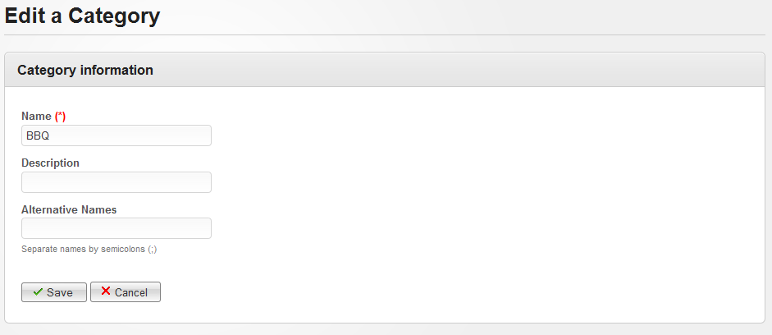**

**Data Fields Definition – Edit A Category Screen**

|  |  |  |  |  |  |  |
| --- | --- | --- | --- | --- | --- | --- |
| **Field name** | **Description** | **Read**  **Only** | **Mandatory** | **Control Type** | **Data Type** | **Length** |
| Name label | “Name” label | Y | Y | Label | String | Fixed |
| Category name | A text box for enter category name | N | Y | Textbox | String | 100 |
| Desciprtion label | “Description” label | Y | Y | Label | String | Fixed |
| Category description | A textbox for enter description for new category | N | N | Textbox | String | 1000 |
| Alter name label | “Alternative Names” label | Y | Y | Label | String | Fixed |
| Alternative name | A textbox for enter other name of new category | N | N | Textbox | String | 100 |

**Buttons / Hyper Links – Edit a Category Screen**

|  |  |  |  |  |
| --- | --- | --- | --- | --- |
| **Function** | **Description** | **Available Criteria** | **Validations** | **Outcome** |
| Save Button | Allow admin save new category | Always available. | Validate textbox whether it’s filled or not. | Redirect to Manage Category page with new category was updated and display message “Category has been updated successfully” |
| Cancel Button | Cancel current action | Always available. | No validation | Redirect back to Manage Category page |

### <Admin> Delete Categories

#### Use Case Diagram



#### Use Case Specification

|  |  |  |  |  |
| --- | --- | --- | --- | --- |
| **USE CASE – Delete Categories SPECIFICATION** | | | | |
| **Use-case No.** | UC049 | **Use-case Version** | | 1.0 |
| **Use-case Name** | Delete Categories | | | |
| **Author** | DungTQ | | | |
| **Date** | 19/01/2011 | **Priority** | Normal | |
| **Actor:**  Admin  **Summary:**  When the admin see a category which places belong to it is a few or mostly closed, they can want to delete it.  **Goal:**  Delete categories in database.  **Triggers**  Click to “Delete” button  **Preconditions:**  Successfully logged into the system with Admin role and accessed to Manage Category page.  **Post Conditions:**  stay remains at Manage Category page and selected category will be deleted from category list,  **Main Success Scenario:**   |  |  |  | | --- | --- | --- | | Step | Actor Action | System Response | | 1 | Click to “Delete” button | Pop up a window to confirm if the admin really want to delete the category. | | 3 | Click to “OK” button | Close pop up, remove selected category from the list, display message “Category has been deleted successfully” |   **Alternative Scenario:**   |  |  |  | | --- | --- | --- | | Step | Actor Action | System Response | | 1 | Click to “Delete” button | Pop up a window to confirm if the admin really want to delete the category. | | 3 | Click to “Cancel” button | Close pop up |   **Exceptions:**  None  **Relationships:**  Login use case  **Business Rules:**  None. | | | | |

**Screen**

**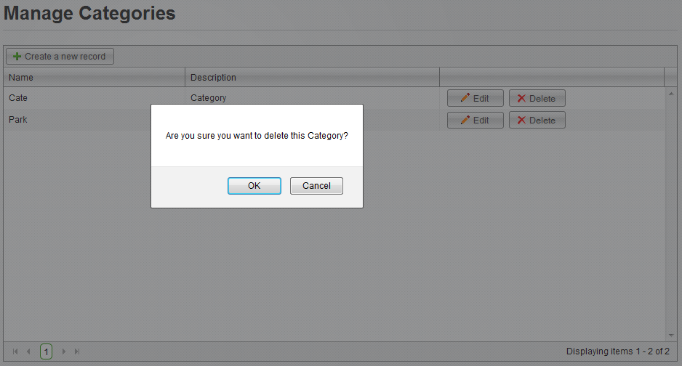**

**Buttons / Hyper Links – Delete Categories Screen**

|  |  |  |  |  |
| --- | --- | --- | --- | --- |
| **Function** | **Description** | **Available Criteria** | **Validations** | **Outcome** |
| Delelte category | This button will remove selected category from the list | Always available with each category | No validation | Pop up a window to confirm if the admin really want to delete the category. |
| Edit category | This button is used to go to Edit page of selected category | Always available with each category | No validation | Redirect to Edit Category page |

### <Admin> List All Advertises

#### Use Case Diagram



#### Use Case Specification

|  |  |  |  |  |
| --- | --- | --- | --- | --- |
| **USE CASE- List all advertises SPECIFICATION** | | | | |
| **Use-case No.** | UC050 | **Use-case Version** | | 1.0 |
| **Use-case Name** | List all advertises | | | |
| **Author** | QuocNM | | | |
| **Date** | 15/01/2011 | **Priority** | Normal | |
| **Actor:**  Administrator  **Summary:**  This is a page where displays all ads of the website. All ads are displayed in this page will be displayed with the owner name, rank... In default, there are 20 items per page.  **Goal:**  This use case allows the actor view all ads of the website.  **Triggers**  Click to “Advertises” menu then click to “Manage Advertises” sub menu.  **Preconditions:**  Successfully logged into the system with Admin role and go to Admin page  **Post Conditions:**  Manage Advertises page will be displayed with all existed ads in database.  **Main Success Scenario:**   |  |  |  | | --- | --- | --- | | Step | Actor Action | System Response | | 1 | Click to “Advertises” menu then click to “Manage Advertises” sub menu. | Manage Advertises page will be displayed with all existed Ads in database. |   **Exceptions:**  None  **Relationships:**  Login use case  **Business Rules:**   |  |  |  | | --- | --- | --- | | No | Business Rule | Error Message | | 1 | There are 20 items per page. |  | | | | | |

**Data Fields Definition – Attach Place Page**

|  |  |  |  |  |  |  |
| --- | --- | --- | --- | --- | --- | --- |
| **Field name** | **Description** | **Read**  **Only** | **Mandatory** | **Control Type** | **Data Type** | **Length** |
| Advertise | This is image/gif/flash which will be used for advertise | N/A | N/A | Image | - | - |
| Company name | Name of company/group/person who will used this advertise to promote on the system | N/A | N/A | Label | Text | Fixed |
| Created date | Date time that the advertise was added to the system | N/A | N/A | Label | Text | Fixed |
| Effective time | Duration which the advertise will be displayed on the website | N/A | N/A | Label | Text | Fixed |
| Ads location | Location the advertise will be located | N/A | N/A | Label | Text | Fixed |

**Buttons / Hyper Links – Attach Place Page**

|  |  |  |  |  |
| --- | --- | --- | --- | --- |
| **Function** | **Description** | **Available Criteria** | **Validations** | **Outcome** |
| Edit advertise | This button is used to edit selected advertise | Always available wich each advertise | No validation | Redirect to Edit Advertise page |
| Delete advertise | The button will delete chosen advertise | Always available wich each advertise | No validation | Pop up confirm |
| Create new advertise | This button is used to add new advertise into the system | Always available | No validation | Redirect to Create Advertise page |

### <Admin> Create New Advertise

#### Use Case Diagram



#### Use Case Specification

|  |  |  |  |  |
| --- | --- | --- | --- | --- |
| **USE CASE- Create new advertise SPECIFICATION** | | | | |
| **Use-case No.** | UC051 | **Use-case Version** | | 1.0 |
| **Use-case Name** | Create new advertise | | | |
| **Author** | QuocNM | | | |
| **Date** | 15/01/2011 | **Priority** | Normal | |
| **Actor:**  Administrator  **Summary:**  Administrator can add new advertise on the system.  **Goal:**  This use case allows admin create new advertise  **Triggers**  Click to “Create a new record” button.  **Preconditions:**  Successfully logged into the system with Admin role and go to Manage Advertises page  **Post Conditions:**  Redirect back to Manage Advertises page  **Main Success Scenario:**   |  |  |  | | --- | --- | --- | | Step | Actor Action | System Response | | 1 | Click to “Create a new record” button. | Redirect to Create Advertise page | | 2 | User enter data for all data fields |  | | 3 | Click to “Save” button | Redirect back to Manage Advertises page with new Advertise, display message inform success adding new advertise |   **Alternative Scenario:**   |  |  |  | | --- | --- | --- | | Step | Actor Action | System Response | | 1 | Click to “Advertises” menu then click to “Create new advertise” sub menu | Redirect to Create Advertise page | | 2 | User enter data for all data fields |  | | 3 | Click to “Save” button | Redirect back to Manage Advertises page with new Advertise, display message inform success adding new advertise |  |  |  |  | | --- | --- | --- | | Step | Actor Action | System Response | | 1 | Click to “Create a new record” button. | Redirect to Create Advertise page | | 2 | User enter data for all data fields |  | | 3 | Click to “Cancel” button | Redirect back to Manage Advertises page |   **Exceptions:**   |  |  |  | | --- | --- | --- | | Step | Actor Action | System Response | | 1 | Click to “Create a new record” button. | Redirect to Create Advertise page | | 2 | Leave required fields blank |  | | 3 | Click to “Save” button | Display error message, required admin fill in data for required fields |   **Relationships:**  Login use case, List all advertises use case  **Business Rules:**  None | | | | |

**Data Fields Definition**

|  |  |  |  |  |  |  |
| --- | --- | --- | --- | --- | --- | --- |
| **Field name** | **Description** | **Read**  **Only** | **Mandatory** | **Control Type** | **Data Type** | **Length** |
| Advertise label | “Advertise” label | N/A | N/A | Label | Text | Fixed |
| Advertise | This is an uploader which will upload image/gif/flash which will be used for advertise | N/A | Y | Uploader | - | - |
| Company label | “Company Name” label | N/A | N/A | Label | Text | Fixed |
| Company name | A text box for enter name of company which hire an ads slot on the website | N | Y | Text box | Text | Fixed |
| Effective time label | “Effective Time” label | N/A | N/A | Label | Text | Fixed |
| Effective from | A calendar for choosing the date which the advertise will be used | N | Y | Calendar | - | - |
| Effective to | A calendar for choosing the date which the advertise will be used until | N | Y | Calendar | - | - |
| Ads location label | “Advertise Location” label | N/A | N/A | Label | Text | Fixed |
| Ads location | A combobox for chosing location of the advertise | N/A | Y | Combobox | Text | Fixed |

**Buttons / Hyper Links – Attach Place Page**

|  |  |  |  |  |
| --- | --- | --- | --- | --- |
| **Function** | **Description** | **Available Criteria** | **Validations** | **Outcome** |
| Create new ads | The button will allow the admin to save the ads. | Always available | Data must be entered in all mandatory data fields | The record will be saved and user will be navigated back to Manage Advertises page and a success message will be displayed |
| Cancel | The button will allow the admin to go back to Manage Advertises page | Always available | No | User will be navigated to Manage Advertises page |

### <Admin> Edit an Advertise

#### Use Case Diagram



#### Use Case Specification

|  |  |  |  |  |
| --- | --- | --- | --- | --- |
| **USE CASE- Edit an advertise SPECIFICATION** | | | | |
| **Use-case No.** | UC052 | **Use-case Version** | | 1.0 |
| **Use-case Name** | Edit an advertise | | | |
| **Author** | QuocNM | | | |
| **Date** | 15/01/2011 | **Priority** | Normal | |
| **Actor:**  Administrator  **Summary:**  When partners change their advertise, admin can edit their advertise on the system to the newest version.  **Goal:**  This use case allows admin edit an advertise.  **Triggers**  Click to “Edit” button  **Preconditions:**  Successfully logged into the system with Admin role and go to Manage Advertises page  **Post Conditions:**  Redirect back to Manage Advertises page  **Main Success Scenario:**   |  |  |  | | --- | --- | --- | | Step | Actor Action | System Response | | 1 | Click to “Edit” button | Redirect to Edit Advertise page | | 2 | Update information |  | | 3 | Click to “Save” button | Redirect back to ManageAdvertises page with success message |   **Alternative Scenario:**   |  |  |  | | --- | --- | --- | | Step | Actor Action | System Response | | 1 | Click to “Edit” button | Redirect to Edit Advertise page | | 2 | Update information |  | | 3 | Click to “Cancel” button | Redirect back to ManageAdvertises page |   **Exceptions:**   |  |  |  | | --- | --- | --- | | Step | Actor Action | System Response | | 1 | Click to “Edit” button | Redirect to Edit Advertise page | | 2 | Update information, leave required field blank |  | | 3 | Click to “Save” button | Display error message, require admin fill in data for required fields |   **Relationships:**  Login use case, List All Advertises use case  **Business Rules:**  None | | | | |

**Data Fields Definition**

|  |  |  |  |  |  |  |
| --- | --- | --- | --- | --- | --- | --- |
| **Field name** | **Description** | **Read**  **Only** | **Mandatory** | **Control Type** | **Data Type** | **Length** |
| Advertise label | “Advertise” label | N/A | N/A | Label | Text | Fixed |
| Advertise | This is an uploader which will upload image/gif/flash which will be used for advertise | N/A | Y | Uploader | - | - |
| Company label | “Company Name” label | N/A | N/A | Label | Text | Fixed |
| Company name | A text box for enter name of company which hire an ads slot on the website | N | Y | Text box | Text | Fixed |
| Effective time label | “Effective Time” label | N/A | N/A | Label | Text | Fixed |
| Effective from | A calendar for choosing the date which the advertise will be used | N | Y | Calendar | - | - |
| Effective to | A calendar for choosing the date which the advertise will be used until | N | Y | Calendar | - | - |
| Ads location label | “Advertise Location” label | N/A | N/A | Label | Text | Fixed |
| Ads location | A combobox for chosing location of the advertise | N/A | Y | Combobox | Text | Fixed |

**Buttons / Hyper Links – Attach Place Page**

|  |  |  |  |  |
| --- | --- | --- | --- | --- |
| **Function** | **Description** | **Available Criteria** | **Validations** | **Outcome** |
| edit new ads | The button will allow the admin to save the ads. | Always available | Data must be entered in all mandatory data fields | The record will be saved and user will be navigated back to Manage Advertises page and a success message will be displayed |
| Cancel | The button will allow the admin to go back to Manage Advertises page | Always available | No | Admin will be navigated to Manage Advertises page |

### <Admin> Delete Advertise

#### Use Case Diagram



#### Use Case Specification

|  |  |  |  |  |
| --- | --- | --- | --- | --- |
| **USE CASE- Delete advertise SPECIFICATION** | | | | |
| **Use-case No.** | UC053 | **Use-case Version** | | 1.0 |
| **Use-case Name** | Delete advertise | | | |
| **Author** | QuocNM | | | |
| **Date** | 15/01/2011 | **Priority** | Normal | |
| **Actor:**  Administrator  **Summary:**  When hired time of an advertise is over, it will be deleted and leave the spot for other ads  **Goal:**  This use case allows admin remove an advertise from advertise list.  **Triggers**  Click to “Delete” button.  **Preconditions:**  Successfully logged into the system with Admin role and go to Manage Advertises page  **Post Conditions:**  Selected advertise will be removed from the list  **Main Success Scenario:**   |  |  |  | | --- | --- | --- | | Step | Actor Action | System Response | | 1 | Click to “Detele” button | Popup confirm | | 2 | Click to “Ok” button | Advertise will be removed, a success message will be displayed |   **Alternative Scenario:**   |  |  |  | | --- | --- | --- | | Step | Actor Action | System Response | | 1 | Click to “Detele” button | Popup confirm | | 2 | Click to “Cancel” button | Popup close |   **Exceptions:**  None  **Relationships:**  Login use case, list all advertises use case  **Business Rules:**  None | | | | |

**Data Fields Definition – Attach Place Page**

|  |  |  |  |  |  |  |
| --- | --- | --- | --- | --- | --- | --- |
| **Field name** | **Description** | **Read**  **Only** | **Mandatory** | **Control Type** | **Data Type** | **Length** |
| Advertise | This is image/gif/flash which will be used for advertise | N/A | N/A | Image | - | - |
| Company name | Name of company/group/person who will used this advertise to promote on the system | N/A | N/A | Label | Text | Fixed |
| Created date | Date time that the advertise was added to the system | N/A | N/A | Label | Text | Fixed |
| Effective time | Duration which the advertise will be displayed on the website | N/A | N/A | Label | Text | Fixed |
| Ads location | Location the advertise will be located | N/A | N/A | Label | Text | Fixed |

**Buttons / Hyper Links – Attach Place Page**

|  |  |  |  |  |
| --- | --- | --- | --- | --- |
| **Function** | **Description** | **Available Criteria** | **Validations** | **Outcome** |
| Edit advertise | This button is used to edit selected advertise | Always available wich each advertise | No validation | Redirect to Edit Advertise page |
| Delete advertise | The button will delete chosen advertise | Always available wich each advertise | No validation | Pop up confirm |
| Create new advertise | This button is used to add new advertise into the system | Always available | No validation | Redirect to Create Advertise page |

### <Admin> Manage Reported Places

#### Use Case Diagram



#### Use Case Specification

|  |  |  |  |  |
| --- | --- | --- | --- | --- |
| **USE CASE – Manage reported places SPECIFICATION** | | | | |
| **Use-case No.** | UC054 | **Use-case Version** | | 1.0 |
| **Use-case Name** | Manage Reported Places | | | |
| **Author** | QuangLM | | | |
| **Date** | 19/01/2011 | **Priority** | Normal | |
| **Actor:**  Admin  **Summary:**  Because all information posted in our website are public, and spam is a big problem we must solve. Similar to other website, we use Report Spam function which allows users report to us about any information what they think it’s spam. And place is one thing which users can report. After that, admin teams will review these reports and approve or reject it.  **Goal:**  View reported place list and delete it cause of spam or confirm it as not spam.  **Triggers**  Click to “Spam” menu then click to “Reported Places” sub menu  **Preconditions:**  Successfully logged into the system with Admin role and accessed to Admin page  **Post Conditions:**  Stay remain at Manage Reported Places page  **Main Success Scenario:**   |  |  |  | | --- | --- | --- | | Step | Actor Action | System Response | | 1 | Click to “Spam” menu then click to “Reported Places” sub menu | Redirect to Manage Reported Places page | | 2 | Click to “Not Spam” button | Reported place will be removed from the list, and system display message “Reports attached to chosen Place has been deleted successfully” |   **Alternative Scenario:**   |  |  |  | | --- | --- | --- | | Step | Actor Action | System Response | | 1 | Click to “Spam” menu then click to “Reported Places” sub menu | Redirect to Manage Reported Places page | | 2 | Click to “Delete” button | Popup confirm | | 3 | Click to “OK” button | Close popup, Remove reported place and display success message |  |  |  |  | | --- | --- | --- | | Step | Actor Action | System Response | | 1 | Click to “Spam” menu then click to “Reported Places” sub menu | Redirect to Manage Reported Places page | | 2 | Click to “Delete” button | Popup confirm | | 3 | Click to “Cancel” button | Close popup |   **Exceptions:**  **Relationships:**  Login use case  **Business Rules:**   |  |  |  | | --- | --- | --- | | **No** | **Rule Description** | **Error Message** | | 1 | Each page display 20 reports |  | | | | | |

**Screen**

**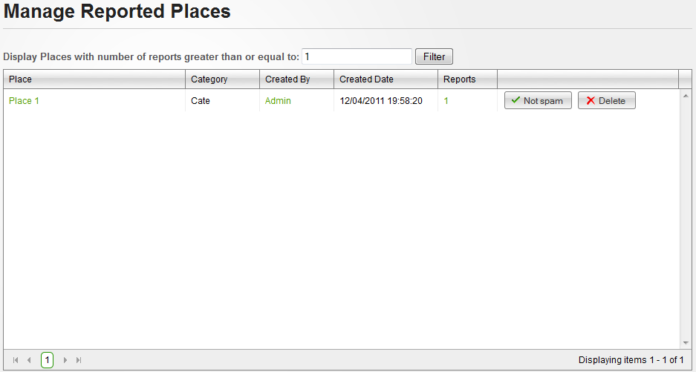**

**Data Fields Definition – Manage Places Marked Spam/fake Screen**

|  |  |  |  |  |  |  |
| --- | --- | --- | --- | --- | --- | --- |
| **Field name** | **Description** | **Read**  **Only** | **Mandatory** | **Control Type** | **Data Type** | **Length** |
| Category | Contains place’s category | Y | - | Label | String | Fixed |
| Created date | Contains place’s created date | Y | - | Label | String | Fixed |
| Filter label | A label with content: “Display Places with number of reports greater than or equal to:” | Y | - | Label | String | Fixed |
| Filter | A textbox for enter minimum report number | N | Y | Textbox | Numeric | - |

**Buttons / Hyper Links – Manage Places Marked Spam/fake Screen**

|  |  |  |  |  |
| --- | --- | --- | --- | --- |
| **Function** | **Description** | **Available Criteria** | **Validations** | **Outcome** |
| Place link | This link will open Place Detail place | Available with each reported place | No validation | Redirect to Place Detail page |
| User link | This linkwill open user profile | Available with each reported place | No validation | Redirect to User Profile page |
| Filter | This button will filter all reported places in the list | Always available | Filter value must be numeric and larger than or equal to 1 | Displayed all reported places with report number larger or equal with filter value |
| Remove from report list | This button will remove chosen place from report list cause it isn’t spam | Available with each reported place | No validation | Reported place will be removed from the list, and system display message “Reports attached to chosen Place has been deleted successfully” |
| Delete a place | This button will delete chosen place cause of spam | Available with each reported place | No validation | Popup confirm |

### <Admin> Manage Reported Comments

#### Use Case Diagram



#### Use Case Specification

|  |  |  |  |  |
| --- | --- | --- | --- | --- |
| **USE CASE – Manage reported comments SPECIFICATION** | | | | |
| **Use-case No.** | UC055 | **Use-case Version** | | 1.0 |
| **Use-case Name** | Manage Reported comments | | | |
| **Author** | QuangLM | | | |
| **Date** | 19/01/2011 | **Priority** | Normal | |
| **Actor:**  Admin  **Summary:**  Because all information posted in our website are public, and spam is a big problem we must solve. Similar to other website, we use Report Spam function which allows users report to us about any information what they think it’s spam. And place is one thing which users can report. After that, admin teams will review these reports and approve or reject it.  **Goal:**  View reported comment list and delete it cause of spam or confirm it as not spam.  **Triggers**  Click to “Spam” menu then click to “Reported Comments” sub menu  **Preconditions:**  Successfully logged into the system with Admin role and accessed to Admin page  **Post Conditions:**  Stay remain at Manage Reported Comments page  **Main Success Scenario:**   |  |  |  | | --- | --- | --- | | Step | Actor Action | System Response | | 1 | Click to “Spam” menu then click to “Reported Comments” sub menu | Redirect to Manage Reported Comments page | | 2 | Click to “Not Spam” button | Reported comment will be removed from the list, and system display message “Reports attached to chosen Comment has been deleted successfully” |   **Alternative Scenario:**   |  |  |  | | --- | --- | --- | | Step | Actor Action | System Response | | 1 | Click to “Spam” menu then click to “Reported Comments” sub menu | Redirect to Manage Reported Comments page | | 2 | Click to “Delete” button | Popup confirm | | 3 | Click to “OK” button | Close popup, Remove reported comment and display success message |  |  |  |  | | --- | --- | --- | | Step | Actor Action | System Response | | 1 | Click to “Spam” menu then click to “Reported Comments” sub menu | Redirect to Manage Reported Comments page | | 2 | Click to “Delete” button | Popup confirm | | 3 | Click to “Cancel” button | Close popup |   **Exceptions:**  **Relationships:**  Login use case  **Business Rules:**   |  |  |  | | --- | --- | --- | | **No** | **Rule Description** | **Error Message** | | 1 | Each page display 20 reports |  | | | | | |

**Screen**

**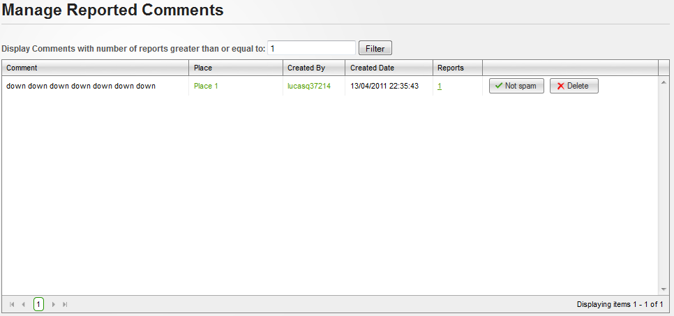**

**Data Fields Definition – Manage Places Marked Spam/fake Screen**

|  |  |  |  |  |  |  |
| --- | --- | --- | --- | --- | --- | --- |
| **Field name** | **Description** | **Read**  **Only** | **Mandatory** | **Control Type** | **Data Type** | **Length** |
| Content | Contains comment’s content | Y | - | Label | String | Fixed |
| Created date | Contains place’s created date | Y | - | Label | String | Fixed |
| Filter label | A label with content: “Display Comments with number of reports greater than or equal to:” | Y | - | Label | String | Fixed |
| Filter | A textbox for enter minimum report number | N | Y | Textbox | Numeric | - |

**Buttons / Hyper Links – Manage Places Marked Spam/fake Screen**

|  |  |  |  |  |
| --- | --- | --- | --- | --- |
| **Function** | **Description** | **Available Criteria** | **Validations** | **Outcome** |
| Place link | This link will open Place Detail place | Available with each reported comment | No validation | Redirect to Place Detail page |
| User link | This linkwill open user profile | Available with each reported comment | No validation | Redirect to User Profile page |
| Filter | This button will filter all reported comments in the list | Always available | Filter value must be numeric and larger than or equal to 1 | Displayed all reported comments with report number larger or equal with filter value |
| Remove from report list | This button will remove chosen comment from report list cause it isn’t spam | Available with each reported comment | No validation | Reported comment will be removed from the list, and system display message “Reports attached to chosen Comment has been deleted successfully” |
| Delete a comment | This button will delete chosen comment cause of spam | Available with each reported comment | No validation | Popup confirm |

### <Admin> Manage Reported Questions

#### Use Case Diagram



#### Use Case Specification

|  |  |  |  |  |
| --- | --- | --- | --- | --- |
| **USE CASE – Manage reported questions SPECIFICATION** | | | | |
| **Use-case No.** | UC056 | **Use-case Version** | | 1.0 |
| **Use-case Name** | Manage Reported Questions | | | |
| **Author** | QuangLM | | | |
| **Date** | 19/01/2011 | **Priority** | Normal | |
| **Actor:**  Admin  **Summary:**  Because all information posted in our website are public, and spam is a big problem we must solve. Similar to other website, we use Report Spam function which allows users report to us about any information what they think it’s spam. And place is one thing which users can report. After that, admin teams will review these reports and approve or reject it.  **Goal:**  View reported question list and delete it cause of spam or confirm it as not spam.  **Triggers**  Click to “Spam” menu then click to “Reported Questions” sub menu  **Preconditions:**  Successfully logged into the system with Admin role and accessed to Admin page  **Post Conditions:**  Stay remain at Manage Reported Questions page  **Main Success Scenario:**   |  |  |  | | --- | --- | --- | | Step | Actor Action | System Response | | 1 | Click to “Spam” menu then click to “Reported Questions” sub menu | Redirect to Manage Reported Questions page | | 2 | Click to “Not Spam” button | Reported question will be removed from the list, and system display message “Reports attached to chosen Question has been deleted successfully” |   **Alternative Scenario:**   |  |  |  | | --- | --- | --- | | Step | Actor Action | System Response | | 1 | Click to “Spam” menu then click to “Reported Questions” sub menu | Redirect to Manage Reported Questions page | | 2 | Click to “Delete” button | Popup confirm | | 3 | Click to “OK” button | Close popup, Remove reported question and display success message |  |  |  |  | | --- | --- | --- | | Step | Actor Action | System Response | | 1 | Click to “Spam” menu then click to “Reported Questions” sub menu | Redirect to Manage Reported Question page | | 2 | Click to “Delete” button | Popup confirm | | 3 | Click to “Cancel” button | Close popup |   **Exceptions:**  **Relationships:**  Login use case  **Business Rules:**   |  |  |  | | --- | --- | --- | | **No** | **Rule Description** | **Error Message** | | 1 | Each page display 20 reports |  | | | | | |

**Screen**

**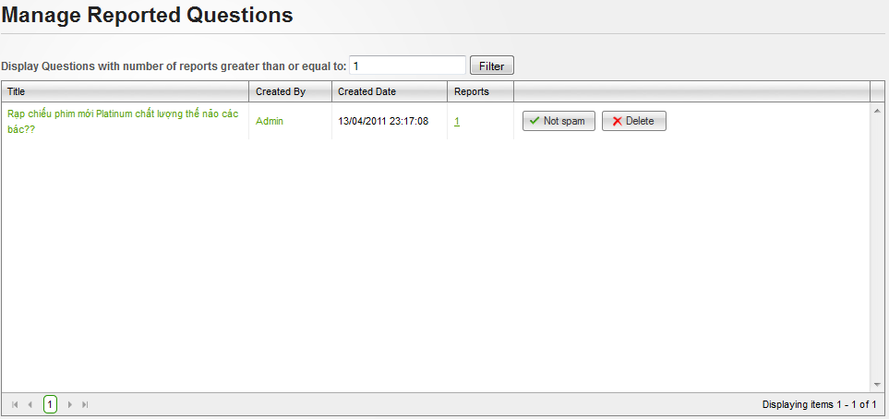**

**Data Fields Definition – Manage Places Marked Spam/fake Screen**

|  |  |  |  |  |  |  |
| --- | --- | --- | --- | --- | --- | --- |
| **Field name** | **Description** | **Read**  **Only** | **Mandatory** | **Control Type** | **Data Type** | **Length** |
| Created date | Contains place’s created date | Y | - | Label | String | Fixed |
| Filter label | A label with content: “Display Comments with number of reports greater than or equal to:” | Y | - | Label | String | Fixed |
| Filter | A textbox for enter minimum report number | N | Y | Textbox | Numeric | - |

**Buttons / Hyper Links – Manage Places Marked Spam/fake Screen**

|  |  |  |  |  |
| --- | --- | --- | --- | --- |
| **Function** | **Description** | **Available Criteria** | **Validations** | **Outcome** |
| Question link | This link will open Question Detail page | Available with each reported question | No validation | Redirect to Question Detail page |
| User link | This linkwill open user profile | Available with each reported question | No validation | Redirect to User Profile page |
| Filter | This button will filter all reported questions in the list | Always available | Filter value must be numeric and larger than or equal to 1 | Displayed all reported questions with report number larger or equal with filter value |
| Remove from report list | This button will remove chosen question from report list cause it isn’t spam | Available with each reported question | No validation | Reported question will be removed from the list, and system display message “Reports attached to chosen Question has been deleted successfully” |
| Delete a question | This button will delete chosen question cause of spam | Available with each reported question | No validation | Popup confirm |

### <Admin> Manage Reported Answers

#### Use Case Diagram



#### Use Case Specification

|  |  |  |  |  |
| --- | --- | --- | --- | --- |
| **USE CASE – Manage reported answers SPECIFICATION** | | | | |
| **Use-case No.** | UC057 | **Use-case Version** | | 1.0 |
| **Use-case Name** | Manage Reported answers | | | |
| **Author** | QuangLM | | | |
| **Date** | 19/01/2011 | **Priority** | Normal | |
| **Actor:**  Admin  **Summary:**  Because all information posted in our website are public, and spam is a big problem we must solve. Similar to other website, we use Report Spam function which allows users report to us about any information what they think it’s spam. And place is one thing which users can report. After that, admin teams will review these reports and approve or reject it.  **Goal:**  View reported answer list and delete it cause of spam or confirm it as not spam.  **Triggers**  Click to “Spam” menu then click to “Reported Answers” sub menu  **Preconditions:**  Successfully logged into the system with Admin role and accessed to Admin page  **Post Conditions:**  Stay remain at Manage Reported Comments page  **Main Success Scenario:**   |  |  |  | | --- | --- | --- | | Step | Actor Action | System Response | | 1 | Click to “Spam” menu then click to “Reported Answers” sub menu | Redirect to Manage Reported Answers page | | 2 | Click to “Not Spam” button | Reported answer will be removed from the list, and system display message “Reports attached to chosen Answer has been deleted successfully” |   **Alternative Scenario:**   |  |  |  | | --- | --- | --- | | Step | Actor Action | System Response | | 1 | Click to “Spam” menu then click to “Reported Answers” sub menu | Redirect to Manage Reported Answers page | | 2 | Click to “Delete” button | Popup confirm | | 3 | Click to “OK” button | Close popup, Remove reported answer and display success message |  |  |  |  | | --- | --- | --- | | Step | Actor Action | System Response | | 1 | Click to “Spam” menu then click to “Reported Answers” sub menu | Redirect to Manage Reported Answers page | | 2 | Click to “Delete” button | Popup confirm | | 3 | Click to “Cancel” button | Close popup |   **Exceptions:**  **Relationships:**  Login use case  **Business Rules:**   |  |  |  | | --- | --- | --- | | **No** | **Rule Description** | **Error Message** | | 1 | Each page display 20 reports |  | | | | | |

**Screen**

**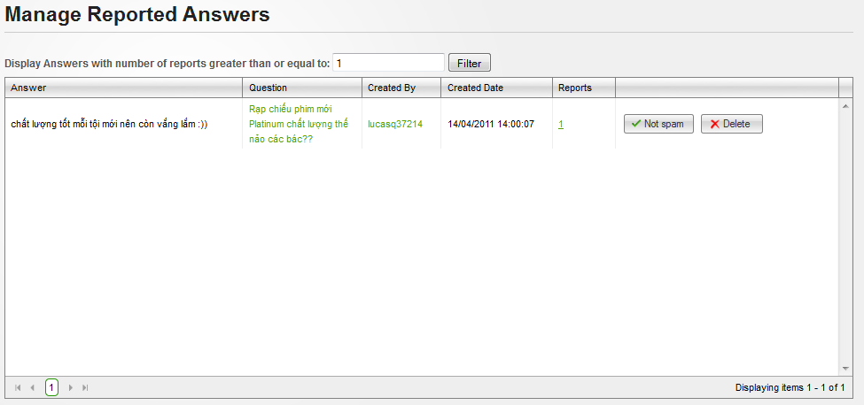**

**Data Fields Definition – Manage Places Marked Spam/fake Screen**

|  |  |  |  |  |  |  |
| --- | --- | --- | --- | --- | --- | --- |
| **Field name** | **Description** | **Read**  **Only** | **Mandatory** | **Control Type** | **Data Type** | **Length** |
| Content | Contains answer’s content | Y | - | Label | String | Fixed |
| Created date | Contains place’s created date | Y | - | Label | String | Fixed |
| Filter label | A label with content: “Display Comments with number of reports greater than or equal to:” | Y | - | Label | String | Fixed |
| Filter | A textbox for enter minimum report number | N | Y | Textbox | Numeric | - |

**Buttons / Hyper Links – Manage Places Marked Spam/fake Screen**

|  |  |  |  |  |
| --- | --- | --- | --- | --- |
| **Function** | **Description** | **Available Criteria** | **Validations** | **Outcome** |
| Question link | This link will open Question Detail place | Available with each reported answer | No validation | Redirect to Question Detail page |
| User link | This linkwill open user profile | Available with each reported answer | No validation | Redirect to User Profile page |
| Filter | This button will filter all reported answers in the list | Always available | Filter value must be numeric and larger than or equal to 1 | Displayed all reported answers with report number larger or equal with filter value |
| Remove from report list | This button will remove chosen answer from report list cause it isn’t spam | Available with each reported answer | No validation | Reported answer will be removed from the list, and system display message “Reports attached to chosen Answer has been deleted successfully” |
| Delete a place | This button will delete chosen answer cause of spam | Available with each reported answer | No validation | Popup confirm |

## Software System Attributes

### Usability

**GUI**

* All the text, image text and help documents should be in Vietnamese.
* The interface should be elegant, simple and out-standing.
* All images must also provide alt attribute.

**Usability for end-users**

* Searching tool should be easy to use.
* The website must provide a help page to support novice users.
* Users can use main functionality of the system without logging in to the system.
* The system should remember information (but not confidential) that users have to provide regularly. For example: name, address…

**Usability for admin and staff**

* Website admin and shop’s staff should need no more than one day of training to be productive with the system.
* Detailed help must be available for the admin and staff, both in web pages and separate documentations.

**Installation**

* The system must be easy to deploy. Customer can deploy successfully and learn to configure, maintain the system within one day of training.
* The documentation for installation must be included. It describes detailed steps for installing or deploying the system. The customer can follow the steps without direct help from the developing team.

### Reliability

* Initial data must be collected carefully and correctly
* The database must be backed up regularly and can be recovered if necessary
* Have a good spam filter
* Rating system must be reliable
* Not conflict with other software
* Rate of fault occurrence (ROFO): a number of 0.005 is acceptable. It means that it is acceptable to have 5 failures happen in each 1000 operational time units (e.g. 5 failures per 1000 hours of operation).
* Mean Time Between Failures (MTBF): 1 month
* Mean Time To Repair (MTTR): immediately when admin finds out problem or website is attacked by someone. Average 1 day.
* Accuracy: precision of floating number should be rounded to 0.01. All currency units must be displayed (e.g. $, VND…)
* Maximum Bugs or Defect Rate: 5 bugs / KLOC.
* Bugs or Defect Rate
  + Minor bugs: bugs related to GUI
  + Significant bugs: bugs related to minor business logic
  + Critical *bugs: function can’t execute correctly, completely loss of data, disconnect to the server*

### Availability

* Systems have to run 24 hours 7 days
* Can be turned off when upgrading and must display an alternative maintenance page in such occasions
* Percentage of time available is about 95-97%. Because the system uses client/server protocol through Internet network, we cannot control cases of force majeure such as power failure, disconnected network…

### Security

* Privacy: the system should provide protection method for protecting user information from outside or from other users. All the information of users must not be available for anyone or software that is not part of the system. User password is also invisible for the system administrator.
* The system must provide methods to prevent common security attacks. E.g. SQL injection, D-Dos…
* Transformation of confidential information must be encrypted.
* The system must provide secure methods for users to recovery their password, including the interference of system’s admin.
* Secure information of customers should not be stored on customer’s machine.
* Utilize certain cryptographic techniques for database
* Provide options for users to choose whether to share private information
* Restrict communications between some areas of the program
* Check data integrity for critical variables
* Must use secure connection (SSL) for transferring sensitive data

### Maintainability

**Coding standards and naming conventions**

* Output of the project must include coding standards and naming conventions documentations. Implementation code must be easy to maintain.
* All code must be clearly commented, including class, method documentations.
* If some components are reused, the documentations of those components must also be included.

**Design**

* The design of the system must be loosely coupled that chances on some module will not affect others.

**Logging**

* All the errors should be logged, supporting for bug fixing and maintenance.
* All strange or sensitive situations should also be logged.

**Email**

* The system must provide an email address to receive customer feedback or send emails.

### Portability

* Website can be used by any people with a browser and an Internet connection.

### Performance

**Load time**

* Every page should be completely displayed within: average 1.5 second and maximum 5 seconds.
* Searching should return and display the result within 2 seconds.
* Comments and rating and the like should affect immediately, without reloading the web page.
* Frequently accessed data must be cached
* Reference *data must be cached*

**Mailing system**

* Mail server should send emails within 1 minute after associated events happen.

**Capacity**

* The system should serve correctly and reasonably with at least 1000 online users at a moment.
* The system can store at least 100000 places and 10000 users without affecting the loading speed.
* If the system is busy, it has to inform users about that.

**Compatibility**

* The system should provide elegant responses for nowadays common screen resolutions: 1024\*768, 1280\*800.
* The output must be compatible with all common browsers: Mozilla Firefox, Internet Explorer, Google Chrome, Apple Safari, and Opera.
* Information of the system can be accessed by searching bots.

# References

[1] Wikipedia, 2011, 'Use case', 8 February, viewed 10 February 2011

<<http://en.wikipedia.org/wiki/Use_case>>

[2] Jeff Atwood,  2011, 'Suggested Edits and Edit Review' blog, February 5th, Stack Exchange, viewed 10 February 2011

<<http://blog.stackoverflow.com/2011/02/suggested-edits-and-edit-review>>